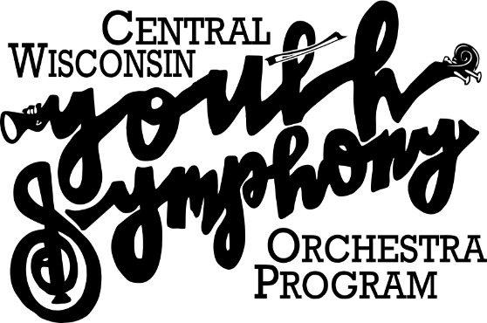

Kurt Van Tiem, Music Director

***Yes***, I wish to make an investment in CWYSOP and the young musicians it serves:

___ $1,000 and above ___ $500 - $999 ___ $250 - $499 ___ $100 - $249 ___ $1 - $99

___ I would like to be contacted regarding Estate Planning options

**Total Amount Enclosed: $**___________

**Thank you for your support!**

**Supporter Form**

Name: *(as you wish it to appear in recognition)* ________________________________________________________________

Business Name *(if applicable):* __________________________________________________________________________

Address: _________________________________________ City: ___________________________ Zip: _____________

Phone: _________________________________ Email *(optional)*:____________________________________________

Date: ___/___/______

* Donations to CWYSOP are tax deductible.
* To donate online, visit the UW-Stevens Point Foundation Office website: https://give.uwsp.edu/give-now.

1. Select “Give Now.”
2. Select the “Make A Gift” page.
3. Select “Designation Box.”
4. Select “Other Specific Fund.”
5. Type in “9148” or “Central Wisconsin Youth Symphony Orchestra.”

* For questions, please call the UW-Stevens Point Foundation Office: 1-800-858-5267 or 715-346-3812,

or email them at foundation@uwsp.edu.

* Checks must be mailed directly to: UWSP Foundation; 2100 Main Street, Suite 134, Stevens Point, WI 54481.

* **Please make checks payable to:** UWSP Foundation
* **If writing a check, you must indicate “CWYSOP” or Acct. # 9148**on your memo line. *(If not, the donation will not be deposited in our account and we will be unaware of your attempt to donate to CWYSOP.)*