Worksheet 1: Stakeholder Identification
Use this worksheet and the accompanying exercise to identify stakeholders to include in the planning process.

Instructions: 1) Identify the broad topic or specific issues to be addressed by planning.
2) Identify types of stakeholders potentially interested in or affected by the issue.
3) Identify specific individuals or groups that should be involved.

 | Identify Potential Issues
Identify Potential Stakeholders | Example  Transportation | Economic Development | Housing | Agriculture | Natural Resources
Example  Local Government  - Elected officials  - Local departments  - Regional government  - State government  - Federal government  - Quasi-public agencies | Public works  Highway dept  Planning dept  RPC / Metro planning org  DOT | Community development  Econ dev corporation  Chamber of commerce  WEDC | Housing authority  WHEDA  HUD | Land and water conservation  Extension  DATCP | Parks and recreation  Land and water conservation  DNR
Community Members
- Age
- Gender
- Race/ethnicity
- Income/employment
- Housing status
- Familial status
- Geographic location
- Political view
- Opinion leaders

Organizations
- Civic
- Cultural
- Religious
- Business
- Geographic
- Special Interest

Private Sector
- Health
- Education
- Business
- Retail/services
- Manufacturing
- Construction
- Agriculture
- Forestry
- Other

Exercise 1: Stakeholder Relationship Mapping
Use the following space or a large sheet of paper to identify stakeholders and their relationships to local planning issues and/or each other. If desired, make notes directly on the paper or use different symbols or lines to identify important relationships (i.e. common interests, influence, etc.). This type of exercise is useful for identifying stakeholders, brainstorming potential issues, and uncovering hidden relationships.

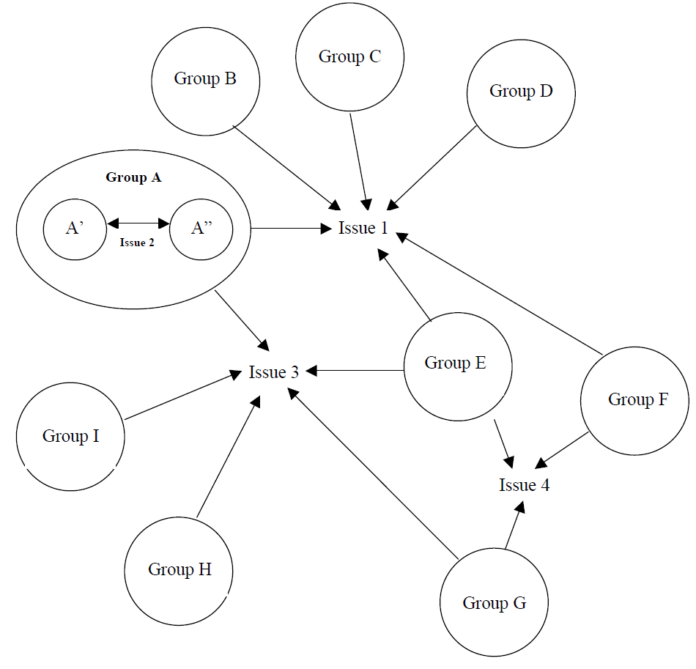
Examples:

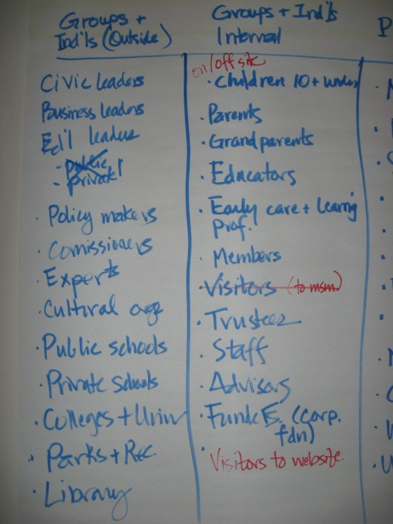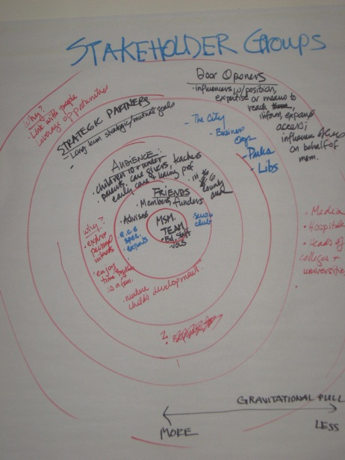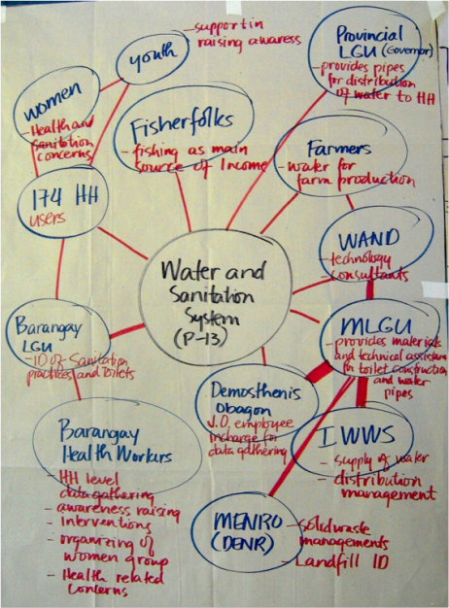

Graphic from Bryson, 2004 and Bryant, 2003. Photos 1 and 2 from Stakeholder Analysis, Museum Notes Blog, February 7, 2011. Photo 3 from Stakeholder Interests, Sustainable Sanitation and Water Management, 2010.
Worksheet 2: Stakeholder Analysis
Use this worksheet and the accompanying exercise to analyze important stakeholder characteristics and begin to identify a strategy for involvement.

Instructions: 1) Make a list of potential stakeholders (see Worksheet 1).
2) Note how each stakeholder is interested in, able to influence, and likely to
participate in the process. Describe additional characteristics as needed.

List Potential Stakeholders | Goals, motivations and interests | Power and influence | Knowledge, resources and support
Example  Citizens for a greener tomorrow | Interested in preserving urban biodiversity by establishing a network of trails and open space. | No official power but able to influence and inform a large number of members. | Knowledgeable and supportive of previous planning efforts. Able to provide volunteers.
Exercise 2: Stakeholder Analysis Matrix
Use the following space or a large sheet of paper to identify and classify stakeholders according to selected dimensions. Represent one stakeholder dimension along each axis. If desired, use different symbols, colors, sizes or lines to represent a third dimension (i.e. size of symbol = degree of influence). Begin to make note of potential strategies to involve each group. This type of exercise is useful for analyzing how stakeholders relate to an issue or process, and identifying methods to engage stakeholders.

Supporter
Maintain ongoing communication
Involve where possible
Leverage support
Low Dimension: e.g. Interest, Support High
Example: Latent
Maintain ongoing communication
Identify and address concerns
Seek to actively engage where interested
Monitor for opposition
Advocate
Maintain ongoing communication
Involve in important decision points
Leverage influence
Indifferent
May not want to participate
Keep informed
Monitor for opposition
Low Dimension: e.g. Power, Influence High
Group G
Group A
Group B
Group C
Group D
Group F
Group E
Group H

Stakeholder Dimensions:

Power: the power a stakeholder has over the decision
Influence: the ability of a stakeholder to influence other stakeholders
Impact: the degree to which the decision will impact each stakeholder
Interest: the perceived level of interest that each stakeholder has in the decision
Support: the degree to which a stakeholder supports or opposes the project
Resources: the level of resources a stakeholder is able to bring to the process
Knowledge: the level of knowledge a stakeholder has about the project

Adapted from Tools for Institutional, Political and Social Analysis of Policy Reform: Annex. 2007. The World Bank.
Worksheet 3: Public Participation Strategy
Use this worksheet to develop a strategy for public participation, including methods, timing and audience.

Instructions: 1) Identify tasks to complete during each major step of the planning process.
2) Identify objectives for public participation at various points in the process.
3) Identify tools and stakeholders appropriate for each task.

Identify Planning Tasks | Identify Participation Strategy
Example | Awareness | Education | Input | Interaction | Decision
Data Collection and Analysis

1. Identify data and information needs |  |  | Plan commission
2. Gather spatial and technical data

3. Verify data for accuracy |  |  | Data review committee of citizen/experts
4. Analyze data for patterns and trends

5. Disseminate information | Press release targeting general public | Kickoff mtg. targeting general public
Issue Identification

1.

2.

3.

Goal and Objective Formulation

1.

2.

3.

Strategy Formulation

1.

2.

3.

Plan Review and Approval

1.

2.

3.

Adapted from Crafting an Effective Plan for Public Participation, Miskowiak, 2004. Center for Land Use Education.
Worksheet 4: Barriers to Participation
Use this worksheet to refine the public participation strategy by identifying barriers to participation and potential solutions.

Instructions: 1) Identify barriers to participation based on knowledge of stakeholders
(Worksheets 1 and 2) and previous participation experience (Worksheet 7).
2) Identify potential solutions, noting audience, timing and methods as
appropriate.

Barriers | Solution
Example  Geography - woodland and lakefront property owners live outside of region | - Send survey and mailings to permanent residence  - Hold weekend meetings during prime visitor season  - Provide webinars to capture those unable to travel  - Post all relevant project information on website
Transportation

Language or reading skills

Cultural or ethnic sensitivities

Political sensitivities

Family/work obligations

Level of interest

Worksheet 5: Communication Strategy
Use this worksheet to develop a communication strategy for public participation, including key information to relay to the public and preferred techniques.

Event: ______________________________________________________________________
Participation objective: _________________________________________________________
Target audience: ______________________________________________________________
Date: _________________________________ Time: _________________________________

Key Information | Responsible party | Target completion
Identify the key information you will relay to the public.

Technical Information | Responsible party | Target completion
Identify technical and background information needed to ensure meaningful participation.

Communication Techniques | Responsible party | Target completion
Identify techniques to communicate with the public.

Public notice (posting, newspaper, etc.)
Mass media (press release, letter to the editor, interview, etc.)
Internet (email, calendar of events, Facebook, etc.)
Print (postcard, factsheet, handout, etc.)
Display (poster, map, photos, scale model, etc.)
Audiovisual (PowerPoint presentation, video, etc.)
Other:
Worksheet 6: Event Logistics
Use this worksheet to plan for individual public participation events, including facility, room setup and equipment needs.

Event: ______________________________________________________________________
Participation objective: _________________________________________________________
Target audience: ______________________________________________________________
Date: _________________________________ Time: _________________________________

Facility | Responsible party | Target completion
Name: ______________________________________________________________________
Location: ____________________________________________________________________
Contact person: _______________________________________________________________
Phone: _______________________________ Email: _________________________________
Rental fee: ____________________________ Capacity: ______________________________
Features: Adequate parking Restrooms Handicap accessible Other: ___________

Equipment | Responsible party | Target completion
Directional signage
Name tags
Sign-in sheet
Presentation materials (maps, posters, PowerPoint presentation, etc.)
Facilitation materials (flipchart, markers, paper, pens, post-it notes, sticky dots, etc.)
A/V equipment (laptop, projector, screen, cart, extension cord, microphone, speakers, etc.)
Refreshments (food, beverages, serving ware, tablecloth, waste/recycling, etc.)
Handouts
Evaluation forms

Room Setup | Responsible party | Target completion
Tables: (registration, refreshments, handouts, displays, etc.)
Chairs:
Other:
Room arrangement:
The physical arrangement of a room sets the tone for public participation. Use the following diagrams to select an arrangement that is appropriate for the intended event. Consider the number of participants, level of interaction and meeting goals.

Circle

A plain circle of chairs is useful when the full involvement of each individual is required. This arrangement encourages discussion and interaction among peers and downplays the role of the leader. Use of audiovisuals or a flip chart may be difficult. If needed, tables can be used to remove the sense of vulnerability some participants may experience. Ideal for up to 20 participants.

Conference Table
Ideal for small groups where close interaction and a lot of discussion are expected. Sharing a single table creates unity but may also suggest formality or hierarchy. Most effective with groups of 6-15 where participants can see and hear each other easily. If the group gets too large, people at the far end of the table may feel left out and form a separate group. Participants may need to move their chairs to properly view a presentation.
U-Shape
Popular set-up for groups where close interaction or collaboration is necessary. Gives participants a sense that they are equal in status. Group size should be limited to about 20 people so that participants can easily see and hear each other. Front area can be used for audiovisuals and center area for simulations or role plays. A table could be added to the front of this arrangement to create additional seating, but may limit functionality.

Classroom
A classroom-style setup provides a work surface for note taking and reference materials. It is ideal for one-way communication such as audiovisual presentations and lecture style programs. Though not ideal, participants can also break out into small groups at their tables or turn to the table behind them. Visibility and group interaction can be enhanced by arranging furniture in a semi-circle. Sound amplification may be needed in larger rooms.

Banquet
Ideal for small group discussion and project work within a larger group setting. Participants are seated at round or small rectangular tables. To maximize visibility, tables can be arranged in a semi-circle and seating limited to one side of the table. Small groups can easily return to the large group to focus on a speaker or audiovisual presentation. Sound amplification may be needed in larger rooms. A meal can be easily incorporated into this setup.

Theater
Ideal for one-way communication to large groups. Examples include audiovisual presentations and lecture style programs. Visibility can be enhanced by providing tiered seating or by placing chairs in a semi-circle. Note taking is cumbersome without tables. Sound amplification may be needed in larger rooms. Microphones placed throughout the room can be less intimidating than requiring speakers to come to the front of the room to provide input.
Graphics from MICE International, Conference Meeting Room Configurations. www.mice-group.com/venues.htm
Worksheet 7: Event Debrief
Use this worksheet to evaluate the strengths and weaknesses of individual public participation events and transfer lessons to future activities.

Event: ______________________________________________________________________
Participation objective: _________________________________________________________
Target audience: ______________________________________________________________
Date: _________________________________ Time: _________________________________

Strengths
What worked well? (timing, location, venue, activities, etc.)

- For specific audiences
- To achieve specific objectives

Weaknesses
What could have been improved?

- Barriers to participation
- Unanticipated events

Lessons Learned
What key learning experiences should be transferred to future events?

Worksheet 8: Documentation and Evaluation
Use this worksheet to document resources invested in the public participation program and evaluate its overall success.

Inputs: Document and evaluate resources invested in public participation
Resources  Example  - Time  - Money  - Equipment  - Technology  - Staff  - Volunteers  - Partners | Evaluation Questions  - Were sufficient resources allocated to the public participation program?  What else was needed?  - Did the results justify the costs? | Evaluation Results

Outputs: Document and evaluate public participation activities and involvement
Activities  - Notices  - Educational materials  - Meetings  - Small group activities | Evaluation Questions  - Were there a range of opportunities to participate, both in-person and remotely?  - Were the locations convenient and accessible?  - Was the information distributed clear and easy to understand? Was it timely? | Evaluation Results
Involvement

- Number of participants
- Diversity of participants
- Attainment of objectives
- Quality of input
- Public satisfaction

Outcomes: Document and evaluate short, medium and long-term results of public participation
Short-term results  - Increase knowledge  - Obtain feedback  - Resolve conflicts  - Gain consensus  - Influence decision-making | Evaluation Questions | Evaluation Results
Medium-term results

- Adopt plan
- Create policies, programs
- Change behavior

Long-term impacts

- Change social conditions
- Change economic conditions
- Change environmental conditions

Logic Model adapted from University of Wisconsin Cooperative Extension, Program Development and Evaluation. www.uwex.edu/ces/pdande/evaluation/evallogicmodel.html

