Hach HQ30D Dissolved Oxygen Meter
Instructions for Use

Basic Operation

- The Hach HQ30d has a user manual for the Luminescent Dissolved Oxygen Probe: Model LDO 10101, LDO10103, LDO10105 as well as a user manual for the meter. You should read both manuals if this meter belongs to your lake group.
- There may be a password protection on the meter you signed out. This means that the settings are set and locked by the “Meter Minder”.

- Push the power button to turn the meter on. Follow the on-screen instructions to set the date and time on the meter. Do not connect the IntelliCal probe to the HQd Meter until the correct date and time are set in the meter.

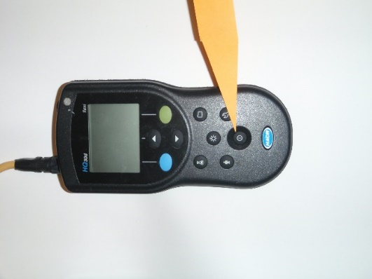

- If there is no power, check the batteries. Calibrate the probe before using. Regular calibration is required for the best measurement accuracy (as recommended in the probe manual).

If you add the DO/temperature profile into SWIMS, there is a box to check that you calibrated the meter before using it. The “Meter Minder” will have already calibrated the meter so you don’t need to worry if you are checking the meter out from the Land Conservation office, DNR or CLMN volunteer.

- Calibration Notes:
  - There are three default calibration methods available for the LDO 101 probe in the Modify Current Settings menu. Be sure to use the User Cal 100% method.
The 3 methods are:
    - User calibration – 100% (User Cal 100%) (allows user calibration)
    - Factory Cal (Calibration with default LDO calibration) (do not use)
    - Default (do not use)
  - Change Calibration options
    - Make sure a probe is connected to the meter.
    - Push and select LDO 101 Settings.
    - Select Modify Current Settings.
    - Select Calibration Options (Select water-saturated air (100%).

Calibration Procedure:
Water-saturated air (100%) calibration procedure:

The manual that comes with the Hach HQ30d describes the water-saturated air (100%) calibration procedure. The Hach manual suggests that you add approximately ¼ inch of reagent water to a narrow-neck bottle, such as a BOD bottle. Most volunteers do not have a BOD bottle or reagent (deionized) water. Volunteers who have called Hach Tech Support have been told to use a zip lock plastic bag with water in. Our research did not find the plastic bag to be useful because holding the bag on the sensor greatly affects the temperature, therefore this method should not be used.

If you are a CLMN chemistry volunteers you can use the flask that is included with your CLMN chemistry kit works well for creating a 100% air-saturated chamber for calibration purposes.

1. Connect the probe to the meter. Make sure that the cable locking nut is securely connected to the meter. Turn on the meter.

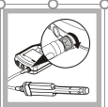

2. Push the BLUE/LEFT key on the meter keypad. Then press Calibrate.
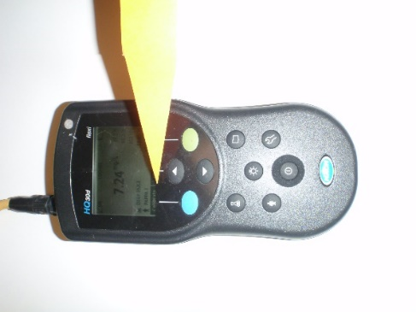

2. Push Methods. Select User Cal – 100%. Push OK.

3. Remove the probe guard and rinse the probe cap with distilled water. Blot dry with a lint free cloth.

4. Add ¼ inch of tap water to the flask. You do not want the water to touch the end of the probe. You want the probe to be dry.

5. Place the probe (gently) into the top of the flask. Leave in place for 5 minutes.

6. Push the GREEN/RIGHT button. Push Read. The display shows “stabilizing” and a progress bar as the probe stabilizes. The display shows the standard value when the reading is stable.

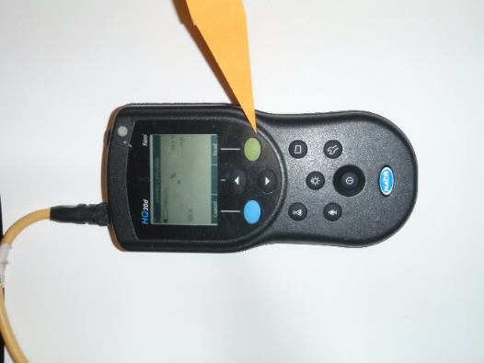

7. When the reading is stable the standard value will be highlighted on the screen and the calibrated reading value will appear on the screen. Press the UP key under Done.

8.When the calibration is successful, the display will show OK in the Upper left-hand corner. A question mark will be displayed if he calibration has expired or there is another problem.

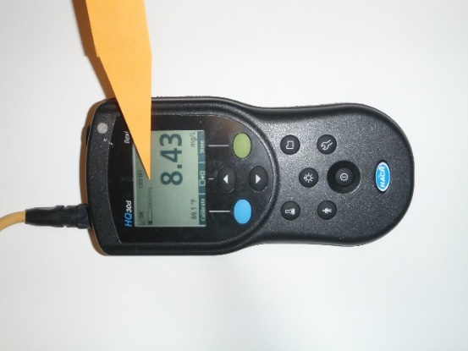

9. Fill out the CLMN/Lake Association – Handheld D.O. Meter Calibration Log
- Hach meter users cannot adjust their barometric pressure. Hach meter users should disregard the Uncorrected BP column on the worksheet.
- The drift check, on the calibration log, should be recorded five minutes after calibration. Do not move the meter from the calibration location for 5 minutes.

10. Press the GREEN/RIGHT key under Store to accept the calibration and return to the measurement mode. Remove the probe from the flask and reinstall the probe guard.

Taking a Dissolved Oxygen Measurement
- Place the probe at the depth you wish to sample
- Press the Green/Right key under Read
- The display with show “stabilizing…” and a progress bar will fill from 0 to 100% as the probe stabilizes in the lake water. When the result has stabilized, the lock icon will appear. You should write the result on your data sheet (those who own the meter can store the results automatically in the data log).
- You should record your dissolved oxygen reading in mg/L (milligrams/Liter). Temperature can be recorded in either degrees Fahrenheit or degrees Celsius.
- Lower the probe to the next depth and record the reading.

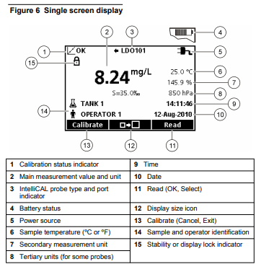

Maintenance

Replacing the LDO probe Cap
The probe cap must be replaced every 365 days or more often if the cap becomes damaged or fouled. The meter will show a reminder message when 30 days of probe service life remains on the probe cap.

For LDO probe cap replacement instructions, refer to the instructions provided with the LDO probe cap replacement kit.

Storage

The manufacturer recommends that the probe is stored dry when the probe is used for measurements of short duration (less than 6 hours).

Software Downloads

To download the most current version of the software, refer to the applicable product page on the manufacturer’s website. Refer to the manual for specific instructions. You need a USB/DC adapter to perform the software downloads. This must be purchased from Hach.

Keypad description

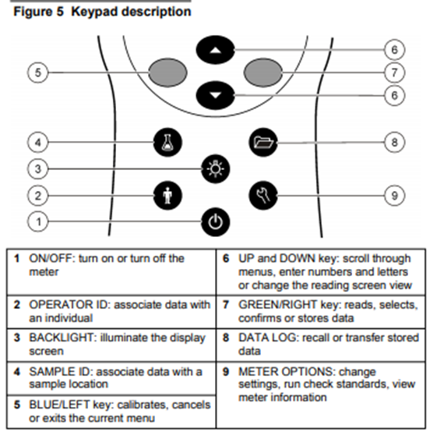

References: DOC022.53.80017, HQd Portable Meter,10/2017, Edition 6
User Manual DOC022.53.80021, Luminescent Dissolved Oxygen Probe: Model LDO10101,
LDO10103, LDO10105, LDO10110, LDO10115 or LDO10130

