To view financial detail by Purchase Order, Voucher or Supplier (formerly known as Vendor), navigate to the WISER Main Menu and choose the ‘Find POs, Vouchers, Vendors’ link under the ‘AP/PO’ heading.
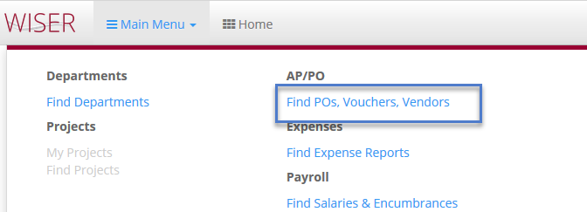

Purchase Order (PO) Search
On the ‘Find AP/PO Data’ page, select the ‘PO Search’ link in the first box to reach the PO Search screen.
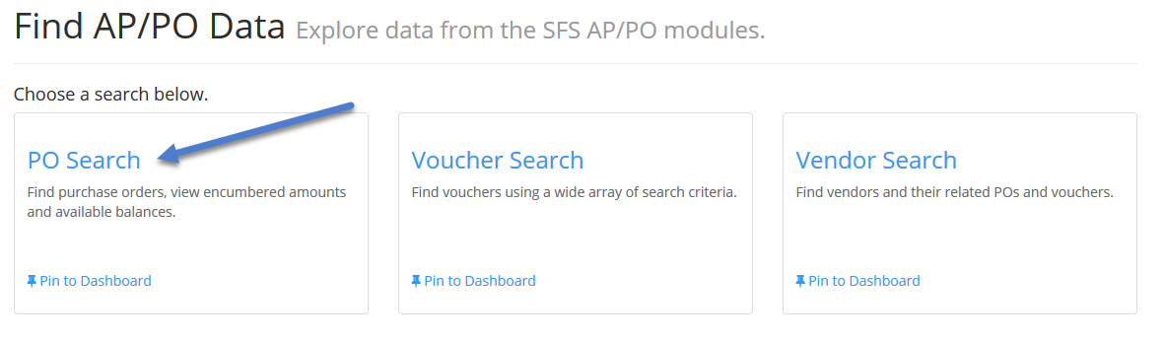
Search for Purchase Orders
On the next screen, one can ‘Find POs’ using the search field options.
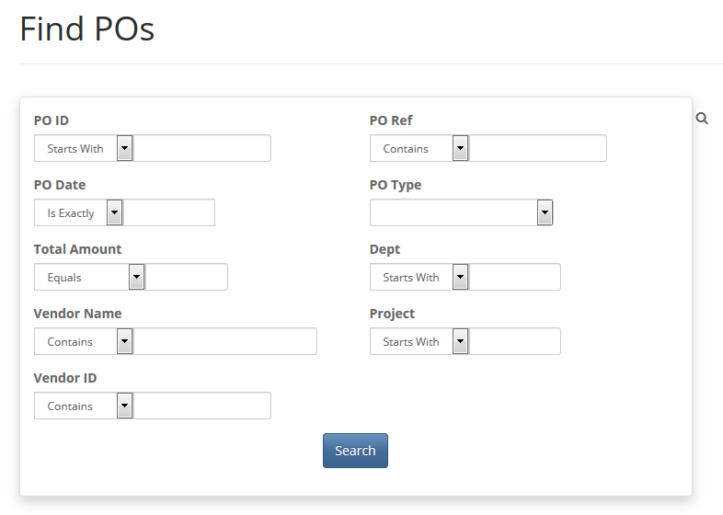
PO Search

On the ‘Find POs’ search screen, are the following search fields:

PO Search Options
PO ID
PO Date
Total Amount
Vendor Name
Vendor ID
PO Ref (Reference)
PO Type
Dept
Project

The PO ID field allows the user to search on complete or partial PO ID. PO Date can be an exact date or a date range. Total Amount is the total dollar amount of the purchase order equal to, greater than or less than the value entered. Vendor Name allows the user to search on purchase orders related to a specific supplier by name or partial name. The Vendor ID field will search on the exact or partial Vendor ID number. The PO Reference field may have relevant PO information, or it may be blank, depending on how individual institutions use this field in SFS. A full dropdown list of PO Type is available for searching. Also available are the Department (Dept) and Project values relating to the purchase order(s).
Once all the criteria have been determined, clicking will retrieve the results.
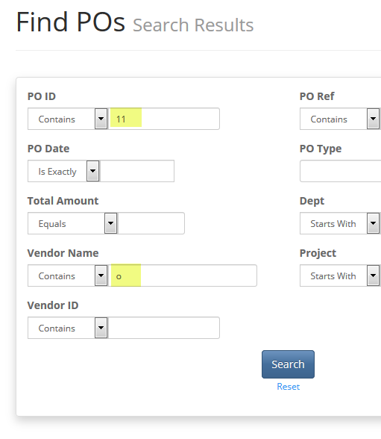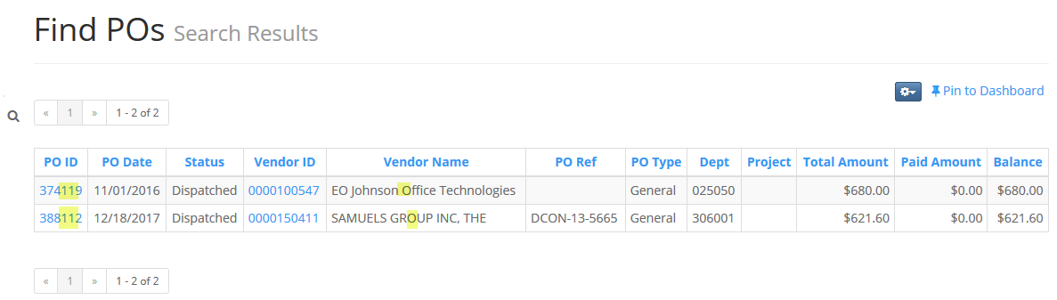
PO Search Example and results
Search Tips:
- Search fields are not case sensitive in WISER.
- Any combination of available search fields may be used to narrow and expedite search requests.
- To update your search criteria, click the magnifying glass.
On the ‘Find POs Search Results’ page, click any heading to sort the data by that field. The Vendor ID and PO ID fields are clickable hyperlinks, which take the user to respective detail information. The PO ID link pulls up the Purchase Order detail information page which includes PO Line, Distribution and AP Invoice data for that purchase order.
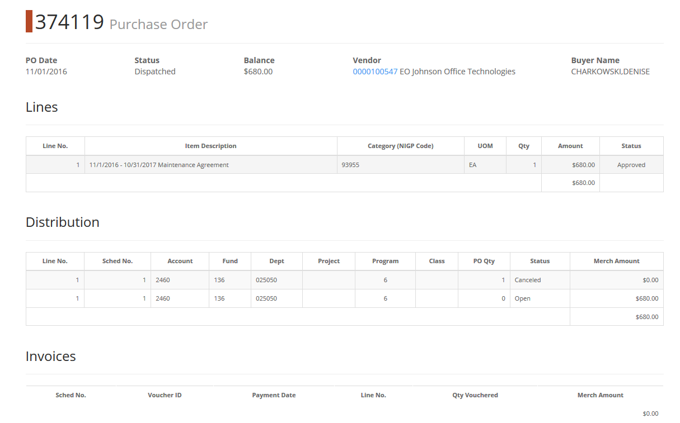
PO Detail
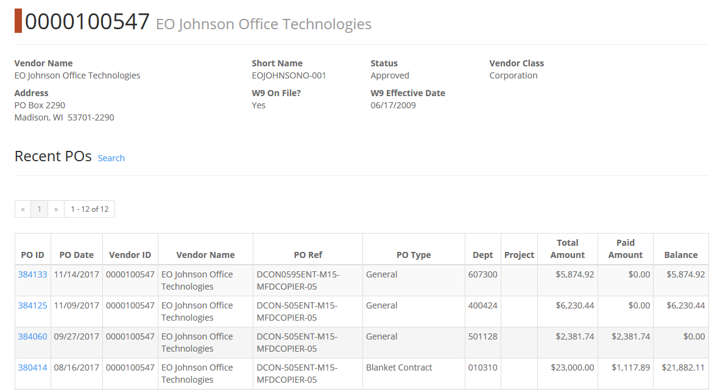
Supplier Detail

The PO Search page results can be exported to Excel or pinned to the Dashboard.
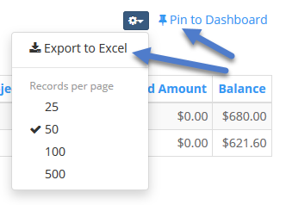

Voucher Search
To view financial information by Voucher, users can select the middle box on the ‘Find AP/PO Data’ search page and click the ‘Voucher Search’ option. 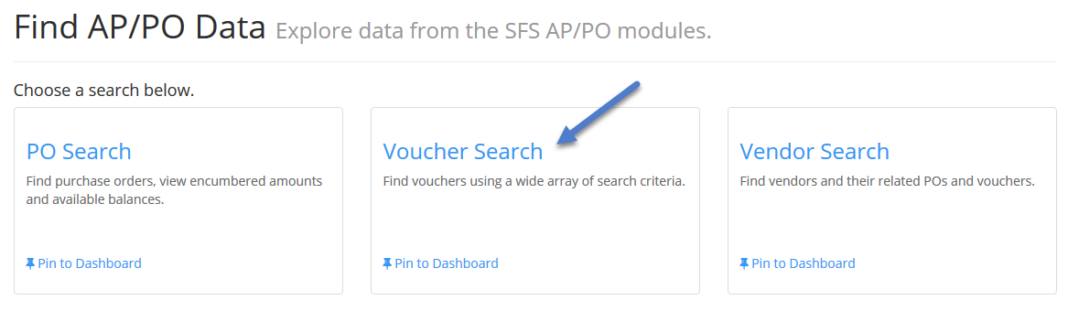 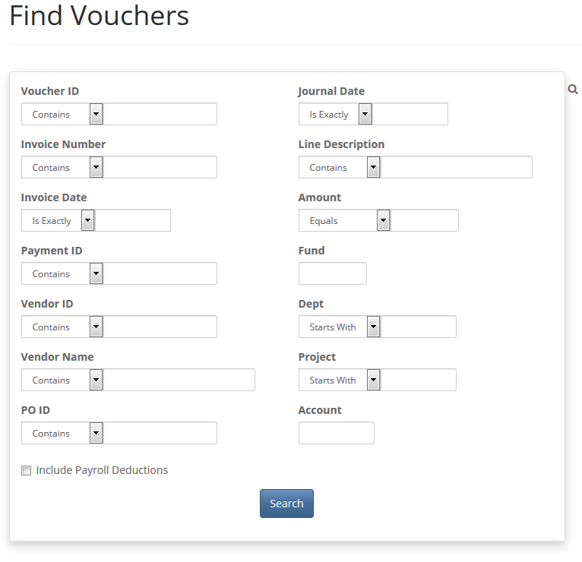
Voucher Search

Voucher Search Options
Voucher ID
Invoice Number
Invoice Date
Payment ID
Vendor ID
Vendor Name
PO ID
Journal Date
Line Description
Amount
Dept
Project
Include Payroll Deductions

The ‘Find Vouchers’ search screen lets the user search on a full or partial Voucher ID or AP Invoice Number. The Invoice Date can be on a specific date, before or after a specific date, or it can be a range of dates. Users can also search on the Payment ID number, Vendor ID, all or part of the Vendor Name (not case specific) and a full or partial PO ID associated with the Voucher. The Journal Date or date range, the Voucher Line Description and dollar Amount of the Voucher are also available as limiting criteria fields. In addition, the ChartField values of Fund, Dept, Project and Account can also be used to search for Vouchers. There is also a checkbox to “Include Payroll Deductions” in your Voucher search. The default is set to unchecked (not include Payroll Deductions).
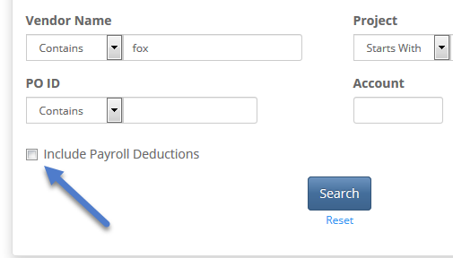
Include Payroll Deductions Option
Once the user clicks , the search itself can be pinned to a Dashboard or the search result information can be exported to Excel.
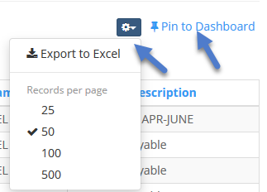
Pin the search to Dashboard or use the gear dropdown to choose "Export to Excel"

As with the PO Search, the Voucher Search allows users to drill into the hyperlinked Voucher ID and Supplier (Vendor) ID values on the Search Results page.
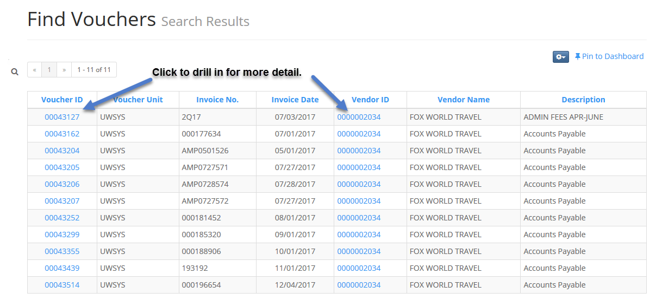
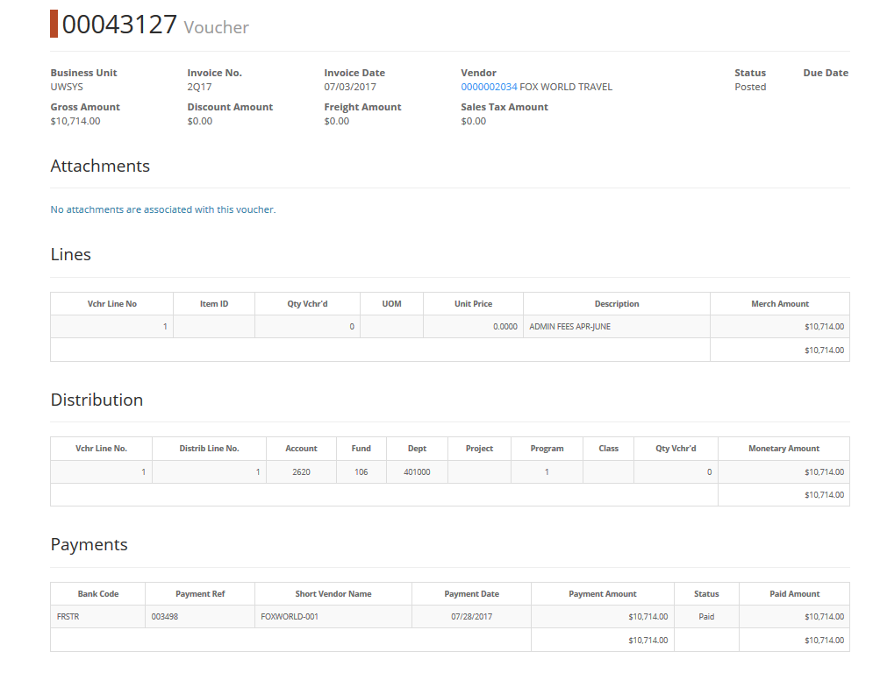
Voucher Detail Page
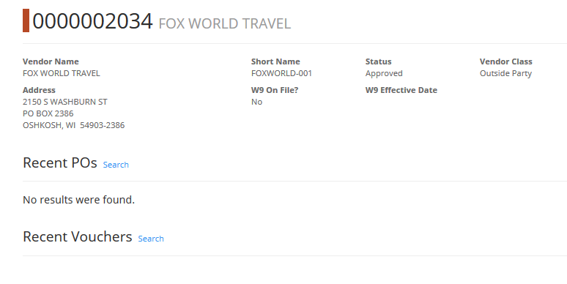
Supplier (Vendor) Detail Page

Supplier (Vendor) Search
From the “Find AP/PO Data” page, users can find valuable information about Suppliers and related transacations by clicking on the ‘Vendor Search’ link. 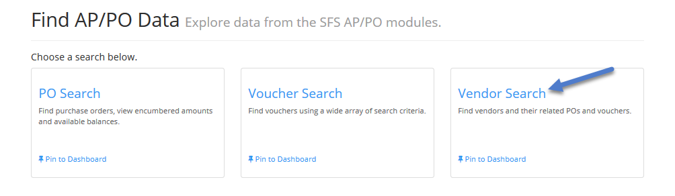

Supplier (Vendor) Search Options
Vendor ID
Vendor Name
Vendor Status
Street Address
City
State
Postal Code
Country

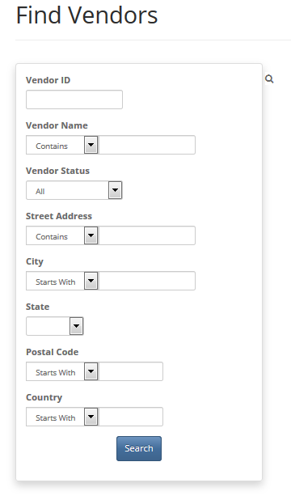
The full 10-digit Vendor ID can be entered in the Vendor ID field, or the remaining numbers once the zeros are truncated. The Vendor ID field defaults to an “ends in..” type of search. So, if one enters “17”, the search will retrieve Vendor ID “0000000017”. If one enters “1785”, the search will retrieve Vendor ID “0000001785”.
The Vendor Name field will allow for full or partial Supplier name entry. Using the Vendor Status field, users can look for ‘Approved’ status Suppliers, ‘Unapproved’ Suppliers or all Suppliers. Users can narrow their Supplier search based on physical location information also. The Street Address, City, State, Postal Code (Zip Code) and Country fields are searchable fields for Supplier address information.
Once the user clicks , the search results page provides the Supplier information requested. There are clickable hyperlinks on the Search Results page which provide greater detail on the Supplier, any associated POs and/or Vouchers.

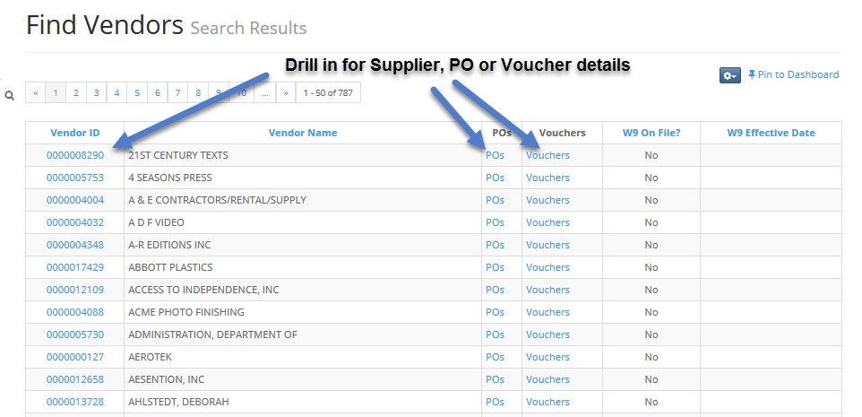
Cannot go further – no data to show
Have questions or comments? Please contact wisdm-bug@lists.wisc.edu or click the link in the bottom right hand corner of any WISER page.

Document Revision History
Author | Version | Date | Description of Change
Stacy VanWormer | 1.0 | 02/19/2018 | Initial Draft

