BUDGET TRANSFER REQUEST
INSTRUCTIONS

- Enter purpose of transfer
If more than 32 characters are needed then use Additional Comments/Justification
- Type of Transfer: Choose one of the three options.
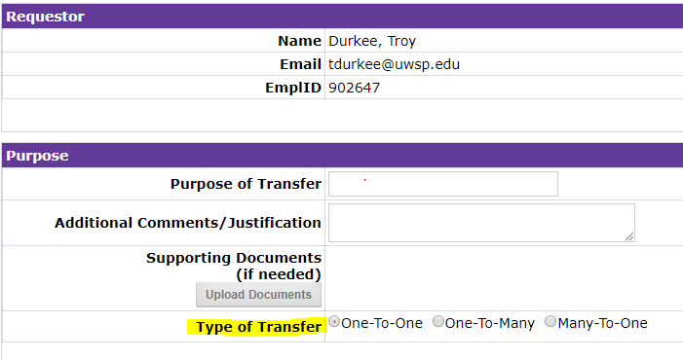

- After clicking on the transfer type the screen will be expanded for you to fill in the specifics for the transfer.
- In the “From” box, choose between 6-Dig Dept. or 7-Char. Proj button, as appropriate. Enter department ID.
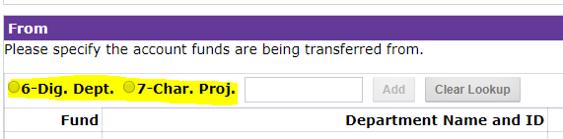

- After adding your department ID you must click on the grey “Add” button to the right of the department or project number
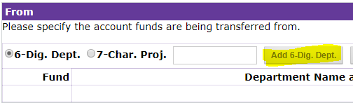
This will autofill the fund, Dept name and program number.
If you selected, “One-to-Many” or “Many-to-One” you will continue the process above until desired department ID’s are added.
- Use the dropdown to choose an account you would like to transfer from.
- Enter the dollar amount to be transferred.
- Continue the same process in the “To” section.
- When all information is entered. You must click the “Calculate Balance” in the Confirm Sums section at the bottom of the page. The balance check must be $0.00 in order to submit.
