Written Communication Qualifications Review

|  |
| --- |
| **Context and Background** |
| The requirement to assess the qualifications of all UWSP’s General Education faculty derives from HLC document, “Determining Qualified Faculty Through HLC’s Criteria for accreditation and Assumed Practices,” section B.2.a., which went into effect Sept 1, 2017. It requires that:  “Faculty teaching general education courses, or other non-occupational courses, hold a master’s degree or higher in the discipline or subfield. If a faculty member holds a master’s degree or higher in a discipline or subfield other than that in which he or she is teaching, that faculty member should have completed a minimum of 18 graduate credit hours in the discipline or subfield in which they teach.” |

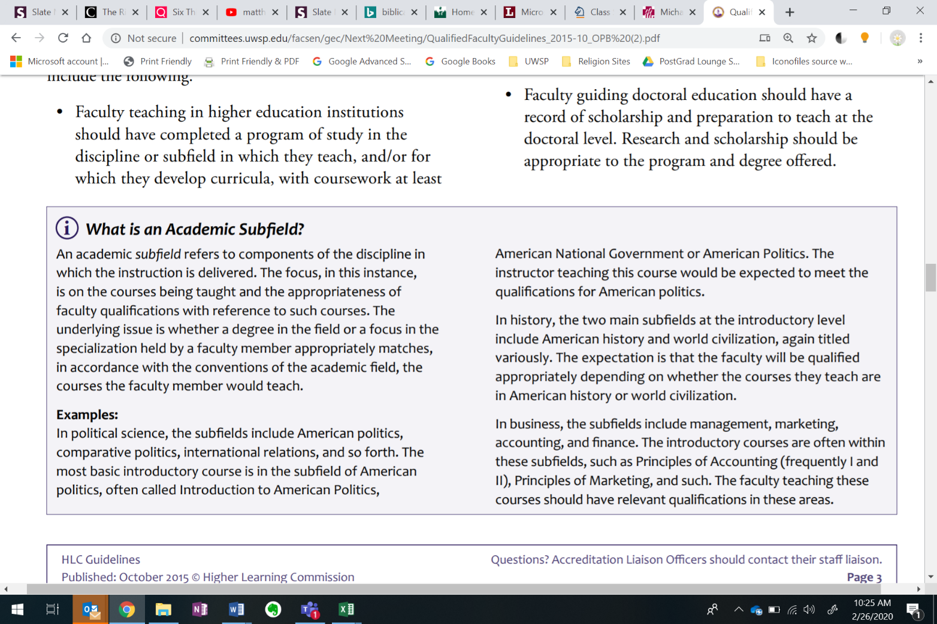

Excerpt from HLC’s “Determining Qualified Faculty through HLC’s Criteria for Accreditation and Assumed Practices”

|  |
| --- |
| **Written Communication Learning Outcomes** |
| 1. Compose an articulate, thoughtful, grammatically correct, and logically organized   piece of writing with properly documented and supported ideas, evidence, and information suitable to the topic, purpose, genre, and audience.   1. Apply your understanding of elements that shape successful writing to critique and   improve your own and others’ writing through effective and useful feedback. |

**Faculty Qualifications**

In order to teach General Education courses in the Written Communication category, faculty must submit the information below, which will be reviewed by the Associate Dean of General Education and the Associate Vice Chancellor for Teaching, Learning and Strategic Planning, in consultation with faculty, chairs, and administration. You may include dissertation credits towards each of the categories below.

1. If you hold a master’s degree or higher in the academic discipline of English or in a specific subfield focused on writing/English pedagogy or the English language, such as Rhetoric and Composition, English Education, Linguistics, and Creative Writing, note this and skip to number three.

|  |
| --- |
|  |

1. If you do not hold a master’s degree or higher in the discipline of English or in a specific subfield focused on writing/English pedagogy or the English language, such as those listed above, identify and briefly describe graduate courses you completed that focused on the content and skills described in both Written Communication learning outcomes, particularly learning outcome #1. Add lines as needed. Go to number three.

|  |  |  |  |
| --- | --- | --- | --- |
| Course title | Specific Field or Subfield | Number of credits | Brief explanation of relevance to category learning outcomes |
|  |  |  |  |
|  |  |  |  |
|  |  |  |  |

1. Indicate your experience teaching undergraduate, first- and second-year composition courses and any graduate training you received (e.g., a course, a mentor program) for teaching composition courses. If you did not teach composition classes as a graduate student, note this. Add lines if needed.

|  |  |  |
| --- | --- | --- |
| Composition course title | Number of credits | Briefly describe the experience and years teaching composition courses and/or describe training you received |
|  |  |  |
|  |  |  |
|  |  |  |