Natural Science Qualifications Review

|  |
| --- |
| **Context and Background** |
| The requirement to assess the qualifications of all UWSP’s General Education faculty derives from HLC document, “Determining Qualified Faculty Through HLC’s Criteria for accreditation and Assumed Practices,” section B.2.a., which went into effect Sept 1, 2017. It requires that:  “Faculty teaching general education courses, or other non-occupational courses, hold a master’s degree or higher in the discipline or subfield. If a faculty member holds a master’s degree or higher in a discipline or subfield other than that in which he or she is teaching, that faculty member should have completed a minimum of 18 graduate credit hours in the discipline or subfield in which they teach.” |

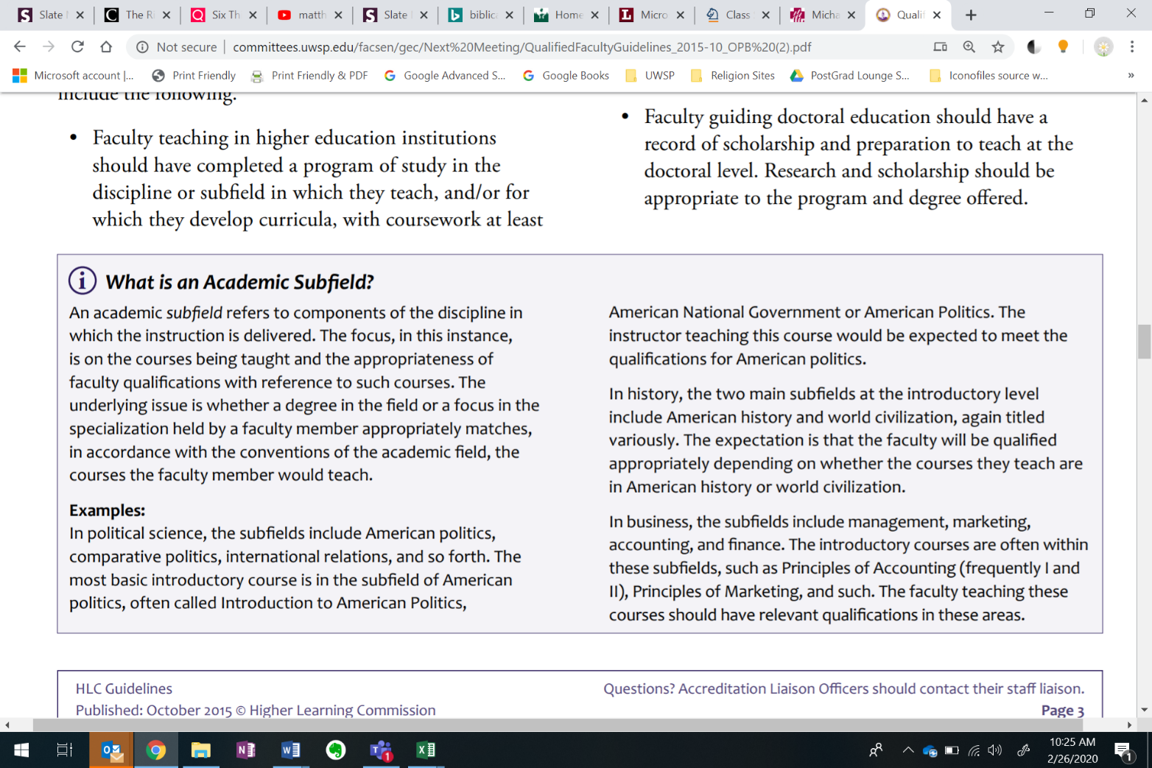

Excerpt from HLC’s “Determining Qualified Faculty through HLC’s Criteria for Accreditation and Assumed Practices”

|  |
| --- |
| **Natural Science Learning Outcomes** |
| 1. Explain major concepts, methods, or theories in the natural sciences to investigate the physical world. 2. Interpret information, solve problems, and make decisions by applying natural science concepts, methods, and quantitative techniques. 3. Describe the relevance of aspects of the natural sciences to their lives and society   (Includes required lab component) |

|  |
| --- |
| **Faculty Qualifications** |

In order to teach General Education courses in the Natural Science category, faculty must submit the information below, which will be reviewed by the Associate Vice Chancellor for Teaching, Learning and Strategic Planning, in consultation with faculty, chairs, and administration.

1. If you have a master’s degree or higher in a discipline or academic subfield that aligns with Natural Science, please provide the title and level of the degree completed. Faculty who fulfill this requirement may skip question number two.

|  |
| --- |
|  |

1. Below, identify and briefly describe graduate courses you completed that focus on one or more of the specific areas of Natural Science described in the learning outcomes. You may count up to eight thesis or dissertation research/writing credits toward the total. Add lines if needed.

|  |  |  |  |
| --- | --- | --- | --- |
| Course title | Specific Field or Subfield | Number of credits | Brief explanation of relevance to category learning outcomes |
|  |  |  |  |
|  |  |  |  |
|  |  |  |  |
|  |  |  |  |
|  |  |  |  |
|  |  |  |  |

1. Briefly describe the laboratory skills in Natural Science that were employed in your graduate coursework or in other aspects of your graduate training that are not included above. You might also describe applied science techniques used in your thesis, dissertation, or other graduate training.

|  |
| --- |
|  |