Critical Thinking Qualifications Review

|  |
| --- |
| The requirement to assess the qualifications of all UWSP’s General Education faculty derives from HLC document, “Determining Qualified Faculty Through HLC’s Criteria for accreditation and Assumed Practices,” section B.2.a., which went into effect Sept 1, 2017. It requires that:  “Faculty teaching general education courses, or other non-occupational courses, hold a master’s degree or higher in the discipline or subfield. If a faculty member holds a master’s degree or higher in a discipline or subfield other than that in which he or she is teaching, that faculty member should have completed a minimum of 18 graduate credit hours in the discipline or subfield in which they teach.” |

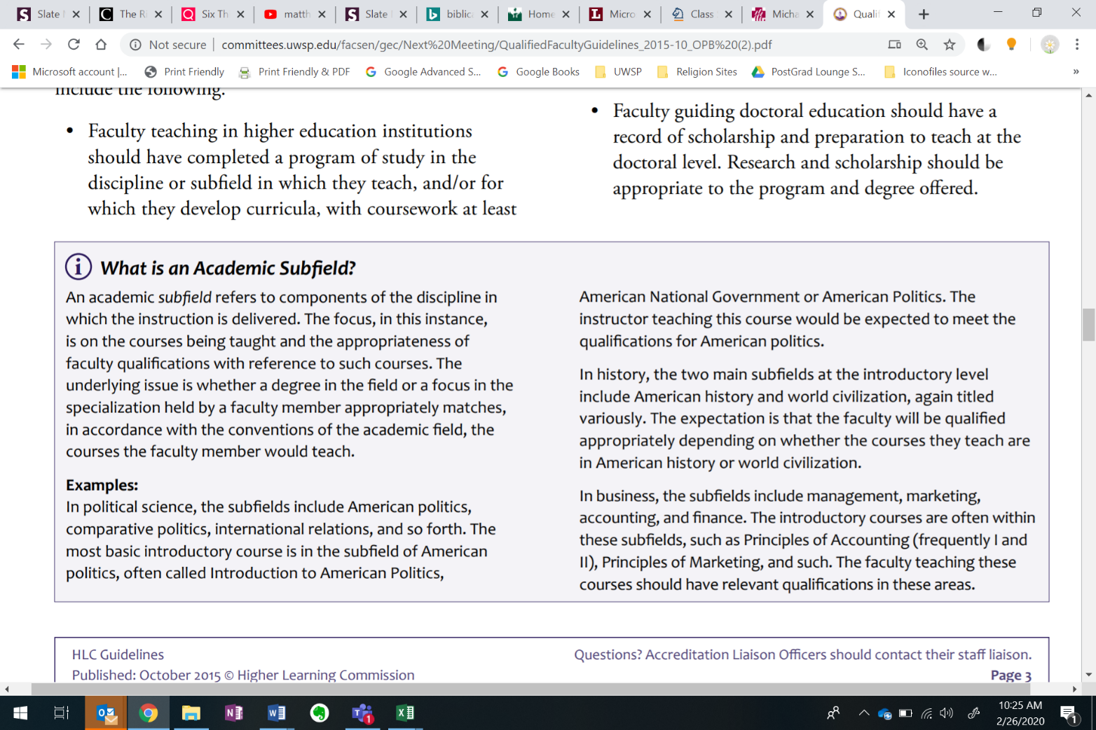

Excerpt from HLC’s “Determining Qualified Faculty through HLC’s Criteria for Accreditation and Assumed Practices”

|  |
| --- |
| **UWSP Critical Thinking Learning Outcomes:**   1. Recognize critical thinking as a process of identifying, analyzing, evaluating, and constructing reasoning in deciding what conclusions to draw (argumentation) or actions to take (decision-making and problem-solving). 2. Identify, analyze, evaluate, and construct reasoning as it is applied to general or discipline-specific questions or issues. 3. Communicate the analysis, evaluation, or construction of reasoning orally, visually, or in writing. |

In order to teach General Education courses in the Critical Thinking category, instructors must

1. Have completed 18 graduate credits in the discipline or subfield in which they teach.

Because all academic disciplines require critical thinking, expertise in *specific* academic disciplines is not required to teach critical thinking at the foundational level, although expertise in *some* academic discipline *is* required.

1. Complete UWSP’s Critical Thinking Center professional development workshop that focuses on critical thinking pedagogy.

Why the Workshops are Required:

While all academic disciplines require critical thinking, few graduate programs help graduate students learn how to teach those skills. These professional development training programs will enable instructors 1) to clearly identify the critical thinking skills that they have mastered in the process of gaining their disciplinary expertise, 2) to frame those skills in way that helps students to appreciate their broad relevance, 3) to help students to improve their proficiency in those skills.

The professional development training programs will also help to promote some uniformity of approach to critical thinking across the curriculum (in order to facilitate our students’ transfer of learning and subsequent scaffolding) and provide instructors with a set of resources to make critical thinking easier to intentionally teach and assess within the context of their disciplines.

Who is Required to Complete the Workshops:

If a critical thinking course has **discussion or lab** sections, leaders of those sessions **are required to participate** in the CT GEP professional development workshops.

The length and content of the workshop series that is required of any instructor is a function of that instructor’s role with respect to the course. Instructors who will be introducing a new course into the CT curriculum, instructors who will be teaching an existing course in the CT curriculum, and instructors of lab or discussion sections for an existing CT course will have different expectations.

If a course is **team-taught**, **only the instructors** who are responsible for helping students to meet the critical thinking learning outcomes or who are charged with assessing student work aimed at those outcomes will be required to take the CT GEP professional development workshops. Instructors who serve other roles (e.g. providing supplemental learning material or items for analysis) are welcome but not required to participate in the workshops.

When Workshops Should Be Completed and When They are Offered:

Instructors who are introducing a new course into the CT curriculum must complete the workshop series before the course is offered. Instructors who are teaching an existing course in the CT curriculum as a lecture, lab, or discussion instructor are expected to complete the workshop series before the semester in which they teach the course, but in the case of an unexpected staffing change or course assignment, they may complete the workshop during the semester in which they teach the course.

These trainings will be offered ideally in the fall, spring, and summer semesters.

What is Covered in the Workshops:

Questions about the length or content of any workshop series can be address to the Head of the Critical Thinking Center, the Critical Thinking GEC Representative, the Chair of the GEC, or the General Education Director.