Wisconsin’s Model Academic
Standards for Social Studies

John T. Benson
State Superintendent

John D. Fortier
Assistant State Superintendent
Division for Learning Support: Instructional Services
Susan M. Grady
Director
Content and Learning Team
Karen R. Prickette
Social Studies Consultant

Madeline A. Uraneck
International Education Consultant

Wisconsin Department of Public Instruction
Madison, Wisconsin
Governor’s Council on Model Academic Standards*

J. Scott McCallum
Lieutenant Governor
Chair

John T. Benson
State Superintendent of Public Instruction
Vice-Chair

Calvin Potter Luther S. Olsen
Senator Representative
District 9 District 41

Alberta Darling Ed Sontag Marlin D. Schneider
Senator Professor Representative
District 8 UW-Stevens Point District 72

This publication is available from

Publication Sales
Wisconsin Department of Public Instruction
Drawer 179
Milwaukee WI 53293-0179
(800) 243-8782
www.dpi.state.wi.us

Bulletin No. 8162

ISBN 1-57337-063-0

©1998 by Wisconsin Department of Public Instruction

The Wisconsin Department of Public Instruction does not discriminate on the basis of sex, race, religion, age, national origin, ancestry, creed, pregnancy, marital or parental status, sexual orientation or physical, mental, emotional or learning disability.


Printed on recycled paper.

*Established by Governor Tommy G. Thompson, January 29, 1997
Table of Contents

Letter from the Lieutenant Governor and
the State Superintendent iv
Acknowledgments v
Introduction vi
Overview of Social Studies Education 1
A: Geography: People, Places, and Environments 2
B: History: Time, Continuity, and Change 5
C: Political Science and Citizenship: Power, Authority, Governance
and Responsibility 10
D: Economics: Production, Distribution, Exchange, and Consumption 13
E: The Behavioral Sciences: Individuals, Institutions, and Society 16
Sample Proficiency Standards 21
Appendix 30

Please note that the page numbers on the CD-ROM version differ from the page numbers found in the hard copy of standards books. In order to make the CD-ROM version more user friendly, we have removed most of the formatting (i.e., blank pages, columns, sizes and types of fonts, etc).
A Letter From the Lieutenant Governor
and the State Superintendent

To the Citizens of Wisconsin:

On behalf of the Governor’s Council on Model Academic Standards, it is our pleasure to present Wisconsin’s Model Academic Standards in the area of English language arts at grades four (4), eight (8), and twelve (12). Wisconsin has long been a model for other states in terms of educational quality. However, the world is rapidly becoming a more complex and challenging place. As a result, we must expect greater academic achievement from our children today if they are to be adequately prepared for the challenges of tomorrow. While Wisconsin’s Model Academic Standards do demand more of our children, we are confident that they are equal to the task.

These standards are also significant because they herald the dramatically different way in which student achievement will be judged. In the past, achievement was determined by comparing a student’s grades to those of his or her peers. In the future, mastery of subject matter will be objectively measured against these new standards at grades four, eight, and twelve. In this way we will know how well a student is learning, not how well that student is doing compared to others.

These model academic standards represent the work of writing teams made up of people from diverse backgrounds. Drafts were subjected to extensive public engagement in which hundreds of additional people offered input. The process of reaching consensus yielded a draft that enjoys very strong public support. Over 74 percent of respondents agreed or strongly agreed that the standards will prepare students for the future. Seventy percent felt they are sufficiently rigorous. Nearly 70 percent agreed or strongly agreed that they are clearly understandable and specific enough to guide local curricula and standards.

It must be stressed that these standards are not intended to limit local districts. Instead they are a model to be met or exceeded. The Council specifically encouraged local districts to implement standards that are more rigorous. However, districts must remember that assessment, including high school graduation exams based on standards, awaits every student in Wisconsin.

In closing, we want to commend the many members of the writing work groups. These teams, comprised of parents, teachers, business people, school board members, and administrators, gave freely of their time to produce the initial drafts. Finally, the citizens of Wisconsin must be thanked for devoting their time and effort to the development of the final draft of Wisconsin’s Model Academic Standards.

Scott McCallum, Lt. Governor John T. Benson, State Superintendent
Acknowledgments

Wisconsin’s Model Academic Standards would not have been possible without the efforts of many people. Members of the task force freely gave their time and expertise in developing the academic standards. In addition, their employing agencies generously granted them time to work on this initiative. The task force members are:

Rick Berg
Wisconsin Department of
Regulation and Licensing
Verona

Crystal Berg
School Board Member
Hartford

Scott Butler
School Board Member
Neenah

Craig Castle
School Board Member
Fond du Lac

Bruce Fetter
Professor and Chair
History Department
UW Milwaukee
(Co-Chair Social Studies Writing/Advisory Team)

Walt Herscher
Teacher
Appleton North High School

Eileen Hilke
Chair, Division of Education
Lakeland College
Sheboygan

J. David Hoeveler
Professor of History
UW Milwaukee

Leslie Johnson
School Board Member
Delavan-Darien

James D. Kraft
Teacher
West High School
Wausau

DeAn Krey
Professor
UW River Falls
(Co-Chair Social Studies Writing/Advisory Team)

Margaret A. Laughlin
Professor
UW Green Bay
(Co-Chair Social Studies Writing/Advisory Team)

Anthony Litt
Teacher
Pulaski High School

Kurt Luedke
Teacher
Slinger High School

Michael McKinnon
Curriculum Supervisor
Janesville Public Schools

Sally Jo Michalko
Teacher
Meadowbrook Elementary
Waukesha
Iris Othrow
Teacher
McFarland Elementary

Stephen A. Rose
Professor
UW-Oshkosh

James M. Stewart
School Board Member
Whitewater Unified
School District

Michelle Trevino
Teacher
Grand Avenue School
Milwaukee

Dayle Upham
Assistant Professor
UW-Stevens Point

Ann Walser
Teacher
Shorewood Hills Elementary
Madison

Bonnie R. Weigell
Parent and Community Volunteer
Milwaukee

Michael Yell
Teacher
Hudson Middle School

Special thanks to Greg Doyle, Director of the Education Information Services Team, Kathy Addie, Donna Collingwood, Amy French, Robin Gee, Victoria Horn, Jill Ness, Sandi Ness, Edy Paske, Carol Stricker, and Tammy Wylesky for their valuable contributions to this publication. Their talents and assistance are sincerely appreciated.
Introduction

Defining the Academic Standards

What are academic standards? Academic standards specify what students should know and be able to do, what they might be asked to do to give evidence of standards, and how well they must perform. They include content, performance, and proficiency standards.

— Content standards refer to what students should know and be able to do.
— Performance standards tell how students will show that they are meeting a standard.
— Proficiency standards indicate how well students must perform.

Why are academic standards necessary? Standards serve as rigorous goals for teaching and learning. Setting high standards enables students, parents, educators, and citizens to know what students should have learned at a given point in time. The absence of standards has consequences similar to lack of goals in any pursuit. Without clear goals, students may be unmotivated and confused.

Contemporary society is placing immense academic demands on students. Clear statements about what students must know and be able to do are essential to ensure that our schools offer students the opportunity to acquire the knowledge and skills necessary for success.

Why are state-level academic standards important? Public education is a state responsibility. The state superintendent and legislature must ensure that all children have equal access to high quality educational programs. At a minimum, this requires clear statements of what all children in the state should know and be able to do as well as evidence that students are meeting these expectations. Furthermore, academic standards form a sound basis on which to establish the content of a statewide assessment system.

Why does Wisconsin need its own academic standards? Historically, the citizens of Wisconsin are very serious and thoughtful about education. They expect and receive very high performance from their schools. While educational needs may be similar among states, values differ. Standards should reflect the collective values of the citizens and be tailored to prepare young people for economic opportunities that exist in Wisconsin, the nation, and the world.

Developing the Academic Standards

How were Wisconsin’s model academic standards developed? Citizens throughout the state developed the academic standards. The first phase involved educators, parents, board of education members, and business and industry people who produced preliminary content and performance standards in 12 subjects including English language arts, mathematics, science, social studies, visual arts, music, theatre, dance, family and consumer education, foreign language, health education, and physical education. These standards are benchmarked to the end of grades 4, 8, and 12.

The next step required public input aimed at getting information to revise and improve the preliminary standards. This effort included forums and focus groups held throughout the state. The state superintendent used extensive media exposure, including telecommunications through the DPI home page, to ensure the widest possible awareness and participation in standards development.
Each subject had at least two drafts taken to the general public for their review. Based on this input, the standards were revised to reflect the values of Wisconsin’s citizens.
In January 1997, Governor Thompson appointed the Governor’s Council on Model Academic Standards. The Council augmented the existing Department of Public Instruction task forces with additional appointees by the Council, these newly configured task forces produced another draft of model academic standards for the subjects that are part of the state assessment system. These include English language arts, mathematics, reading, science, and social studies.
Once these draft standards were completed, public review became the focus. Using a series of statewide forums coupled with a wide mailing distribution and telecommunications access through both the Wisconsin Department of Public Instruction and the lieutenant governor’s home pages, Wisconsin citizens provided valuable feedback. As with previous drafts, all comments received serious consideration.

Who wrote the academic standards and what resources were used? Each subject area’s academic standards were drafted by teams of educators, parents, board of education members, and business and industry people that were sub-groups of larger task forces. This work was done after reviewing national standards in the subject area, standards from other states, standards from local Wisconsin school districts, and standards like the nationwide New Standards Project.
After the creation of the Governor’s Council on Model Academic Standards, four task forces representing English language arts (reading was folded into this group) mathematics, science, and social studies were appointed. Combining the existing DPI task force members with the Council’s appointees further ensured that the many voices of Wisconsin’s citizenry were represented through the parents, educators, school board members, and business and industry people sitting on those task forces. Documents reviewed included the national standards in the subject area, standards from other states, and standards from local Wisconsin schools. The two most frequently used resources were the first and second drafts of content and performance standards developed by the DPI and the Modern Red Schoolhouse standards developed by the Hudson Institute and Dr. Finley McQuade.

How was the public involved in the standards process? The DPI was involved in extensive public engagement activities to gather citizen input on the first two drafts of the academic standards. Over 19 focus group sessions, 17 community forums, and more than 450 presentations at conferences, conventions, and workshops were held. More than 500,000 paper copies of the standards tabloids were distributed across the state in addition to more than 4,000 citizen visits to the standards on the DPI web page. Input from these activities, along with more than 90 reviews by state and national organizations, provided the writers with feedback on Wisconsin’s model academic standards.

Continuing the emphasis on public engagement started by the DPI with previous standards drafts, the Governor’s Council on Model Academic Standards held nine community forums. In addition, more than 50,000 paper copies of the standards were distributed. Recipients included each public school building as well as all major education stakeholders and interest groups. Lending the prestige of their offices to the standards development, members of the Council met with editorial boards of media outlets throughout the state discussing the model academic standards.

Will academic standards be developed in areas other than the 12 areas listed above? Yes, currently the DPI has convened six task forces to develop academic standards in agriculture, business, environmental education, marketing, technology education, and information and technology literacy. Task force members include educators, parents, school board members, and representatives of business and industry. These academic standards will be completed by the start of the 1998-99 school year.

Using the Academic Standards

How will the Department of Public Instruction use the Wisconsin Model Academic Standards? Upon completing its work, the Governor’s Council on Model Academic Standards submitted academic content and performance standards for English language arts, mathematics, science, and social studies to the governor. On January 13, 1998, Governor Thompson signed Executive Order 326, thus approving and issuing the model academic and performance standards developed by the Governor’s Council. These approved standards will be used as the basis for state testing, especially as it relates to the Wisconsin Reading Comprehension Test, the Wisconsin Student Assessment System, and the planned High School Graduation Test.
Additionally, the DPI will use the Wisconsin Model Academic Standards as the basis for revision of its Guides to Curriculum Planning and as the foundation for professional development activities that it sponsors.

Must a district adopt the Wisconsin Model Academic Standards? Adopting the Wisconsin Model Academic Standards is voluntary, not mandatory. Districts, however, must have academic standards in place by August 1, 1998. At a minimum, districts are required to have standards in reading and writing, geography and history, mathematics, and science. Districts may adopt the model state standards, or standards from other sources, or develop their own standards.

How will local districts use the academic standards? Adopting the Wisconsin Model Academic Standards is voluntary, not mandatory. Districts may use the academic standards as guides for developing local grade-by-grade level curriculum. Implementing standards may require some school districts to upgrade school and district curriculums. In some cases, this may result in significant changes in instructional methods and materials, local assessments, and professional development opportunities for the teaching and administrative staff.

What is the difference between academic standards and curriculum? Standards are statements about what students should know and be able to do, what they might be asked to do to give evidence of learning, and how well they should be expected to know or do it. Curriculum is the program devised by local school districts used to prepare students to meet standards. It consists of activities and lessons at each grade level, instructional materials, and various instructional techniques. In short, standards define what is to be learned at certain points in time, and from a broad perspective, what performances will be accepted as evidence that the learning has occurred. Curriculum specifies the details of the day-to-day schooling at the local level.

What is the link between statewide academic standards and statewide testing? Statewide academic standards in mathematics, English language arts, science, and social studies determine the scope of statewide testing. While these standards are much broader in content than any single Wisconsin Student Assessment System (WSAS) test, they do describe the range of knowledge and skills that may appear on the tests. If content does not appear in the academic standards, it will not be part of a WSAS test. The statewide standards clarify what must be studied to prepare for WSAS tests. If students have learned all of the material indicated by the standards in the assessed content areas, they should do very well on the state tests.

Relating the Academic Standards to All Students

Parents and educators of students with disabilities, with limited English proficiency (LEP), and with accelerated needs may ask why academic standards are important for their students. Academic standards serve as a valuable basis for establishing meaningful goals as part of each student’s developmental progress and demonstration of proficiency. The clarity of academic standards provides meaningful, concrete goals for the achievement of students with exceptional education needs (EEN), LEP, and accelerated needs consistent with all other students.
Academic standards may serve as the foundation for individualized programming decisions for students with EEN, LEP, and accelerated needs. While the vast majority of students with EEN and LEP should be expected to work toward and achieve these standards, accommodations and modifications to help these students reach the achievement goals will need to be individually identified and implemented. For students with EEN, these decisions are made as part of their individualized education program (IEP) plans. Accelerated students may achieve well beyond the academic standards and move into advanced grade levels or into advanced coursework.
Clearly, these academic standards are for all students. As our state assessments are aligned with these standards and school districts adopt, adapt, or develop their own standards and multiple measures for determining proficiencies of students, greater accountability for the progress of all students can be assured. In Wisconsin this means all students reaching their full individual potential, every school being accountable, every parent a welcomed partner, every community supportive, and no excuses.
Applying the Academic Standards Across the Curriculum

When community members and employers consider what they want citizens and employees to know and be able to do, they often speak of broad areas of applied knowledge such as communication, thinking, problem solving, and decision making. These areas connect or go beyond the mastery of individual subject areas. As students apply their knowledge both within and across the various curricular areas, they develop the concepts and complex thinking of educated persons.
Community members need these skills to function as responsible citizens. Employers prize those employees who demonstrate these skills because they are people who can continue learning and connect what they have learned to the requirements of a job. College and university faculty recognize the need for these skills as the means of developing the level of understanding that separates the expert from the beginner.
Teachers in every class should expect and encourage the development of these shared applications, both to promote the learning of the subject content and to extend learning across the curriculum. These applications fall into five general categories:

1) Application of the Basics

2) Ability to Think
— Problem solving
— Informed decision making
— Systems thinking
— Critical, creative, and analytical thinking
— Imagining places, times, and situations different from one’s own
— Developing and testing a hypothesis
— Transferring learning to new situations

3) Skill in Communication
— Constructing and defending an argument
— Working effectively in groups
— Communicating plans and processes for reaching goals
— Receiving and acting on instructions, plans, and models
— Communicating with a variety of tools and skills
4) Production of Quality Work
— Acquiring and using information
— Creating quality products and performances
— Revising products and performances
— Developing and pursuing positive goals

5) Connections with Community
— Recognizing and acting on responsibilities as a citizen
— Preparing for work and lifelong learning
— Contributing to the aesthetic and cultural life of the community
— Seeing oneself and one’s community within the state, nation, and world
— Contributing and adapting to scientific and technological change

Overview of Social Studies

I know of no safe depository of the ultimate powers of the society but with the people themselves; and if we think them not enlightened enough to exercise their control with a wholesome discretion, the remedy is not to take power from them, but to inform their discretion through instruction. —Thomas Jefferson (1820)

In order to ensure our survival as a free nation, students at all grade levels in Wisconsin are required to learn about the principles and ideals upon which the United States is founded and understand the world in which they live.

Definition of Social Studies

“Social studies” is the title used to describe the study of the social sciences and humanities. Within the curriculum, social studies provides coordinated, systematic study of information, skills, and concepts from the disciplines of history, geography, political science, economics, anthropology, psychology, law, archaeology, and sociology with attention also given to connections among the peoples and nations of the world, the effect of science and technology on society (and vice versa), and the ways to practice good citizenship. Social studies helps young people develop the knowledge and skills necessary to make informed and reasoned decisions as citizens of a culturally diverse, democratic society in an interdependent world.

Knowledge and Skills

Students at all levels should develop skills and understandings in all five strands found in the Wisconsin Model Academic Standards for Social Studies. These skills and understandings are embedded in the performance standards. The curriculum in elementary and middle schools establishes the foundation for the entire social studies program. Without this foundation, students cannot develop the attitudes nor acquire the knowledge and skills necessary to participate in a democratic society and understand an increasingly complex world. It is also important to recognize that the designated levels, by grade four, by grade eight, and by grade twelve, lead students to higher and deeper levels of knowledge and skills as they progress through school.

Connections in Social Studies

The organization of these standards allows the social studies curriculum to be developed as separate disciplines or in an integrated course. In elementary, middle, and junior high schools, the five strands of social studies are usually integrated in a time during the day called “social studies.” In high schools, the social studies courses are given names such as United States History, Geography, Global Studies, World History, Economics, Civics, Social Studies, Current Events, Sociology, Psychology, and so on. Courses with these names might include performance standards from one, several, or all of the social studies strands.
A. GEOGRAPHY: People, Places, and Environments

Content Standard
Students in Wisconsin will learn about geography through the study of the relationships among people, places, and environments.

Rationale:

Students gain geographical perspectives on the world by studying the earth and the interactions of people with places where they live, work, and play. Knowledge of geography helps students to address the various cultural, economic, social, and civic implications of life in earth’s many environments. In Wisconsin schools, the content, concepts, and skills related to geography may be taught in units and courses that deal with geography, history, global studies, anthropology, sociology, psychology, current events, and world religions.

Additional information for developing a curriculum is available in:

A Guide to Curriculum Planning in Social Studies, Wisconsin Department of Public Instruction (1-800-243-8782).

Curriculum Standards for Social Studies. National Council for the Social Studies Publications, P.O. Box 79078, Baltimore, MD 21279-0078 (1-800-683-0812)

Geography for Life: National Geography Standards 1994. National Geographic Society, P.O. Box 1640, Washington, D.C. 20013-1640, USA (1-800-368-2728)

PERFORMANCE STANDARDS

By the end of grade 4 students will:

A.4.1 Use reference points, latitude and longitude, direction, size, shape, and scale to locate positions on various representations of the earth’s surface

A.4.2 Locate on a map or globe physical features such as continents, oceans, mountain ranges, and land forms; natural features such as resources, flora, and fauna; and human features such as cities, states, and national borders

A.4.3 Construct a map of the world from memory, showing the location of major land masses, bodies of water, and mountain ranges

A.4.4 Describe and give examples of ways in which people interact with the physical environment, including use of land, location of communities, methods of construction, and design of shelters

A.4.5 Use atlases, databases, grid systems, charts, graphs, and maps to gather information about the local community, Wisconsin, the United States, and the world

A.4.6 Identify and distinguish between predictable environmental changes, such as weather patterns and seasons, and unpredictable changes, such as floods and droughts, and describe the social and economic effects of these changes

A.4.7 Identify connections between the local community and other places in Wisconsin, the United States, and the world

A.4.8 Identify major changes in the local community that have been caused by human beings, such as a construction project, a new highway, a building torn down, or a fire; discuss reasons for these changes; and explain their probable effects on the community and the environment

A.4.9 Give examples to show how scientific and technological knowledge has led to environmental changes, such as pollution prevention measures, air-conditioning, and solar heating

By the end of grade 8 students will:

A.8.1 Use a variety of geographic representations, such as political, physical, and topographic maps, a globe, aerial photographs, and satellite images, to gather and compare information about a place

A.8.2 Construct mental maps of selected locales, regions, states, and countries and draw maps from memory, representing relative location, direction, size, and shape

A.8.3 Use an atlas to estimate distance, calculate scale, identify dominant patterns of climate and land use, and compute population density

A.8.4 Conduct a historical study to analyze the use of the local environment in a Wisconsin community and to explain the effect of this use on the environment

A.8.5 Identify and compare the natural resource bases of different states and regions in the United States and elsewhere in the world, using a statistical atlas, aerial photographs, satellite images, and computer databases

A.8.6 Describe and distinguish between the environmental effects on the earth of short-term physical changes, such as those caused by floods, droughts, and snowstorms, and long-term physical changes, such as those caused by plate tectonics, erosion, and glaciation

A.8.7 Describe the movement of people, ideas, diseases, and products throughout the world

A.8.8 Describe and analyze the ways in which people in different regions of the world interact with their physical environments through vocational and recreational activities

A.8.9 Describe how buildings and their decoration reflect cultural values and ideas, providing examples such as cave paintings, pyramids, sacred cities, castles, and cathedrals

A.8.10 Identify major discoveries in science and technology and describe their social and economic effects on the physical and human environment

A.8.11 Give examples of the causes and consequences of current global issues, such as the expansion of global markets, the urbanization of the developing world, the consumption of natural resources, and the extinction of species, and suggest possible responses by various individuals, groups, and nations

By the end of grade 12 students will:

A.12.1 Use various types of atlases and appropriate vocabulary to describe the physical attributes of a place or region, employing such concepts as climate, plate tectonics, volcanism, and landforms, and to describe the human attributes, employing such concepts as demographics, birth and death rates, doubling time, emigration, and immigration

A.12.2 Analyze information generated from a computer about a place, including statistical sources, aerial and satellite images, and three-dimensional models

A.12.3 Construct mental maps of the world and the world’s regions and draw maps from memory showing major physical and human features

A.12.4 Analyze the short-term and long-term effects that major changes in population in various parts of the world have had or might have on the environment

A.12.5 Use a variety of geographic information and resources to analyze and illustrate the ways in which the unequal global distribution of natural resources influences trade and shapes economic patterns

A.12.6 Collect and analyze geographic information to examine the effects that a geographic or environmental change in one part of the world, such as volcanic activity, river diversion, ozone depletion, air pollution, deforestation, or desertification, may have on other parts of the world

A.12.7 Collect relevant data to analyze the distribution of products among global markets and the movement of people among regions of the world

A.12.8 Identify the world’s major ecosystems and analyze how different economic, social, political, religious, and cultural systems have adapted to them

A.12.9 Identify and analyze cultural factors, such as human needs, values, ideals, and public policies, that influence the design of places, such as an urban center, an industrial park, a public project, or a planned neighborhood

A.12.10 Analyze the effect of cultural ethics and values in various parts of the world on scientific and technological development

A.12.11 Describe scientific and technological development in various regions of the world and analyze the ways in which development affects environment and culture

A.12.12 Assess the advantages and disadvantages of selected land use policies in the local community, Wisconsin, the United States, and the world

A.12.13 Give examples and analyze conflict and cooperation in the establishment of cultural regions and political boundaries

B. HISTORY: Time, Continuity, and Change

Content Standard
Students in Wisconsin will learn about the history of Wisconsin, the United States, and the world, examining change and continuity over time in order to develop historical perspective, explain historical relationships, and analyze issues that affect the present and the future.

Rationale:

Students need to understand their historical roots and how past events have shaped their world. In developing these insights, students must know what life was like in the past and how things change and develop over time. Reconstructing and interpreting historical events provides a needed perspective in addressing the past, the present, and the future. In Wisconsin schools, the content, concepts, and skills related to history may be taught in units and courses in United States and world history, global studies, geography, economics, anthropology, sociology, psychology, current events, and the humanities.

Additional information for developing a curriculum is available in:

A Guide to Curriculum Planning in Social Studies, Wisconsin Department of Public Instruction (1-800-243-8782)

Curriculum Standards for Social Studies. National Council for the Social Studies Publications, P.O. Box 79078, Baltimore, MD 21279-0078 (1-800-683-0812)

National Standards for History. National Center for History in the Schools, University of California, Los Angeles, 1100 Glendon Avenue, Suite 927, Box 951588, Los Angeles, CA 90095-1588 (1-310-825-4702)

Building a History Curriculum: Guidelines for Teaching History in Schools. National Council for History Education, 26915 Westwood Rd., B-2, Westlake, OH 44145 (1-440-835-1776)

Building a United States History Curriculum. National Council for History Education, 26915 Westwood Rd., B-2, Westlake, OH 44145 (1-440-835-1776)

Building a World History Curriculum. National Council for History Education, 26915 Westwood Rd., B-2, Westlake, OH 44145 (1-440-835-1776)

HISTORICAL ERAS AND THEMES

Fourth-twelfth grade students studying Wisconsin history will learn about:

• the prehistory and the early history of Wisconsin’s native people
• early explorers, traders, and settlers to 1812
• the transition from territory to statehood, 1787-1848
• immigration and settlement
• Wisconsin’s role in the Civil War, 1860-1865
• mining, lumber, and agriculture
• La Follette and the Progressive Era, 1874-1914
• the world wars and conflicts
• prosperity, depression, industrialization, and urbanization
• Wisconsin’s response to 20th century change

Fifth-twelfth grade students studying United States history will learn about:

• the prehistory and early history of the Americas to 1607
• colonial history and settlement, 1607-1763
• the American Revolution and the early national period, 1763-1815
• the paradox of nationalism and sectionalism in an expanding nation, 1815-1860
• the Civil War and Reconstruction, 1861-1877
• the growth of industrialization and urbanization, 1865-1914
• World War I and America’s emergence as a world power, 1890-1920
• prosperity, depression, and the New Deal, 1920-1941
• World War II, the Cold War, the Korean War, and the Vietnamese conflict, 1941-1975
• the search for prosperity and equal rights in Cold War and post-Cold War America, 1945-present

Fifth-twelfth grade students studying world history will learn about:

• prehistory to 2000 BC
• early pastoral civilizations, nonwestern empires, and tropical civilizations
• classical civilizations, including China, India, Egypt, Greece, and Rome, 1000 BC to 500 AD
• multiple religions (Judaism, Christianity, Islam, Buddhism, Hinduism) and civilizations to 1100
• expansion and centralization of power, including the decline of feudalism, 1000-1500
• the early modern world, 1450-1800
• global unrest, change, and revolution, 1750-1850
• global encounters, industrialization, urbanization, and imperialism, 1850-1914
• wars, revolutions, and ideologies, 1900-1945
• post-industrialism, global interdependence, and fragmentation in the contemporary world, 1945-present

PERFORMANCE STANDARDS

By the end of grade 4 students will:

B.4.1 Identify and examine various sources of information that are used for constructing an understanding of the past, such as artifacts, documents, letters, diaries, maps, textbooks, photos, paintings, architecture, oral presentations, graphs, and charts

B.4.2 Use a timeline to select, organize, and sequence information describing eras in history

B.4.3 Examine biographies, stories, narratives, and folk tales to understand the lives of ordinary and extraordinary people, place them in time and context, and explain their relationship to important historical events

B.4.4 Compare and contrast changes in contemporary life with life in the past by looking at social, economic, political, and cultural roles played by individuals and groups

B.4.5 Identify the historical background and meaning of important political values such as freedom, democracy, and justice

B.4.6 Explain the significance of national and state holidays, such as Independence Day and Martin Luther King, Jr. Day, and national and state symbols, such as the United States flag and the state flags

B.4.7 Identify and describe important events and famous people in Wisconsin and United States history

B.4.8 Compare past and present technologies related to energy, transportation, and communications, and describe the effects of technological change, either beneficial or harmful, on people and the environment

B.4.9 Describe examples of cooperation and interdependence among individuals, groups, and nations

B.4.10 Explain the history, culture, tribal sovereignty, and current status of the American Indian tribes and bands in Wisconsin

By the end of grade 8 students will:

B.8.1 Interpret the past using a variety of sources, such as biographies, diaries, journals, artifacts, eyewitness interviews, and other primary source materials, and evaluate the credibility of sources used

B.8.2 Employ cause-and-effect arguments to demonstrate how significant events have influenced the past and the present in United States and world history

B.8.3 Describe the relationships between and among significant events, such as the causes and consequences of wars in United States and world history

B.8.4 Explain how and why events may be interpreted differently depending upon the perspectives of participants, witnesses, reporters, and historians

B.8.5 Use historical evidence to determine and support a position about important political values, such as freedom, democracy, equality, or justice, and express the position coherently

B.8.6 Analyze important political values such as freedom, democracy, equality, and justice embodied in documents such as the Declaration of Independence, the United States Constitution, and the Bill of Rights

B.8.7 Identify significant events and people in the major eras of United States and world history

B.8.8 Identify major scientific discoveries and technological innovations and describe their social and economic effects on society

B.8.9 Explain the need for laws and policies to regulate science and technology

B.8.10 Analyze examples of conflict, cooperation, and interdependence among groups, societies, or nations

B.8.11 Summarize major issues associated with the history, culture, tribal sovereignty, and current status of the American Indian tribes and bands in Wisconsin

B.8.12 Describe how history can be organized and analyzed using various criteria to group people and events chronologically, geographically, thematically, topically, and by issues

By the end of grade 12 students will:

B.12.1 Explain different points of view on the same historical event, using data gathered from various sources, such as letters, journals, diaries, newspapers, government documents, and speeches

B.12.2 Analyze primary and secondary sources related to a historical question to evaluate their relevance, make comparisons, integrate new information with prior knowledge, and come to a reasoned conclusion

B.12.3 Recall, select, and analyze significant historical periods and the relationships among them

B.12.4 Assess the validity of different interpretations of significant historical events

B.12.5 Gather various types of historical evidence, including visual and quantitative data, to analyze issues of freedom and equality, liberty and order, region and nation, individual and community, law and conscience, diversity and civic duty; form a reasoned conclusion in the light of other possible conclusions; and develop a coherent argument in the light of other possible arguments

B.12.6 Select and analyze various documents that have influenced the legal, political, and constitutional heritage of the United States

B.12.7 Identify major works of art and literature produced in the United States and elsewhere in the world and explain how they reflect the era in which they were created

B.12.8 Recall, select, and explain the significance of important people, their work, and their ideas in the areas of political and intellectual leadership, inventions, discoveries, and the arts, within each major era of Wisconsin, United States, and world history

B.12.9 Select significant changes caused by technology, industrialization, urbanization, and population growth, and analyze the effects of these changes in the United States and the world

B.12.10 Select instances of scientific, intellectual, and religious change in various regions of the world at different times in history and discuss the impact those changes had on beliefs and values

B.12.11 Compare examples and analyze why governments of various countries have sometimes sought peaceful resolution to conflicts and sometimes gone to war

B.12.12 Analyze the history, culture, tribal sovereignty, and current status of the American Indian tribes and bands in Wisconsin

B.12.13 Analyze examples of ongoing change within and across cultures, such as the development of ancient civilizations; the rise of nation-states; and social, economic, and political revolutions

B.12.14 Explain the origins, central ideas, and global influence of religions, such as Buddhism, Islam, Hinduism, Judaism, and Christianity

B.12.15 Identify a historical or contemporary event in which a person was forced to take an ethical position, such as a decision to go to war, the impeachment of a president, or a presidential pardon, and explain the issues involved

B.12.16 Describe the purpose and effects of treaties, alliances, and international organizations that characterize today’s interconnected world

B.12.17 Identify historical and current instances when national interests and global interests have seemed to be opposed and analyze the issues involved

B.12.18 Explain the history of slavery, racial and ethnic discrimination, and efforts to eliminate discrimination in the United States and elsewhere in the world

C. POLITICAL SCIENCE AND CITIZENSHIP:
Power, Authority, Governance, and Responsibility

Content Standard
Students in Wisconsin will learn about political science and acquire the knowledge of political systems necessary for developing individual civic responsibility by studying the history and contemporary uses of power, authority, and governance.

Rationale:

Knowledge about the structures of power, authority, and governance and their evolving functions in contemporary society is essential if young citizens are to develop civic responsibility. Young people become more effective citizens and problem solvers when they know how local, state, and national governments and international organizations function and interact. In Wisconsin schools, the content, concepts, and skills related to political science may be taught in units and courses dealing with government, history, law, political science, global studies, civics, and current events.

Additional information for developing a curriculum is available in:

A Guide to Curriculum Planning in Social Studies, Wisconsin Department of Public Instruction (1-800-243-8782)

Curriculum Standards for Social Studies. National Council for the Social Studies Publications, P.O. Box 79078, Baltimore, MD 21279-0078 (1-800-683-0812)

National Standards for Civics and Government. The Center for Civic Education, 5146 Douglas Fir Road, Calabasas, CA 91302-1467 (1-800-350-4223)

PERFORMANCE STANDARDS

By the end of grade 4 students will:

C.4.1 Identify and explain the individual’s responsibilities to family, peers, and the community, including the need for civility and respect for diversity

C.4.2 Identify the documents, such as the Declaration of Independence, the Constitution, and the Bill of Rights, in which the rights of citizens in our country are guaranteed

C.4.3 Explain how families, schools, and other groups develop, enforce, and change rules of behavior and explain how various behaviors promote or hinder cooperation

C.4.4 Explain the basic purpose of government in American society, recognizing the three levels of government

C.4.5 Explain how various forms of civic action such as running for political office, voting, signing an initiative, and speaking at hearings, can contribute to the well-being of the community

C.4.6 Locate, organize, and use relevant information to understand an issue in the classroom or school, while taking into account the viewpoints and interests of different groups and individuals

By the end of grade 8 students will:

C.8.1 Identify and explain democracy’s basic principles, including individual rights, responsibility for the common good, equal opportunity, equal protection of the laws, freedom of speech, justice, and majority rule with protection for minority rights

C.8.2 Identify, cite, and discuss important political documents, such as the Constitution, the Bill of Rights, and landmark decisions of the Supreme Court, and explain their function in the American political system

C.8.3 Explain how laws are developed, how the purposes of government are established, and how the powers of government are acquired, maintained, justified, and sometimes abused

C.8.4 Describe and explain how the federal system separates the powers of federal, state, and local governments in the United States, and how legislative, executive, and judicial powers are balanced at the federal level

C.8.5 Explain how the federal system and the separation of powers in the Constitution work to sustain both majority rule and minority rights

C.8.6 Explain the role of political parties and interest groups in American politics

C.8.7 Locate, organize, and use relevant information to understand an issue of public concern, take a position, and advocate the position in a debate

C.8.8 Identify ways in which advocates participate in public policy debates

C.8.9 Describe the role of international organizations such as military alliances and trade associations

By the end of grade 12 students will:

C.12.1 Identify the sources, evaluate the justification, and analyze the implications of certain rights and responsibilities of citizens

C.12.2 Describe how different political systems define and protect individual human rights

C.12.3 Trace how legal interpretations of liberty, equality, justice, and power, as identified in the United States Constitution, the Bill of Rights, and other United States Constitutional Amendments, have changed and evolved over time

C.12.4 Explain the multiple purposes of democratic government, analyze historical and contemporary examples of the tensions between those purposes, and illustrate how governmental powers can be acquired, used, abused, or legitimized

C.12.5 Analyze different theories of how governmental powers might be used to help promote or hinder liberty, equality, and justice, and develop a reasoned conclusion

C.12.6 Identify and analyze significant political benefits, problems, and solutions to problems related to federalism and the separation of powers

C.12.7 Describe how past and present American political parties and interest groups have gained or lost influence on political decision-making and voting behavior

C.12.8 Locate, organize, analyze, and use information from various sources to understand an issue of public concern, take a position, and communicate the position

C.12.9 Identify and evaluate the means through which advocates influence public policy

C.12.10 Identify ways people may participate effectively in community affairs and the political process

C.12.11 Evaluate the ways in which public opinion can be used to influence and shape public policy

C.12.12 Explain the United States’ relationship to other nations and its role in international organizations, such as the United Nations, North Atlantic Treaty Organization, World Bank, International Monetary Fund, and North American Free Trade Agreement

C.12.13 Describe and evaluate ideas of how society should be organized and political power should be exercised, including the ideas of monarchism, anarchism, socialism, fascism, and communism; compare these ideas to those of representative democracy; and assess how such ideas have worked in practice

C.12.14 Explain and analyze how different political and social movements have sought to mobilize public opinion and obtain governmental support in order to achieve their goals

C.12.15 Describe and analyze the origins and consequences of slavery, genocide, and other forms of persecution, including the Holocaust

C.12.16 Describe the evolution of movements to assert rights by people with disabilities, ethnic and racial groups, minorities, and women

D. ECONOMICS: Production, Distribution, Exchange, Consumption

Content Standard
Students in Wisconsin will learn about production, distribution, exchange, and consumption so that they can make informed economic decisions.

Rationale:

Individuals, families, businesses, and governments must make complex economic choices as they decide what goods and services to provide and how to allocate limited resources for distribution and consumption. In a global economy marked by rapid technological change, students must learn how to be better producers, consumers, and economic citizens. In Wisconsin schools, the content, concepts, and skills related to economics may be taught in units and courses including economics, history, government, global studies, and current events.

Additional information for developing a curriculum is available in:

A Guide to Curriculum Planning in Social Studies, Wisconsin Department of Public Instruction (1-800-243-8782)

Curriculum Standards for Social Studies. National Council for the Social Studies Publications, P.O. Box 79078, Baltimore, MD 21279-0078 (1-800-683-0812)

National Content Standards in Economics. National Council on Economic Education, 1140 Avenue of the Americas, New York, NY 10036 (1-800-338-1192)

PERFORMANCE STANDARDS

By the end of grade 4 students will:

D.4.1 Describe and explain of the role of money, banking, and savings in everyday life

D.4.2 Identify situations requiring an allocation of limited economic resources and appraise the opportunity cost (for example, spending one’s allowance on a movie will mean less money saved for a new video game)

D.4.3 Identify local goods and services that are part of the global economy and explain their use in Wisconsin

D.4.4 Give examples to explain how businesses and industry depend upon workers with specialized skills to make production more efficient

D.4.5 Distinguish between private goods and services (for example, the family car or a local restaurant) and public goods and services (for example, the interstate highway system or the United States Postal Service)

D.4.6 Identify the economic roles of various institutions, including households, businesses, and government

D.4.7 Describe how personal economic decisions, such as deciding what to buy, what to recycle, or how much to contribute to people in need, can affect the lives of people in Wisconsin, the United States, and the world

By the end of grade 8 students will:

D.8.1 Describe and explain how money makes it easier to trade, borrow, save, invest, and compare the value of goods and services

D.8.2 Identify and explain basic economic concepts: supply, demand, production, exchange, and consumption; labor, wages, and capital; inflation and deflation; market economy and command economy; public and private goods and services

D.8.3 Describe Wisconsin’s role in national and global economies and give examples of local economic activity in national and global markets

D.8.4 Describe how investments in human and physical capital, including new technology, affect standard of living and quality of life

D.8.5 Give examples to show how government provides for national defense; health, safety, and environmental protection; defense of property rights; and the maintenance of free and fair market activity

D.8.6 Identify and explain various points of view concerning economic issues, such as taxation, unemployment, inflation, the national debt, and distribution of income

D.8.7 Identify the location of concentrations of selected natural resources and describe how their acquisition and distribution generates trade and shapes economic patterns

D.8.8 Explain how and why people who start new businesses take risks to provide goods and services, considering profits as an incentive

D.8.9 Explain why the earning power of workers depends on their productivity and the market value of what they produce

D.8.10 Identify the economic roles of institutions such as corporations and businesses, banks, labor unions, and the Federal Reserve System

D.8.11 Describe how personal decisions can have a global impact on issues such as trade agreements, recycling, and conserving the environment

By the end of grade 12 students will:

D.12.1 Explain how decisions about spending and production made by households, businesses, and governments determine the nation’s levels of income, employment, and prices

D.12.2 Use basic economic concepts (such as supply and demand; production, distribution, and consumption; labor, wages, and capital; inflation and deflation; market economy and command economy) to compare and contrast local, regional, and national economies across time and at the present time

D.12.3 Analyze and evaluate the role of Wisconsin and the United States in the world economy

D.12.4 Explain and evaluate the effects of new technology, global economic interdependence, and competition on the development of national policies and on the lives of individuals and families in the United States and the world

D.12.5 Explain how federal budgetary policy and the Federal Reserve System’s monetary policies influence overall levels of employment, interest rates, production, and prices

D.12.6 Use economic concepts to analyze historical and contemporary questions about economic development in the United States and the world

D.12.7 Compare, contrast, and evaluate different types of economies (traditional, command, market, and mixed) and analyze how they have been affected in the past by specific social and political systems and important historical events

D.12.8 Explain the basic characteristics of international trade, including absolute and comparative advantage, barriers to trade, exchange rates, and balance of trade

D.12.9 Explain the operations of common financial instruments (such as stocks and bonds) and financial institutions (such as credit companies, banks, and insurance companies)

D.12.10 Analyze the ways in which supply and demand, competition, prices, incentives, and profits influence what is produced and distributed in a competitive market system

D.12.11 Explain how interest rates are determined by market forces that influence the amount of borrowing and saving done by investors, consumers, and government officials

D.12.12 Compare and contrast how values and beliefs, such as economic freedom, economic efficiency, equity, full employment, price stability, security, and growth, influence decisions in different economic systems

D.12.13 Describe and explain global economic interdependence and competition, using examples to illustrate their influence on national and international policies

D.12.14 Analyze the economic roles of institutions, such as corporations and businesses, banks, labor unions, and the Federal Reserve System

E. THE BEHAVIORAL SCIENCES: Individuals, Institutions, and Society

Content Standard
Students in Wisconsin will learn about the behavioral sciences by exploring concepts from the discipline of sociology, the study of the interactions among individuals, groups, and institutions; the discipline of psychology, the study of factors that influence individual identity and learning; and the discipline of anthropology, the study of cultures in various times and settings.

Rationale:

Learning about the behavioral sciences helps students to understand people in various times and places. By examining cultures, students are able to compare our ways of life and those of other groups of people in the past and present. As citizens, students need to know how institutions are maintained or changed and how they influence individuals, cultures, and societies. Knowledge of the factors that contribute to an individual’s uniqueness is essential to understanding the influences on self and on others. In Wisconsin schools, the content, concepts, and skills related to the study of psychology, sociology, and anthropology may be taught in units and courses dealing with anthropology, sociology, psychology, government, history, geography, civics, global studies, current events, and the humanities.

Additional information for developing a curriculum is available in:

A Guide to Curriculum Planning in Social Studies, Wisconsin Department of Public Instruction (1-800-243-8782)

Curriculum Standards for Social Studies. National Council for the Social Studies Publications, P.O. Box 79078, Baltimore, MD 21279-0078 (1-800-683-0812)

American Anthropological Association, 4350 N. Fairfax Dr., Suite 640, Arlington, VA 22203 (703-528-1902)

American Psychological Association, 750 First St. NE, Washington, DC 20002-4242 (202-336-5500)

American Sociological Association, 1722 N St. NW, Washington, DC 20036 (202-833-3410)

PERFORMANCE STANDARDS

By the end of grade 4 students will:

E.4.1 Explain the influence of prior knowledge, motivation, capabilities, personal interests, and other factors on individual learning

E.4.2 Explain the influence of factors such as family, neighborhood, personal interests, language, likes and dislikes, and accomplishments on individual identity and development

E.4.3 Describe how families are alike and different, comparing characteristics such as size, hobbies, celebrations, where families live, and how they make a living

E.4.4 Describe the ways in which ethnic cultures influence the daily lives of people

E.4.5 Identify and describe institutions such as school, church, police, and family, and describe their contributions to the well being of the community, state, nation, and global society

E.4.6 Give examples of group and institutional influences such as laws, rules, and peer pressure on people, events, and culture

E.4.7 Explain the reasons why individuals respond in different ways to a particular event and the ways in which interactions among individuals influence behavior

E.4.8 Describe and distinguish among the values and beliefs of different groups and institutions

E.4.9 Explain how people learn about others who are different from themselves

E.4.10 Give examples and explain how the media may influence opinions, choices, and decisions

E.4.11 Give examples and explain how language, stories, folk tales, music, and other artistic creations are expressions of culture and how they convey knowledge of other peoples and cultures

E.4.12 Give examples of important contributions made by Wisconsin citizens, United States citizens, and world citizens

E.4.13 Investigate and explain similarities and differences in ways that cultures meet human needs

E.4.14 Describe how differences in cultures may lead to understanding or misunderstanding among people

E.4.15 Describe instances of cooperation and interdependence among individuals, groups, and nations, such as helping others in famines and disasters

By the end of grade 8 students will:

E.8.1 Give examples to explain and illustrate the influence of prior knowledge, motivation, capabilities, personal interests, and other factors on individual learning

E.8.2 Give examples to explain and illustrate how factors such as family, gender, and socioeconomic status contribute to individual identity and development

E.8.3 Describe the ways in which local, regional, and ethnic cultures may influence the everyday lives of people

E.8.4 Describe and explain the means by which individuals, groups, and institutions may contribute to social continuity and change within a community

E.8.5 Describe and explain the means by which groups and institutions meet the needs of individuals and societies

E.8.6 Describe and explain the influence of status, ethnic origin, race, gender, and age on the interactions of individuals

E.8.7 Identify and explain examples of bias, prejudice, and stereotyping, and how they contribute to conflict in a society

E.8.8 Give examples to show how the media may influence the behavior and decision-making of individuals and groups

E.8.9 Give examples of the cultural contributions of racial and ethnic groups in Wisconsin, the United States, and the world

E.8.10 Explain how language, art, music, beliefs, and other components of culture can further global understanding or cause misunderstanding

E.8.11 Explain how beliefs and practices, such as ownership of property or status at birth, may lead to conflict among people of different regions or cultures and give examples of such conflicts that have and have not been resolved

E.8.12 Describe conflict resolution and peer mediation strategies used in resolving differences and disputes

E.8.13 Select examples of artistic expressions from several different cultures for the purpose of comparing and contrasting the beliefs expressed

E.8.14 Describe cooperation and interdependence among individuals, groups, and nations, such as helping others in times of crisis

By the end of grade 12 students will:

E.12.1 Summarize research that helps explain how the brain’s structure and function influence learning and behavior

E.12.2 Explain how such factors as physical endowment and capabilities, family, gender, ethnicity, religion, socioeconomic status, attitudes, beliefs, work, and motivation contribute to individual identity and development

E.12.3 Compare and describe similarities and differences in the ways various cultures define individual rights and responsibilities, including the use of rules, folkways, mores, and taboos

E.12.4 Analyze the role of economic, political, educational, familial, and religious institutions as agents of both continuity and change, citing current and past examples

E.12.5 Describe the ways cultural and social groups are defined and how they have changed over time

E.12.6 Analyze the means by which and extent to which groups and institutions can influence people, events, and cultures in both historical and contemporary settings

E.12.7 Use scientific methods to assess the influence of media on people’s behavior and decisions

E.12.8 Analyze issues of cultural assimilation and cultural preservation among ethnic and racial groups in Wisconsin, the United States, and the world

E.12.9 Defend a point of view related to an ethical issue such as genetic engineering, declaring conscientious objector status, or restricting immigration

E.12.10 Describe a particular culture as an integrated whole and use that understanding to explain its language, literature, arts, traditions, beliefs, values, and behaviors

E.12.11 Illustrate and evaluate ways in which cultures resolve conflicting beliefs and practices

E.12.12 Explain current and past efforts of groups and institutions to eliminate prejudice and discrimination against racial, ethnic, religious, and social groups such as women, children, the elderly, and individuals who are disabled

E.12.13 Compare the ways in which a universal theme is expressed artistically in three different world cultures

E.12.14 Use the research procedures and skills of the behavioral sciences (such as gathering, organizing, and interpreting data from several sources) to develop an informed position on an issue

E.12.15 Identify the skills needed to work effectively alone, in groups, and in institutions

E.12.16 Identify and analyze factors that influence a person’s mental health

E.12.17 Examine and describe various belief systems that exist in the world, such as democracy, socialism, and capitalism

Sample Proficiency Standards

C: Political Science and Citizenship: Power, Authority, Governance, and Responsibility

Content Standard
Students in Wisconsin will learn about political science and acquire the knowledge of political systems necessary for developing individual civic responsibility by studying the historic and contemporary uses of power, authority, and governance.

Performance Standards

C.12.1 Identify the sources, evaluate the justification, and analyze the implications of certain rights and responsibilities of citizens

C.12.3 Trace how legal interpretations of liberty, equality, justice, and power, as identified in the United States Constitution, the Bill of Rights, and other United States Constitutional Amendments, have changed and evolved over time

Sample Task

Students were asked to read and interpret landmark court cases related to the interpretation of the First Amendment (i.e., Tinker v. Des Moines, 1969; Barker v. Hardway, 1969; and United States v. O’Brien, 1968). The students were asked to examine the issues involving rights, responsibilities, and the status of the individual in relation to the general welfare of the country and respond to the following statement in essay form. “In the 1960s, several controversial court rulings were made concerning the freedom of speech. Based on the decisions with which you are familiar, agree or disagree with the following statement: ‘The Constitutional freedom of speech, guaranteed to all Americans, extends to any activity of a nonviolent nature.’”
Samples of Student Work
Explanations of ratings of Student Work

Advanced

The writer correctly identifies that nonviolent activity is not always protected. All three cases are described and differentiated in multiple paragraphs that are well organized. The writer separates violent from nonviolent and recognizes that the O’Brien case is different. The essay is factually correct, and the writer substantiates opinion with multiple references to the cases.
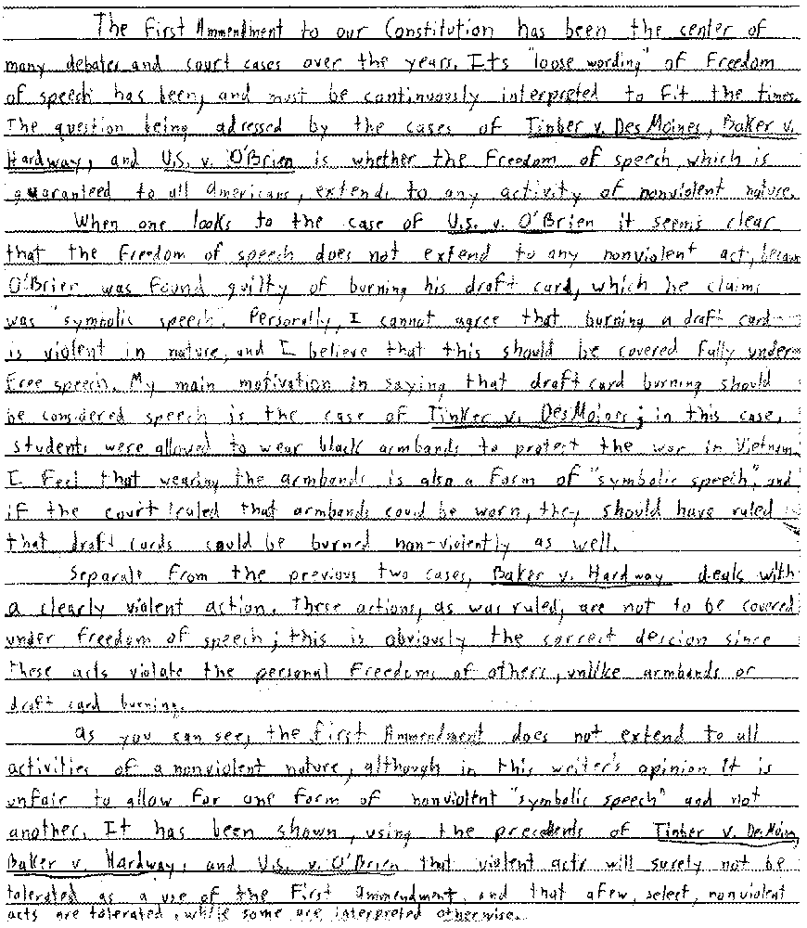

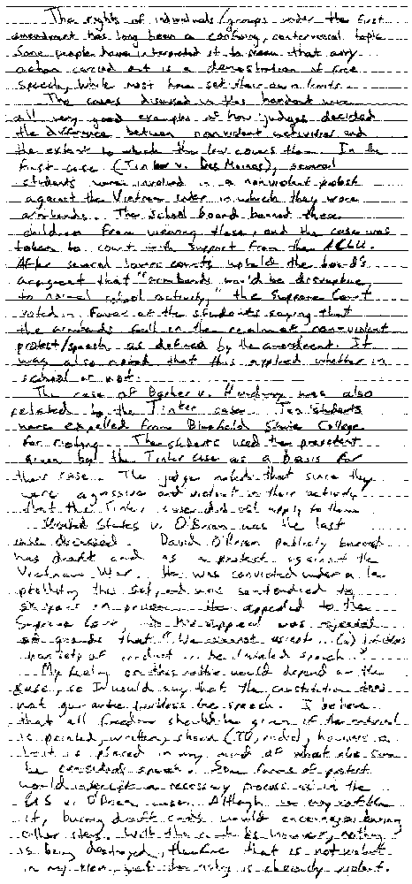
Proficient

The writer clearly answers whether nonviolence is protected. All three cases are mentioned with no error. The writer mentions or quotes or paraphrases the decisions and supports answers with multiple references that differentiate the cases.

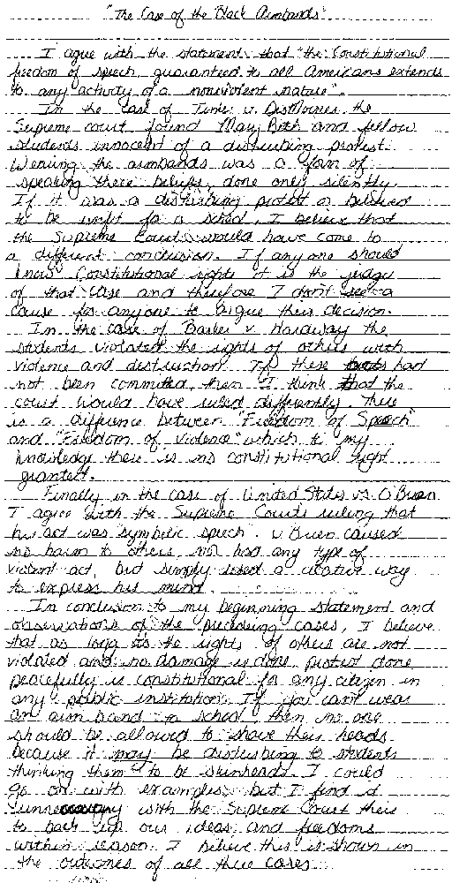

Basic

The writer does not clearly answer the question regarding nonviolence, but refers to one or more of the cases. The writer gives unsupported opinions and may include some factual errors.

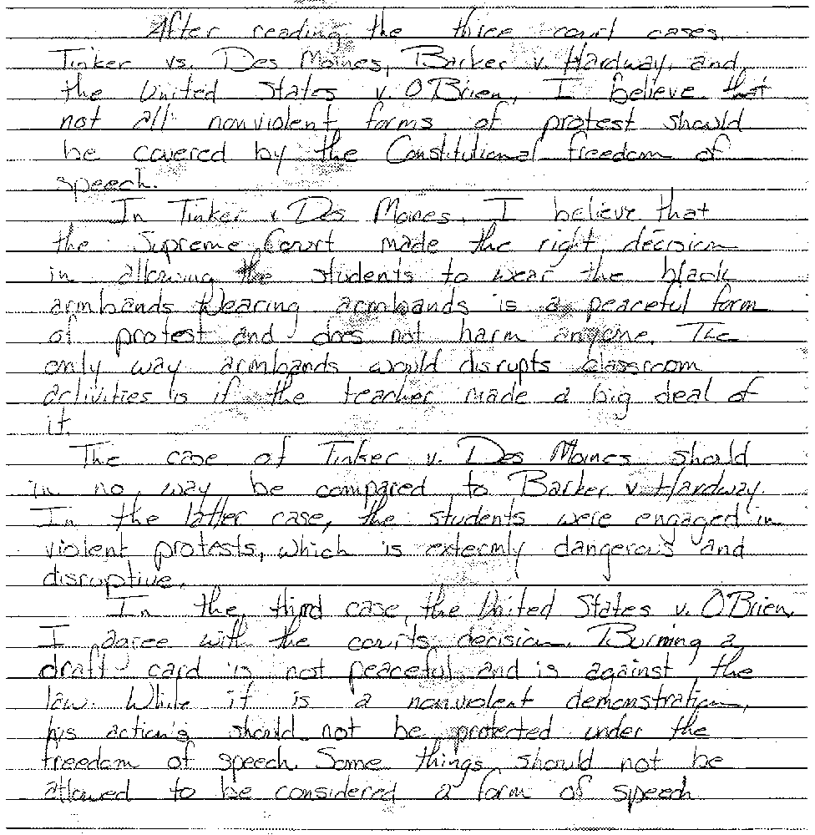

Minimal

There is little or no reference to any of the cases. The writer gives irrelevant comments which contain factual errors and provide little detail. The writer has ignored or misunderstood the task.

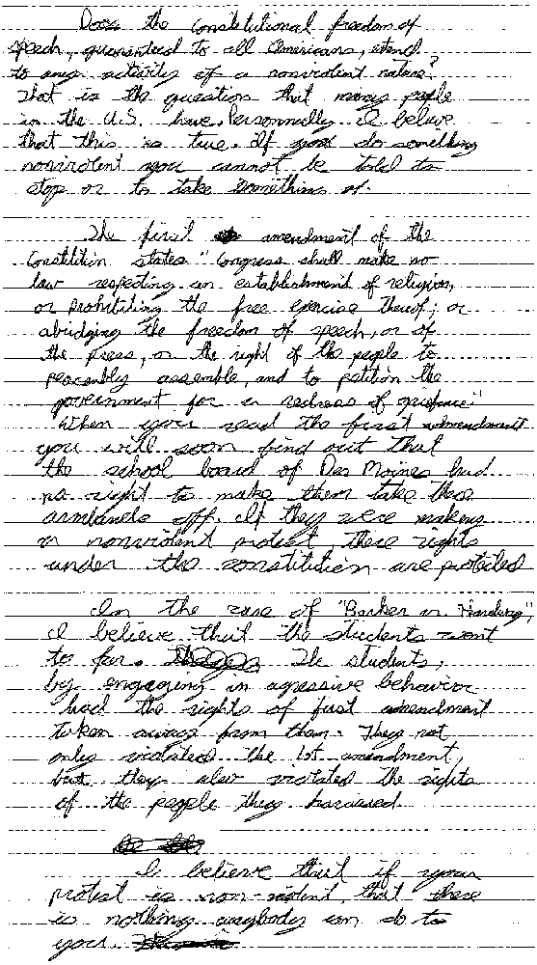
Appendix

We extend our appreciation and thanks to the many people who commented on the Wisconsin Model Academic Standards for Social Studies through letters, focus groups, public forums, and in meetings

Organizations

Achieve, Inc.
Matt Gandal
Bob Schwartz
Cambridge, Massachusetts & Washington, D.C.
American Historical Society
Peter Stearns
Washington, D.C.
Council for Basic Education
Christopher Cross
Washington, D.C.
Hudson Institute
Sally Kilgore
Indianapolis, Indiana
Modern Red Schoolhouse
Sally Kilgore
Nashville, Tennessee
National Center on Education and the Economy
Washington, D.C.,
funding source for New Standards Project
Pittsburgh, Pennsylvania
National Council for History Education, Inc.
Theodore Rabb
Elaine Wrisley Reed
Westlake, Ohio
National Council for the Social Studies
Pat Nickel
Martharose Laffey
Washington, D.C.
National History Education Network
Loretta Lobes
Pittsburgh, Pennsylvania
Wisconsin Council for Economic Education
Bill Isbister
Jim Grunloh
Mark Schug
Lawrence Weiser
Milwaukee, Wisconsin
Wisconsin Council for the Social Studies
Mary Lindgren
Neenah, Wisconsin
Wisconsin Education Association Council
Katie Stout
Russ Allen
Madison, Wisconsin
Wisconsin State Superintendent’s Parent
Advisory Council
Madison, Wisconsin

Individuals

Vicki Adams
Evansville
Professor Stephen E. Ambrose
UW-Madison
Butch Beedle
Evansville
Tina Benson
Evansville
Mike Blanchard
Eau Claire
Al Block
South Milwaukee
Professor Allan G. Bogue
UW-Madison
Karen Drazkowski
La Crosse
Professor Patrick J. Gagnon
Lakeland College
Robert W. Greene
Madison
Professor Mary E. Haas
West Virginia University
John Hanson
Oregon
Professor H. Michael Hartoonian
University of Minnesota
Kris Henning
Evansville
Harry Hobbs
Eau Claire
Gordon Hoffmann
Menomonie
Pete Hybben
Menomonie
Phyllis Krutch
UW Board of Regents
Professor Gloria Ladson-Billings
UW-Madison
J.P. Leary
American Indian Studies Consultant
DPI
Professor Kurt E. Leichtle
UW-River Falls
Professor Thomas T. Lewis
Mount Senario College
Ladysmith
Mike Loftus
Evansville
Professor James J. Lorence
UW Center
Marathon County
Bobbie Malone
Madison
Edmond Manydeeds
Eau Claire
Ann McKinley
Eau Claire
Professor Jack L. Nelson
Rutgers University
Mary Ellen Ochs
Menomonie
Sandra J. Odorzynski
Green Bay
Sandra J. Owens
Oregon
Stephanie Pearce
Waukesha
Linda Riley
Menomonie
Joe Schroeder
Evansville
Bob Scott
Evansville
Glenace Smelcer
Evansville
Anita Sparks
Milwaukee
Dr. Irene Thorelli
La Crosse

We gratefully appreciate and acknowledge the contributions of Mike McKinnon and the committee of Wisconsin educators that developed the performance assessments used in the standards.

Michael McKinnon
Facilitator
Janesville
Sue Gogue
West Baraboo
Donna Herzfeldt
Janesville
Tom Howe
Madison
Michael Koren
Fox Point
Jeanne Kress
Franklin
Stephanie Pearce
Waukesha
Jean Schollmeier
Janesville
Gary Studeman
Beloit
Kathy Vick-Martini
Rhinelander
Mark Waggoner
Green Bay
Dave Wessel
Spencer
Melissa Rodriquez
Kewaunee

We appreciate the contribution of the many parents, business people, and community leaders who participated in the focus group meetings and the leadership and facilitation of Nancy M. Johnson, Vice President, Corporate Research and Development, American Family Insurance, Madison.
Focus groups were held in June, August, and September 1996, in Janesville, Racine, Sparta, and Ashland. Separate focus groups were held for social studies in Eau Claire facilitated by Linda Riley and in Evansville facilitated by Gary Bersell.
We recognize the contribution of the many educators, community members, and business and political leaders who shared their views at three successive rounds of public forums held around the state. Public forums were held in October and November 1996, in Chippewa Falls, Kenosha, Merrill, Milwaukee, Oshkosh, Sheboygan, Stoughton, and Wisconsin Rapids; in February and March 1997 in Ashland, Green Bay, La Crosse, Madison, Milwaukee, Muscoda, Rib Lake, and Rice Lake; and in October 1997, in Appleton, Eau Claire, Green Bay, La Crosse, Madison, Milwaukee, Platteville, Stevens Point, and Superior.
We also thank those states and Wisconsin school districts whose standards documents helped to inform our work.

