Internship
Upper Mississippi River National Wildlife & Fish Refuge, McGregor District
U.S. Fish and Wildlife Service
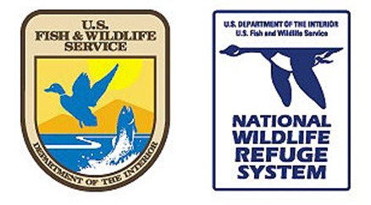
Location: Prairie du Chien, WI
Start Date: Flexible (April or May)
End Date: 12 to 24 weeks from start
Work Schedule: 40 hrs. /week
Expense Stipend: $950/month
Housing Stipend: reimbursed up to $750/month
Last Date to Apply: January 14th, 2026
Description: Intern will perform duties as assigned pertaining to the visitor use and biology program of the Upper Mississippi River NW&FR, McGregor District. The incumbent serves as a Visitor Services intern assisting with the operations of the refuge's visitor services program. Intern will also cooperate with the Friends of Pool 9 on various projects. Intern will occasionally support the biology program. Duties may include but are not limited to:
- Develop, present and/or assist with a variety of interpretive programs including orientation talks, walks, and demonstrations to a variety of general public audiences or school groups.
- Initiate or assist with development or revision of interpretive materials, such as brochures, guidebooks, handouts, and exhibits. Operates a variety of audiovisual and other equipment used in connection with interpretive programs.
- Serve as point of contact for refuge anniversary planning.
- Support FOP9 coordination efforts, plan film festival and assist with photography contest.
- Assist refuge biological program. Duties may include: floodplain forest inventory, Bald Eagle nest production surveys, invasive species mapping and/or treatment, and goose banding.
Qualifications:
- Current valid driver’s license
- Ability to communicate and/or willingness to learn to communicate effectively with visitors and staff by writing or through interpretive activities that aid in implementing the refuge's outreach program
- Self-motivated
- Ability to work independently and as part of a team
- Ability to work long hours in the field under all weather conditions
- Interest in environmental interpretation and natural resource conservation
To Apply: Send resume, cover letter, and 3 references as a single document to District Manager
Kendra_Pednault@fws.gov by January 14th, 2026. For questions, please call: 608-306-2202
Visit: http://www.fws.gov/refuge/upper_mississippi_river/ for more information about the Refuge

