Transportation Expenses
Visit http://inwisconsin.com/select-wisconsin/available-sites/locate-in-wisconsin and scroll down to see map.
Select Heat Maps, Consumer Expenses, Transportation, Total Transportation (or other variable), $ Per Household.
Use plus/minus tool to zoom and hand tool to drag map to desired location.
Data is shown for counties and zip codes.
Source: In Wisconsin, Wisconsin Economic Development Corporation

Housing and Transportation Affordability
Visit http://htaindex.cnt.org/map/ and enter location.
Use plus/minus tool to zoom and hand tool to drag map to desired location.
Data is available for census tracts, municipalities and counties located in Core Based Statistical Areas (CBSA – urban areas with core population of at least 10,000 people).
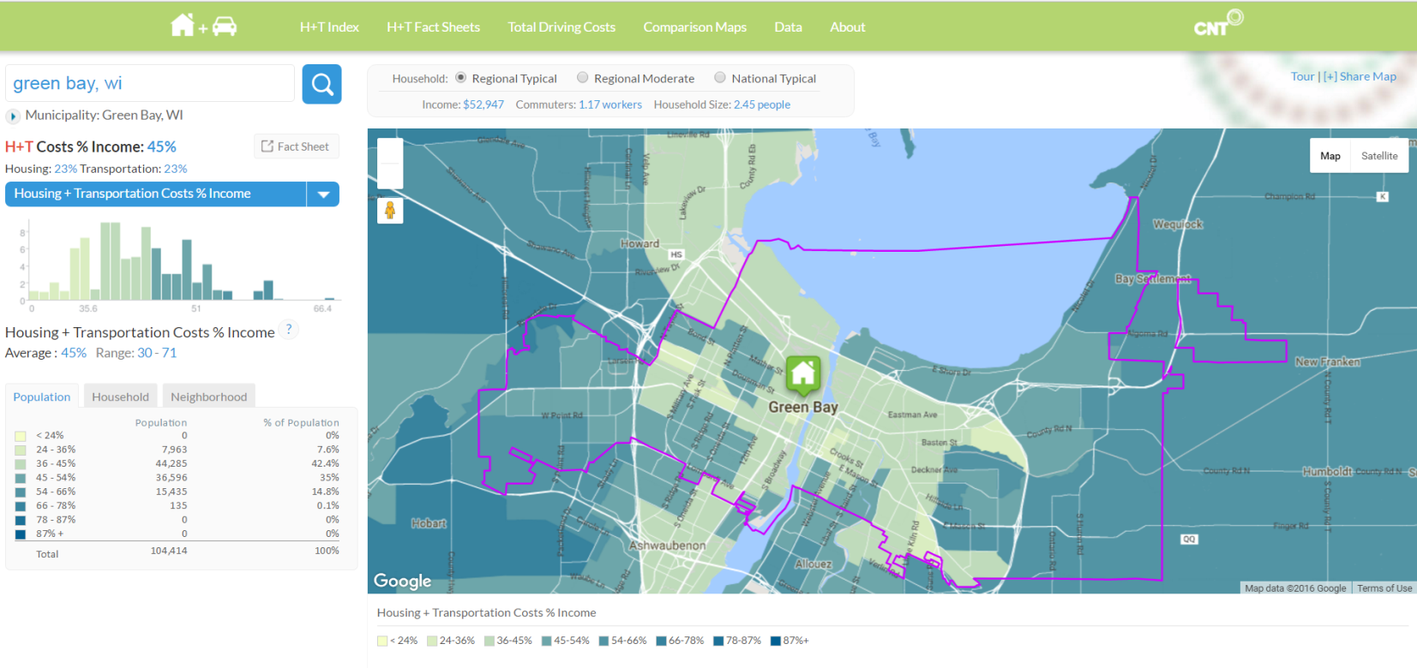
Click on H+T Fact Sheets and enter location for additional data and graphics.
Source: H+T® Index, Center for Neighborhood Technology

