**Shoreland Zoning Resources**

**Overview of Shoreland Zoning**

A video explaining basics, science, county efforts, and the legislative changes to shoreland zoning. [www.youtube.com/watch?v=enus9Ceub2g](https://www.youtube.com/watch?v=enus9Ceub2g)

**Shoreland science handouts**

<https://bit.ly/shorelandscience>

**History of Shoreland Zoning**

Three short videos about the Wisconsin residents who helped develop the Public Trust Doctrine. This is the legal basis and the rationale behind shoreland zoning and goes back to the Wisconsin Constitution. [dnr.wi.gov/topic/waterways/about_us/doctrine.htm](http://dnr.wi.gov/topic/waterways/about_us/doctrine.htm)

Wisconsin shoreland zoning timeline.

[www.uwsp.edu/cnr-ap/clue/Documents/Water/Wisconsin%20Shoreland%20Zoning%20Timeline%207-19.pdf](http://www.uwsp.edu/cnr-ap/clue/Documents/Water/Wisconsin%20Shoreland%20Zoning%20Timeline%207-19.pdf)

**Role of the zoning board webinar recording**

This webinar covers decisions typically assigned to the zoning board of adjustment or appeals, including variances, administrative appeals, and conditional uses. It takes a closer look at the quasi-judicial role of the zoning board and how their decisions impact communities.

[www.uwsp.edu/cnr-ap/clue/Pages/Webinars/Role-of-the-ZB-of-Adjustment_Appeals.aspx](http://www.uwsp.edu/cnr-ap/clue/Pages/Webinars/Role-of-the-ZB-of-Adjustment_Appeals.aspx)

CLUE offers zoning board training through webinars and workshops.

**Zoning Board Handbook**

Zoning boards act like judges to decide on variances, administrative appeals, and in some counties, conditional uses. Their decisions impact shoreland zoning and other types of zoning. The [Zoning Board Handbook](https://www.uwsp.edu/cnr-ap/clue/Pages/publications-resources/Zoning.aspx) is intended to assist zoning board members, local government officials and citizens in understanding the role of the zoning board and the procedures and standards with which their decisions must comply.

[www.uwsp.edu/cnr-ap/clue/Documents/ZoningHandbook/Zoning_Board_Handbook.pdf](http://www.uwsp.edu/cnr-ap/clue/Documents/ZoningHandbook/Zoning_Board_Handbook.pdf)

Summary of shoreland zoning, including suggestions for zoning board members. Starts on page 139 of the Zoning Board Handbook.

**Publications for waterfront property owners**

[www.uwsp.edu/cnr-ap/clue/Pages/publications-resources/water.aspx](http://www.uwsp.edu/cnr-ap/clue/Pages/publications-resources/water.aspx)

* The value of shoreland zoning
* Choosing the right waterfront property
* Protecting your waterfront investment: 10 shoreland stewardship practices
* Impervious surfaces: How they impact fish, wildlife and waterfront property values
* The water’s edge: Helping fish and wildlife on your waterfront property

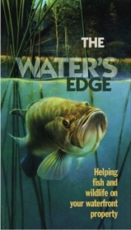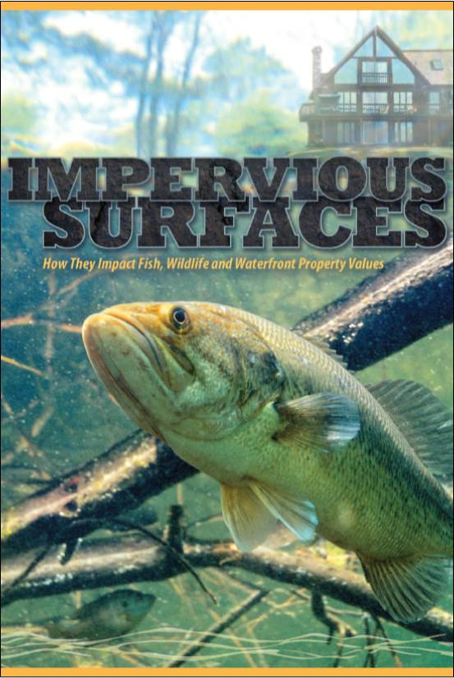**Videos you might play for the public**

Our Lakeshore Connection (8 minutes)

<https://www.youtube.com/watch?v=dwjAoRwLrmM>

Impacts of impervious surfaces on fish, wildlife and waterfront property values (12 minutes)

<https://www.youtube.com/watch?v=UPjPnaGNB1c&feature=youtu.be>

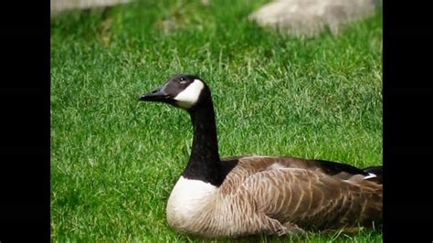Larry the All-American Bullfrog (one minute video about habitat for frogs) <https://www.youtube.com/watch?v=fABglKV6MLc>

Sebastian the Goose Encourages Natural Shorelines (two minutes)

<https://www.youtube.com/watch?v=uhKIGxXgrLg>

*Compiled by Lynn Markham, Center for Land Use Education 3/14/22*