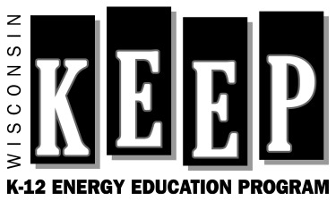
Wisconsin K-12 Energy Education Program (KEEP)
Renewable Energy in Building Science Conceptual Framework
General Review Questions

Name:
Title:
Affiliation:

Thank you for conducting this review of the Renewable Energy in Building Science Conceptual Framework. Please read the questions below and keep them in mind as you review the document. If your answer to any question is “No,” please provide recommendations for improving the information or situation. Please indicate all responses on this form because responses may be overlooked if written direction on the document.

- Do you think the content of the Renewable Energy in Building Science Conceptual Framework is thorough and cohesive enough to be used by High School Construction Educators?

- Staying with the scope of renewable energy in building science, what concepts are missing from the Concept Table?

- Do the Areas of Emphasis help determine which concepts should be taught in which classes? Explain how you will use the Areas of Emphasis when planning your curriculum.

- Are the concepts organized appropriately under the Topic Areas? Explain how you will use the Topic Areas when planning your curriculum.

- Are the current concepts properly stated? If there are any that need to be reworded, please indicate which ones.

- Is it worthwhile to list Wisconsin’s Model Academic Standards for Technology Education?

- Is it worthwhile to list the International Technology Education Association Literacy Standards?

- What sections of the Framework do you find most useful?

- What sections of the Framework need improvement?

- Is there any information that should be incorporated into the next edition of this Framework?

Please return form to the:
Wisconsin K-12 Energy Education Program (KEEP)
403 LRC, UW-Stevens Point
Stevens Point, WI 54481
715.346.4698 (f)
energy@uwsp.edu

