| **CLOs-Course-level Learning Outcome**   * What do students need to be able to do when they complete this course? * Students will be able to: | **Assessment Method**   * How will you know they learned? * **Summative Assessments** “of learning” | **Content (Learning Materials)**   * What will you provide to give them access to information? * These are resources that provide information. | **Learning Activities**   * What will they do to learn the material? * **Formative Assessments** “for learning” |
| --- | --- | --- | --- |
|  |  |  |  |
|  |  |  |  |
|  |  |  |  |
|  |  |  |  |
|  |  |  |  |
|  |  |  |  |
|  |  |  |  |

# Course Goals/Instructor Goals:

# Big Rocks: Important note: Your "big rocks" do NOT have to be expressed in any particular way.  They are NOT necessarily items that will appear on your syllabus. However, they should be things likely to direct your thinking about the design of your course.  The key is identifying something about the course that will drive your commitment to teaching it, something that is your connection to its success, what matters most to you about the course. (Borrowed from Lindsay Bernhagen Ph.D.)

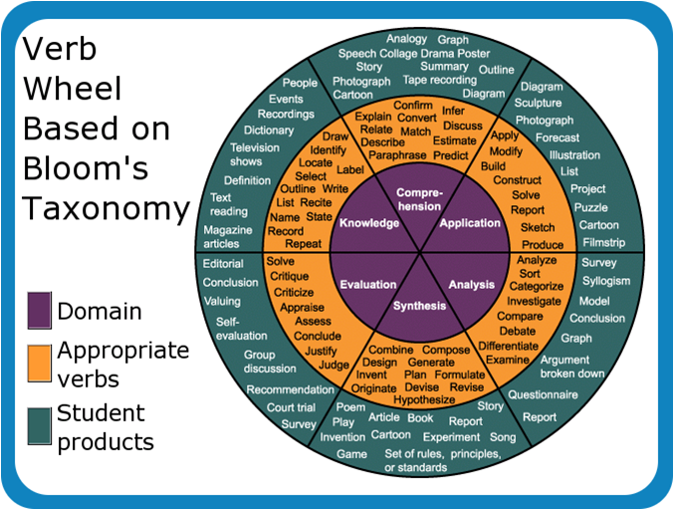

*Verb Wheel Based on Bloom's Taxonomy*. Digital image. *Teachingenglishlanguagearts.com*. N.p., 2 Jan. 2012. Web. 14 Apr. 2016. <http://teachingenglishlanguagearts.com/wp-content/uploads/2012/01/Bloom-Taxonomy-Wheel.png>.