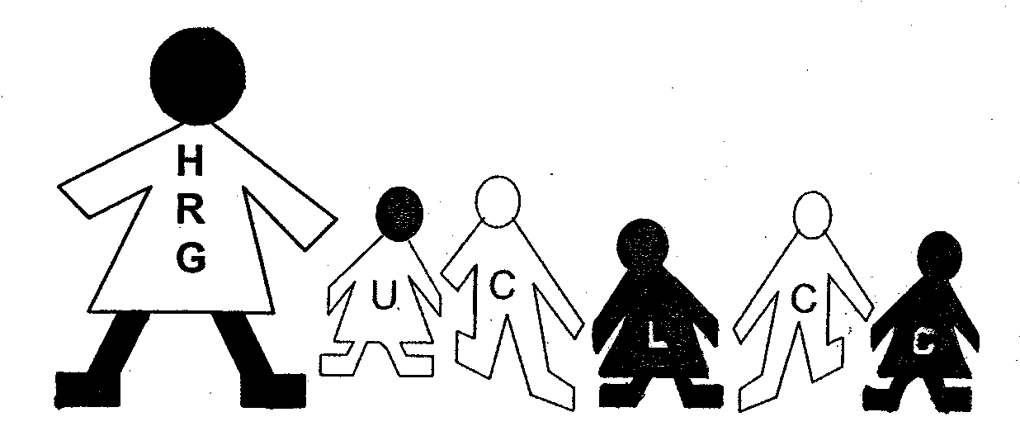

Waiting List Enrollment
HRG-UCLCC
Helen R Godfrey - University Child Learning & Care Center

Name _____________________________________ Date: _____________________

Address _______________________________________________________________

City ______________________________________ State ______ Zip Code ________

Telephone: Home ____________________ Work ___________________________

Place of Employment: ___________________________________________________

E-Mail Address: ____________________________Cell Phone __________________

Children’s Name Age Birth date or Due Date

_________________________________ ____ ___________________

_________________________________ ____ ___________________

_________________________________ ____ ___________________

Is your child(ren) currently in childcare? _____ If yes, where: __________________________

Affiliation with the University (please circle one below)

Student–Full Time Student-Part-time Faculty/Staff Alumni

Indicate the type of care you need: _______ Full Time _______ Part-time

Please list the hours care is needed for each day below:

Monday Tuesday Wednesday Thursday Friday

__________ __________ __________ __________ __________

When do you need to care to begin (i.e. ASAP, next semester, summer, date etc.)

_______________________________________________________________________

Please return completed form to: UWSP Children’s Learning Center
HRG-UCLCC
910 Fremont Street, Delzell Hall
Stevens Point, WI 54481
Or email to: child.care@uwsp.edu

**Placement on the waitlist is not perpetual. Please reach out to the center at least every 6 months via email stating your wishes to remain on the waitlist or be removed; as well as give any updates (DOB, name, address, etc.). Names will be removed at the end of the academic year (May), if we do not hear from you.

