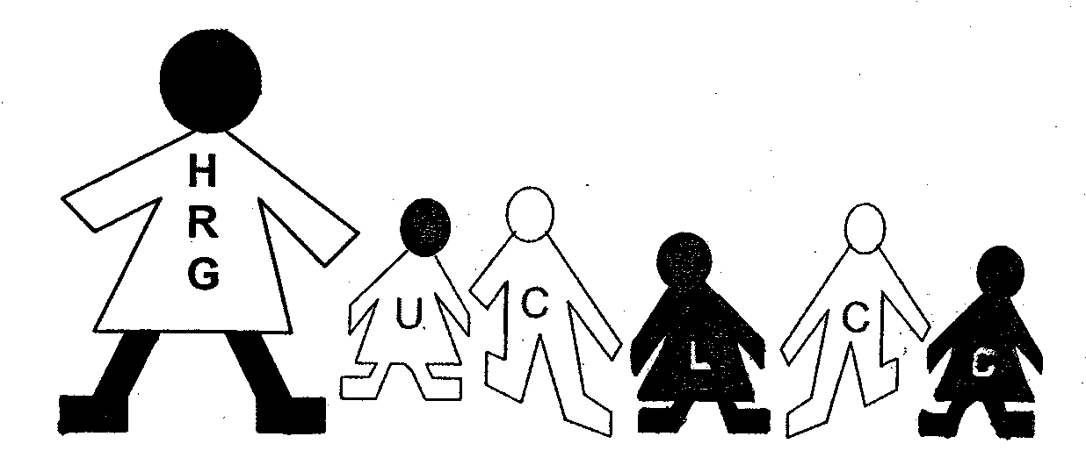

HRG-UCLCC Parental Consent & Photo Permission

***********************************************************************************************************

MEDIA RELEASE (Newspaper, TV, Advertising, Social Media)
Please read carefully and check one of the three statements

- I give UCLCC permission to release my child/children’s picture and name.
- I give UCLCC permission to release my child/children’s picture only, without their name.
- I do not give UCLCC permission for my child/children’s name or picture to be released.

CHILD PORTFOLIO (FILE) PERMISSION

- Yes I give permission for my child’s/children photo/photos to be put in my child’s assessment
- No portfolio folder for the purpose of teacher/parent/guardian communication regarding my
child’s development at HRG/UCLCC. Child portfolio files are confidential and shared only with a child’s parent/guardian and the appropriate HRG/UCLCC teaching & administrative staff working with the child. The portfolios are shared at Parent/Teacher Conferences.

CHILD NEWSLETTER (FILE) PERMISSION

- Yes I give permission for my child’s/children photo/photos and name to be used in classroom
- No newsletters for the purpose of teacher/parent/guardian communication. Classroom newsletters
are sent out via email from your child’s teacher weekly with highlights of the classroom from each week and what learning and special activities have taken place. A hard copy is also available for viewing in the lobby area of the UCLCC. Newsletters are often individualized and incorporated into each child’s portfolio to be later shared at Parent/Teacher Conferences.

CUBBY/CLASSROOM PERMISSION

- Yes I give permission for my child/children’s photo to be put on their cubby (with 1st name, last
- No initial) and also in classroom displays for children to identify with classroom activities/artwork.

PARENT MANUAL

I hereby acknowledge that I have read the HRG/UCLCC Parent Manual (on line at www.uwsp.edu/childcare). I fully understand the manual & policies and agree to comply with them. A hard copy is also available in the main office.

Child’s Name __________________________________________________________________
(PLEASE PRINT

Parent/Guardian Name__________________________________________________________
(PLEASE PRINT)

Parent/Guardian Sign______________________________________date____________

