How To Do Your Timesheet
- Log on to your “MyPoint”
- Click on the Finances tab
- Under the Student Jobs and Opportunities section, click “My UW System”
- Click on UW-Stevens Point and continue
- Log in to your account using your UWSP Login ID and password
- Click on “Timesheet”
  - You may have to log in yet again
- If you have multiple jobs listed, click on the appropriate job for the shift you are entering
- Filling out the time sheet:
  - Always remember: First in, Last out if you are working one shift with no breaks
    - Example:
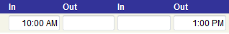

    - If you are working multiple shifts in one day
      - Example:
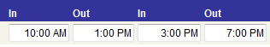
  - If you are working a late night shift:
    - If the time changes from PM to AM, enter your punch out time for the “Last Out” for the next day, unless you are working another shift
      - Example (not working another shift that day):
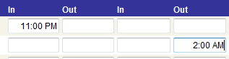
      - Example (working another shift):
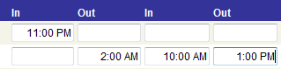

      - Example (working multiple shifts with an overnight shift):
