Directions for Grant Resource Center (GRC) Account Creation and Funding Searches & Alerts
Individuals should now create their own individual accounts for access to GRC. General institutional logins are no longer current. For help with account creation, contact GRCMembership@aascu.org and note you are with membership institution University of Wisconsin-Stevens Point.

1. Go to https://aascu.org/resources-expertise/grc . Hover over Member Corner at the top to click Profile.
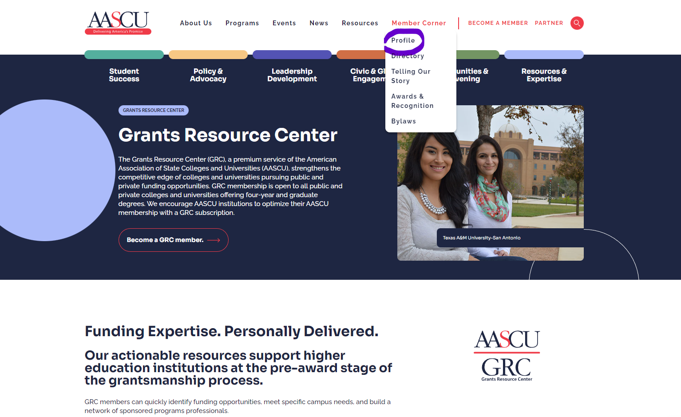

2. Click Create a new account.
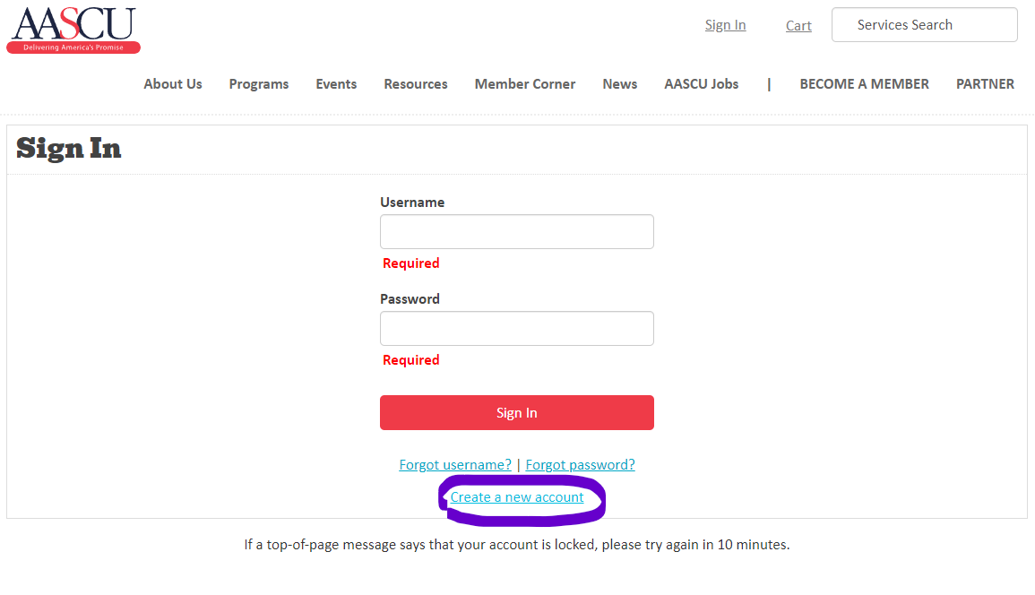
3. In the Institute Name text box, begin typing University of Wisconsin, and select University of Wisconsin-Stevens Point from the dropdown. Then complete the other fields, please note your uwsp.edu email address must be used for account creation.
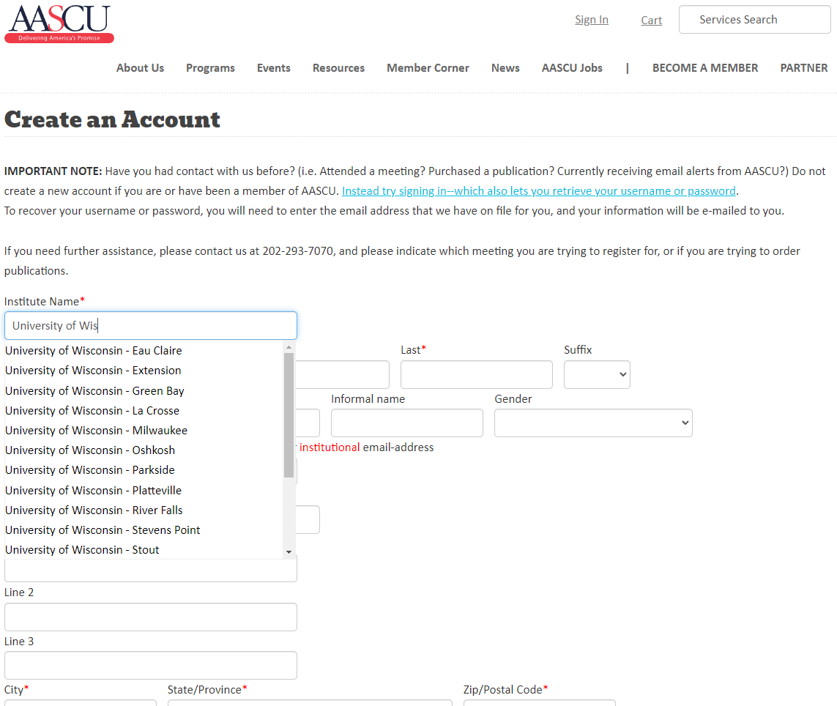

4. When your account is created, navigate to the Grants Resource Center Page (https://aascu.org/resources-expertise/grc/) and click “Learn more about our resources”
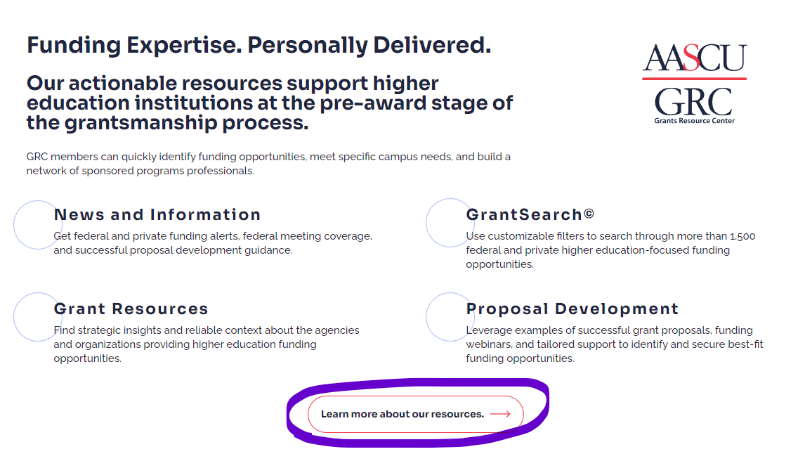

5. There are several options to explore, we encourage you to eventually browse the resources available: News and Information, GrantSearch, Grant Resources, and Proposal Development.
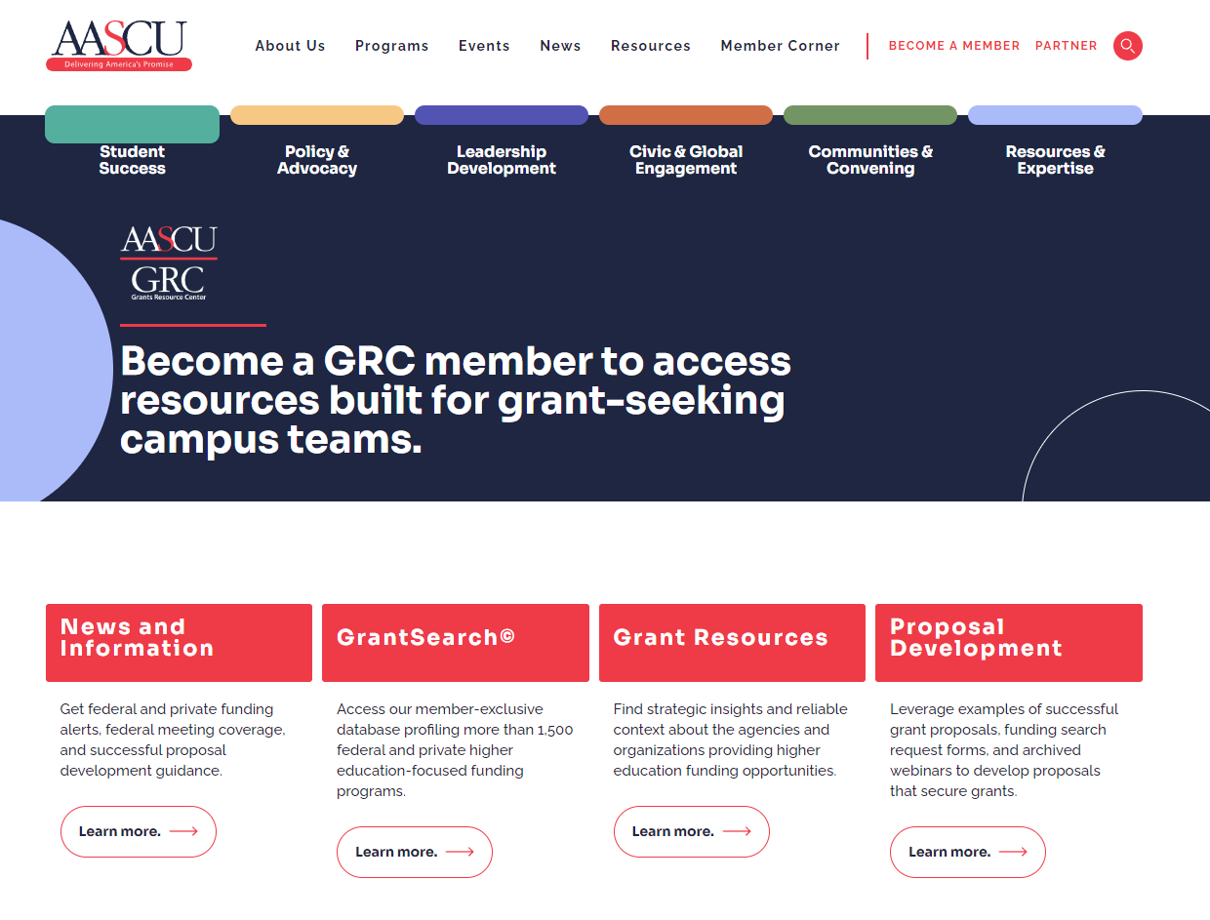

4. Click “Learn More” under GrantSearch. There is an option to generally search “GrantSearch” or enter information to get direct emails, “Get faculty alerts”.
