Safety Data Sheet (SDS) Requirement

Chemical manufacturers and importers must obtain or develop a SDS for each hazardous chemical they produce or import. SDS are detailed informational documents of hazardous chemicals which defines the physical and chemical properties of the product, and is planned to provide end users in laboratories, workers and emergency personnel with consistent and readily understandable information regarding safe procedures for handling, storage, disposal, protective equipment, and spill and emergency response.

Before purchasing a product or material, take into account the possible environmental and health effects and, if possible, consider purchasing a safer or more environmentally friendly product. Contact the Environmental Health & Safety (EHS) for assistance in reviewing SDS issues as needed.

Employers must have a safety data sheet in the workplace for each hazardous chemical they use following OSHA standard 29 CFR 1910.1200(g).

Supervisors of departments shall be responsible for maintaining a current SDS for each hazardous chemical in their area(s) of responsibility. It must be readily accessible to each employee who may come in contact with the hazardous chemical. Supervisors are also responsible to provide department-specific training on hazardous chemicals for their employees.

EHS officer will assist in compiling and maintaining the master SDS files as necessary.
With the revised Hazard Communication Standard, SDS are standardized and presented in 16-section format that is used and recognized globally. These 16-sections include;
Section 1, Identification includes product identifier; manufacturer or distributor name, address, phone number; emergency phone number; recommended use; restrictions on use.
Section 2, Hazard(s) identification includes all hazards regarding the chemical; required label elements.
Section 3, Composition/information on ingredients includes information on chemical ingredients; trade secret claims.
Section 4, First-aid measures includes important symptoms/effects, acute, delayed; required treatment.
Section 5, Fire-fighting measures lists suitable extinguishing techniques, equipment; chemical hazards from fire.
Section 6, Accidental release measures lists emergency procedures; protective equipment; proper methods of containment and cleanup.
Section 7, Handling and storage lists precautions for safe handling and storage, including incompatibilities.
Section 8, Exposure controls/personal protection lists OSHA’s Permissible Exposure Limits (PELs); ACGIH Threshold Limit Values (TLVs); and any other exposure limit used or recommended by the chemical manufacturer, importer, or employer preparing the SDS where available as well as appropriate engineering controls; personal protective equipment (PPE).
Section 9, Physical and chemical properties lists the chemical's characteristics.
Section 10, Stability and reactivity lists chemical stability and possibility of hazardous reactions.
Section 11, Toxicological information includes routes of exposure; related symptoms, acute and chronic effects; numerical measures of toxicity.
Section 12, Ecological information*
Section 13, Disposal considerations*
Section 14, Transport information*
Section 15, Regulatory information*
Section 16, Other information, includes the date of preparation or last revision.
*Note: Since other Agencies regulate this information, OSHA will not be enforcing Sections 12 through 15 (29 CFR 1910.1200(g)(2)). Also, see OSHA 1910.1200 App D for the specific content of each section of the safety data sheet.

All employees who work with hazardous chemicals must be able to readily access an SDS during each work shift from their work areas. These sheets are available through the ChemWatch link on the UW-Stevens Point EHS website.

New SDSs

When a new product is purchased, the purchaser must obtain the MSDS from the product manufacturer or distributor.

Upon receipt of the SDS, the purchaser will do the following:

- Make a copy of the SDS.
- Put the copy in the appropriate department’s SDS file or binder.
- Identify the department or trade that will be using the product by placing the name in the upper right corner of the original.
- Forward the original to the UW-Stevens Point EHS Office: 101 George Stien Building.
  - The MSDS will then be assigned a number by EHS.
  - It will be kept on file in the Risk Management Office.

Updated SDSs

Manufacturers and distributors will occasionally send updated or revised versions of SDSs already on file at UW-Stevens Point. When the purchaser or department using the product receives an updated SDS, they should follow the steps outlined below:

- Make a copy of the SDS.
- Put the copy in the appropriate department’s SDS file or binder.
- Forward a copy to the UW-Stevens Point EHS Officer: 101 George Stien Building.
- Build an electronic folder in ChemWatch. See Appendix A for ChemWatch user guide.

Occasionally, EHS will receive updated SDS direct from the supplier. If EHS knows which department it belongs to, the replacement will be forwarded to that supervisor and they should update their files accordingly.

Archiving MSDSs of materials no longer used or replaced

Safety Data Sheets that have been replaced with a newer version and/or SDSs of discontinued materials must be sent to the EHS Officer to be filed in our SDS Archives. Use the following form when sending these SDS to EHS.

APPENDIX A
University of Wisconsin Stevens Point CHEMWATCH User Guide
Introduction:
According to Hazard Communication Standard (HCS), all employees who work with hazardous chemicals must be able to readily access Safety Data Sheets (SDS), which are standardized and presented in 16-section format and used globally, during each work shift from their work areas. University of Wisconsin Stevens Point’s students, faculty, and employees can access SDS through an online SDS database – ChemWatch - on the UW- Stevens Point Environmental Health and Safety website. ChemWatch provides a database of both vendor SDS and independently researched ChemWatch SDS. Additionally, it provides users with chemical management, risk assessment, and regulatory databases.
This user guide provides you with quick easy steps for accessing the CHEMWATCH, searching for SDS, and printing labels. Also, it provides an overview for the Materials Module, Folder Management as well as steps for “How to access e-Learning Center” for more detail information.

How to access
Go to one of these addresses http://www.uwsp.edu/rmgt/Pages/chemwatch.aspx
http://www.uwsp.edu/rmgt/Pages/ehs/safety/hazcom.aspx
http://www.uwsp.edu/rmgt/Pages/default.aspx
Click on “CHEMWATCH” shortcut.
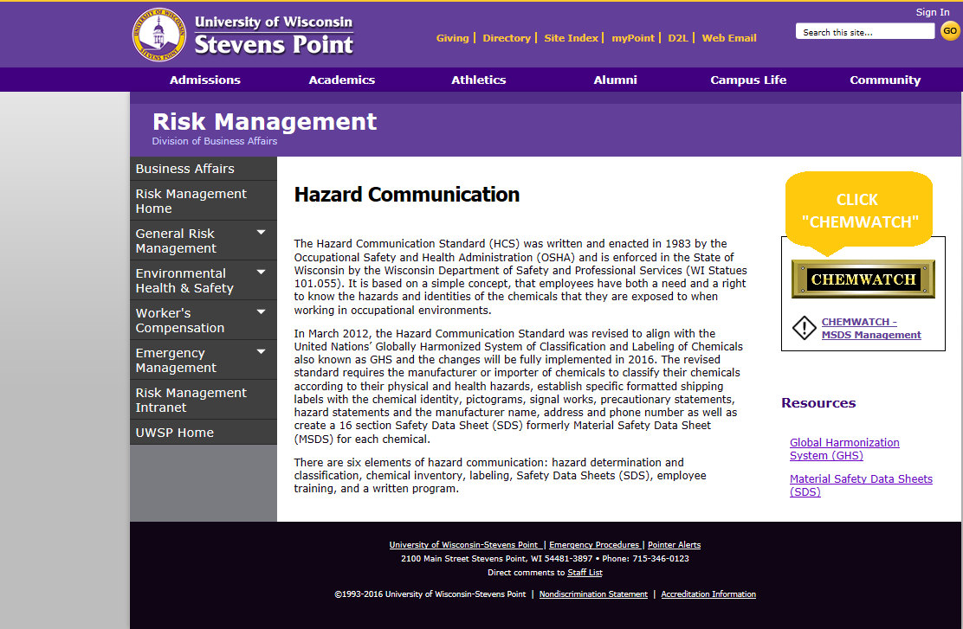

How to access E-Learning Center
Step 1: Click “eLearning” to access eLearning center.

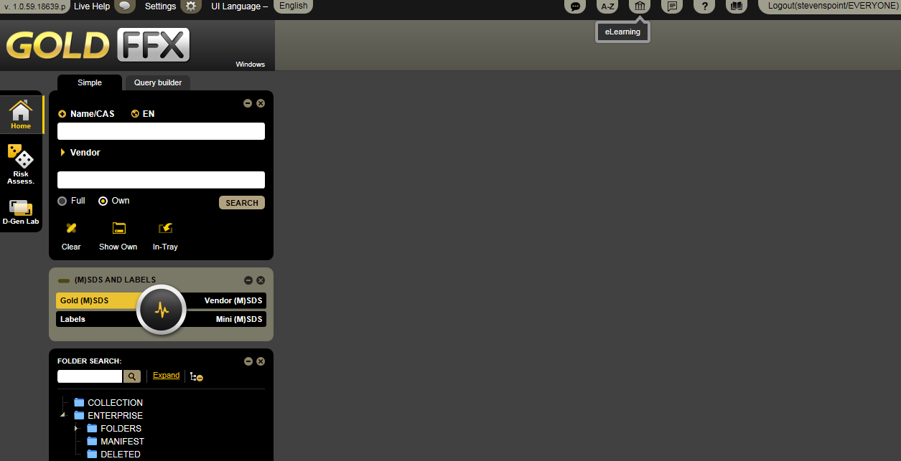
Click “eLearning”

Step 2: Then click “Modules” to choose a training package you would like to complete.
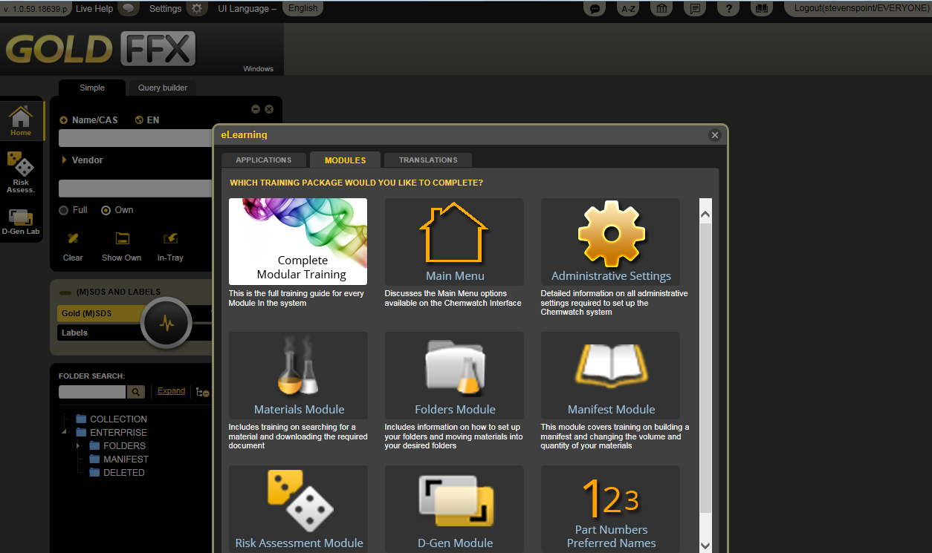
Click “Modules”

Note: Quick access to modules index
If you select “Complete Modular Training” module and click on “Menu” button that is in the upper right corner of the complete modular training page, you can see below mentioned index and select the title you want from this menu.
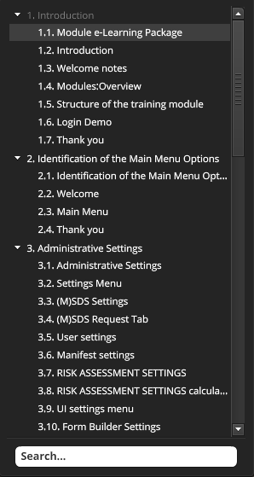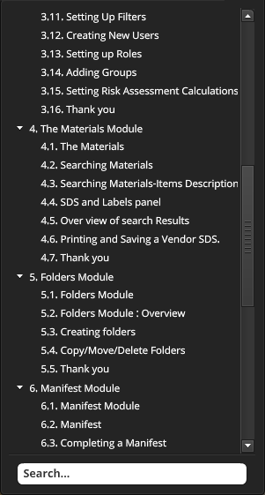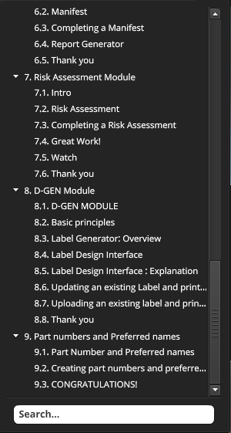

How to change the language
GoldFFX is available in 46 different languages. You can easily change the language by clicking “UI Language”. However, please remember the fact that all SDSs and labels must be in English at UW-Stevens Point campus.
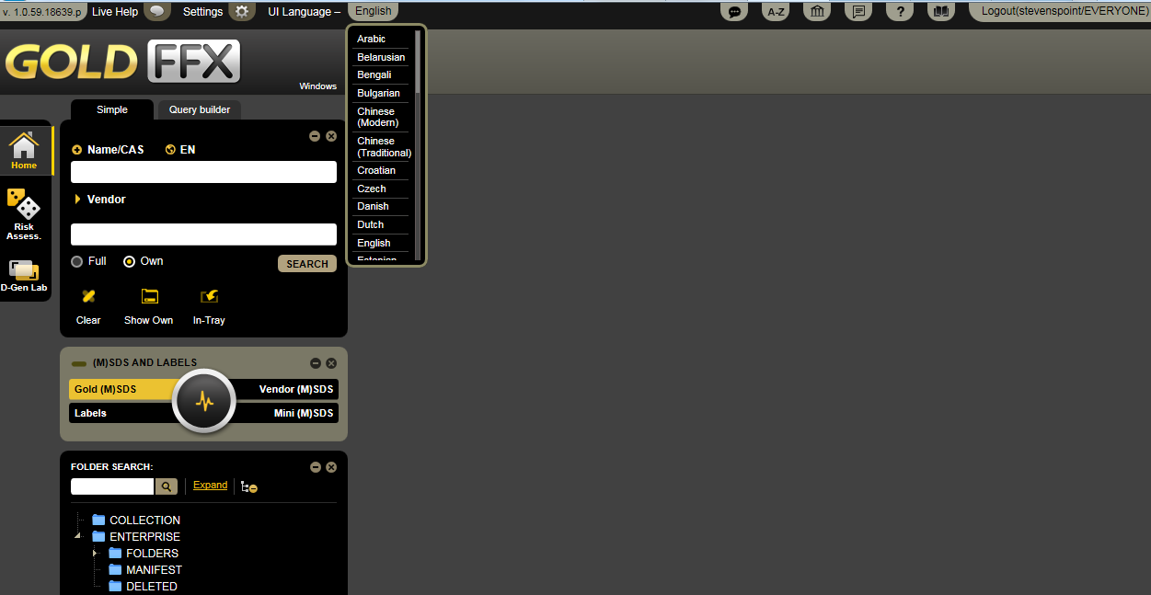
Click “Ul Language” to change the language. And select the language you want.

Overview of the Materials Module

The screenshot below illustrates the basic components of the Materials Module.

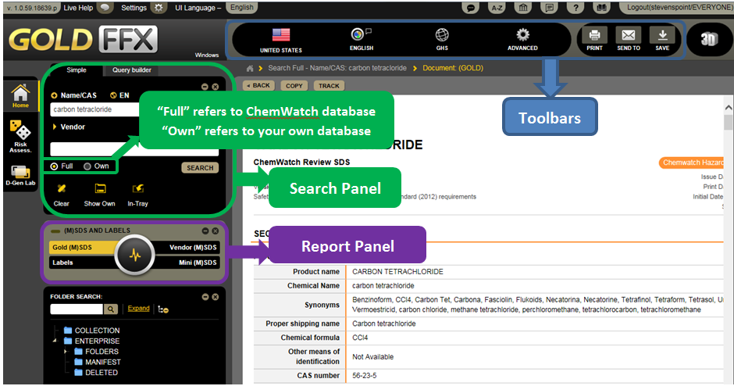

Search Panel
Search panel allows search by,
- product name,
- synonym,
- common name,
- chemical formula,
- trade name, or
- manufacturer’s name.
In search panel the “Full” button will yield the search results from full database of ChemWatch and the “Own” button will yield the search results only from the chemicals stored in UW-Stevens Point folders.

Report Panel
Report panel allows you to choose the types of data, information, and report to display by clicking on different buttons within the panel.

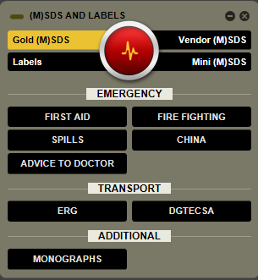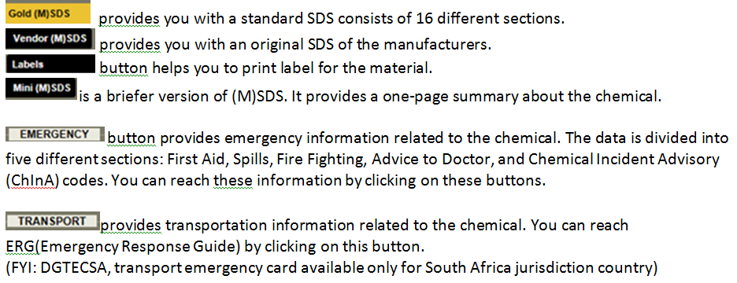

Additional information about Vendors SDS:
As the screenshot below illustrates, a search for Vendors SDS of a chemical can give you many results. You can sort by Name, Vendor, Type, Language, Country, Source Type, and Issue Date.
Also sorting by Issue Date allows you to find the most recent SDS.
Source Type;
- Primary refers to SDSs directly from the manufacturers.
- Secondary refers to SDSs from other sources such as internet.

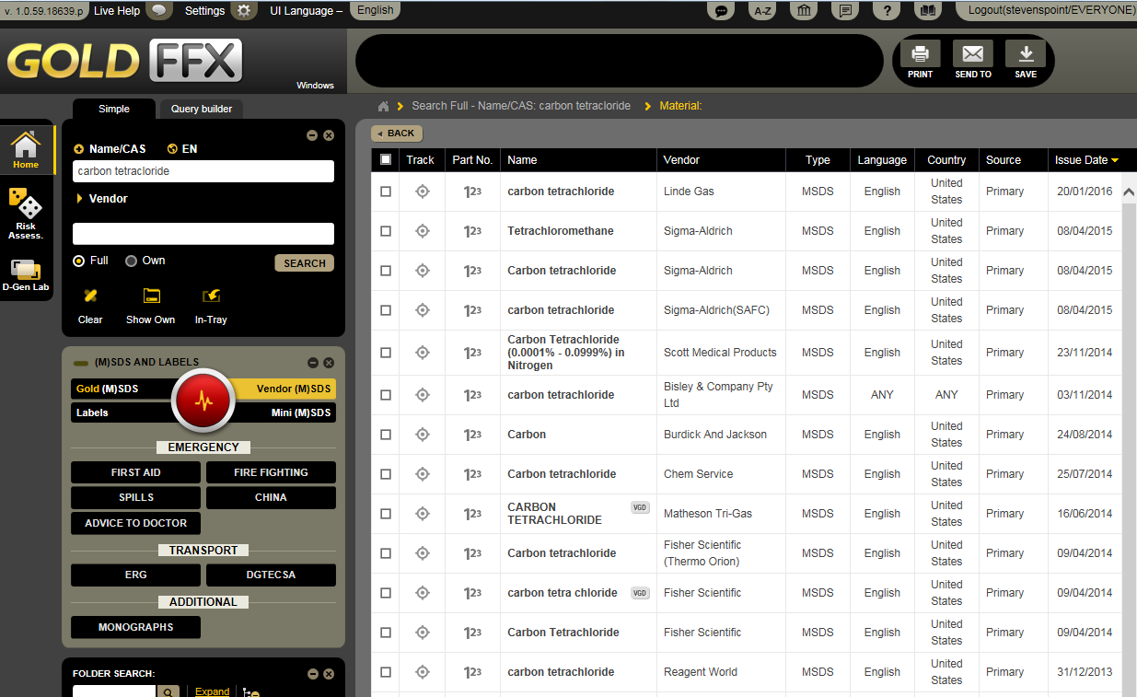

Toolbars
The toolbars provides users with language and format options.
The GHS tab allows display SDS in Local or GHS (“Globally Harmonized System”) format. You can choose either of them by clicking “GHS” tab.
The Advanced tab allows users to display or hide fields in the output report screen. Check boxes to select fields to display in the SDS screen, such as NFPA (“National Fire Protection Association”) Diamond and/or WHMIS (“Workplace Hazardous Materials Information System”) classification. Click “SAVE” once all the options are chosen.

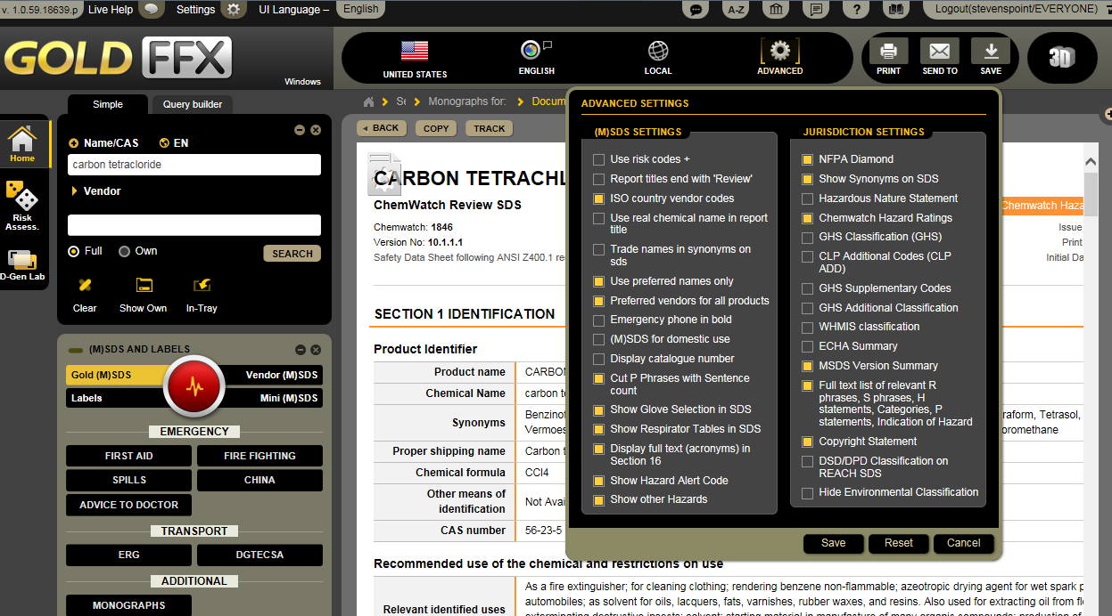
How to search for SDS
Step 1: Enter the name of the chemical that you want to search, to the “Name/CAS” bar.
Step 2: Select “Full” to yield the search results from full database of ChemWatch or “Own” button to search the chemical in UW-Stevens Point folders.
Step 3: Select the desired report type from report panel.
Step 4: Click “Search” button to start SDS search.

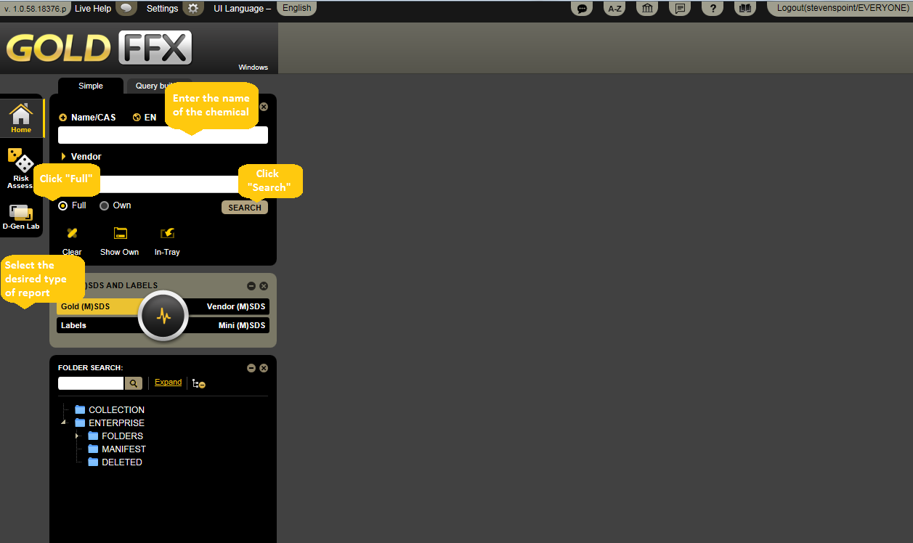

Step 5: Select the correct chemical from search results.
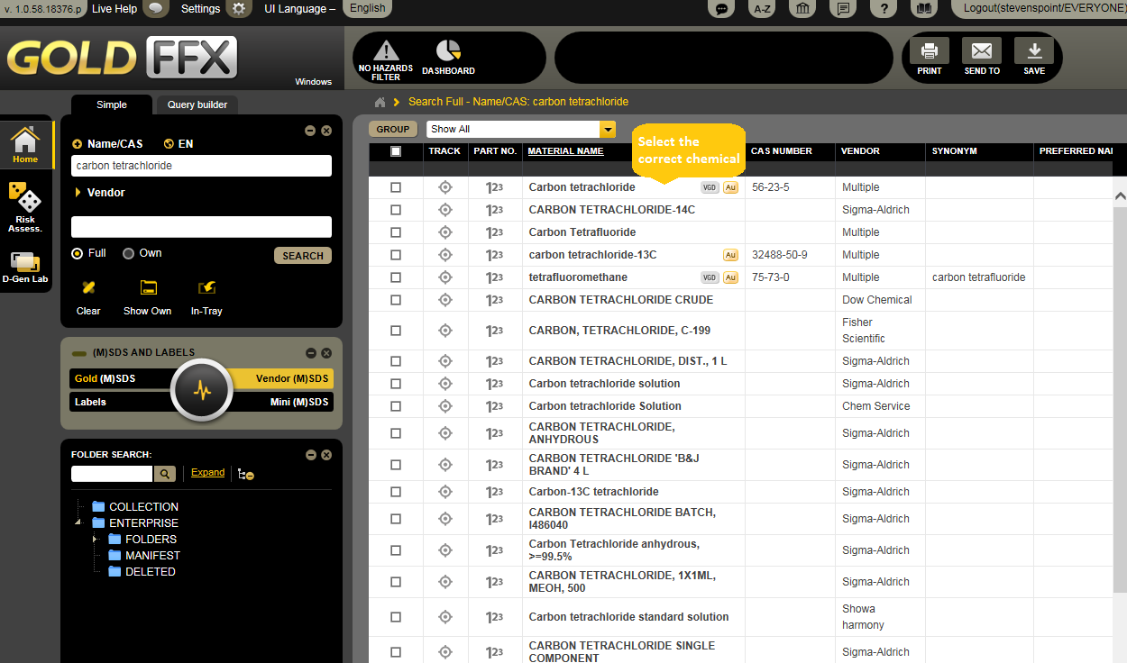
Step 6: Click “Print” on the upper right corner of the page to print out the SDS.
Step 7: You can also send the SDS via email by clicking “Send To” button that placed on the upper right corner of the page.
Step 8: If you want to save the SDS on your computer, click “Save” button on the toolbar.
Step 9: You can also maximize the SDS screen to see the full SDS by clicking (+).
Step 10: Click “Clear” to empty the search box for new search.

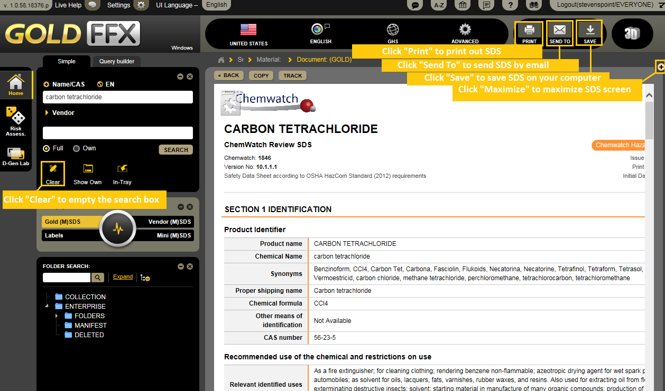

How to print labels
Step 1: Clicking “Labels” on report panel automatically opens a new window of “Label Templates”. Select the format you want and click on it.
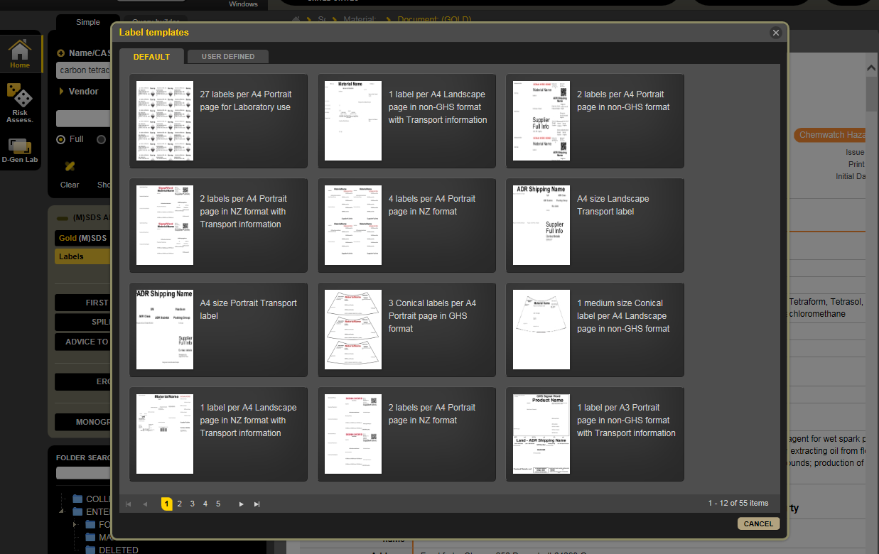

Step 2: You can print, save, or send labels by using buttons on the toolbar on the up right corner of the page.

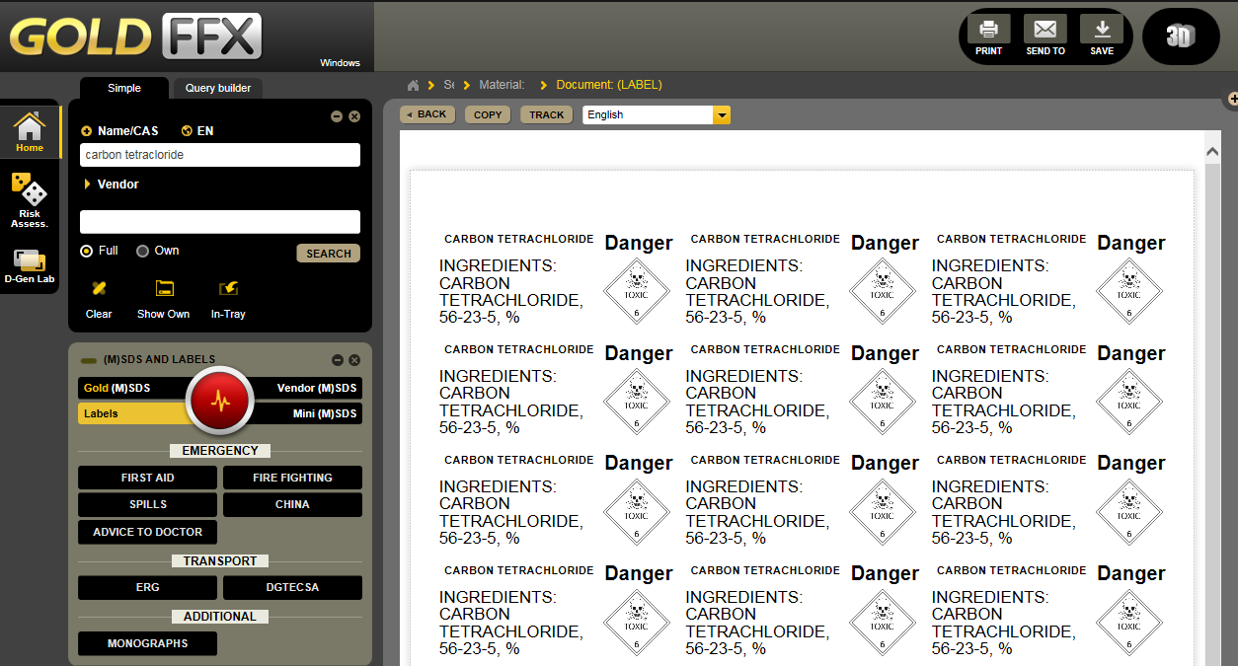
Click “Print” to print labels, Click “Send To” for sending labels via email, Click “Save” to save labels on your computer

Folder management overview
Folder management includes creating and editing folders/stores. In order to create or edit folders/stores, users need to have read/write permission. Users with read only permission can only be able to view contents of folders/stores.

The program's default directories within the tree structure hierarchy architecture are; Collection, Enterprise, Folders, Manifest and Deleted. All these main directories cannot be edited.

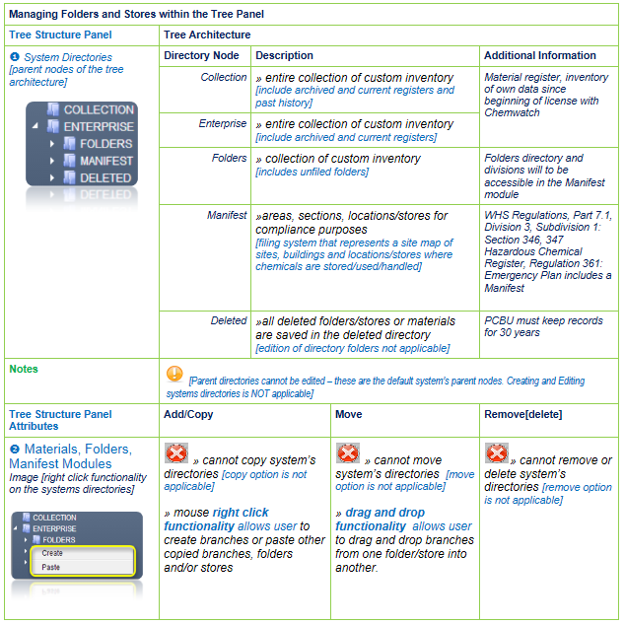

How to build a folder
Step 1: Mouse right click on Folders directory and select “create” option.

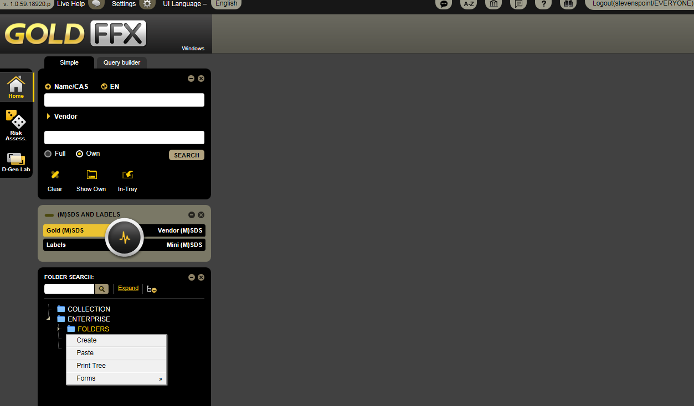
Click “Create” to form a folder

Step 2: Type the name of the folder, e.g. Contractors Register in the folder name panel and click the save button.

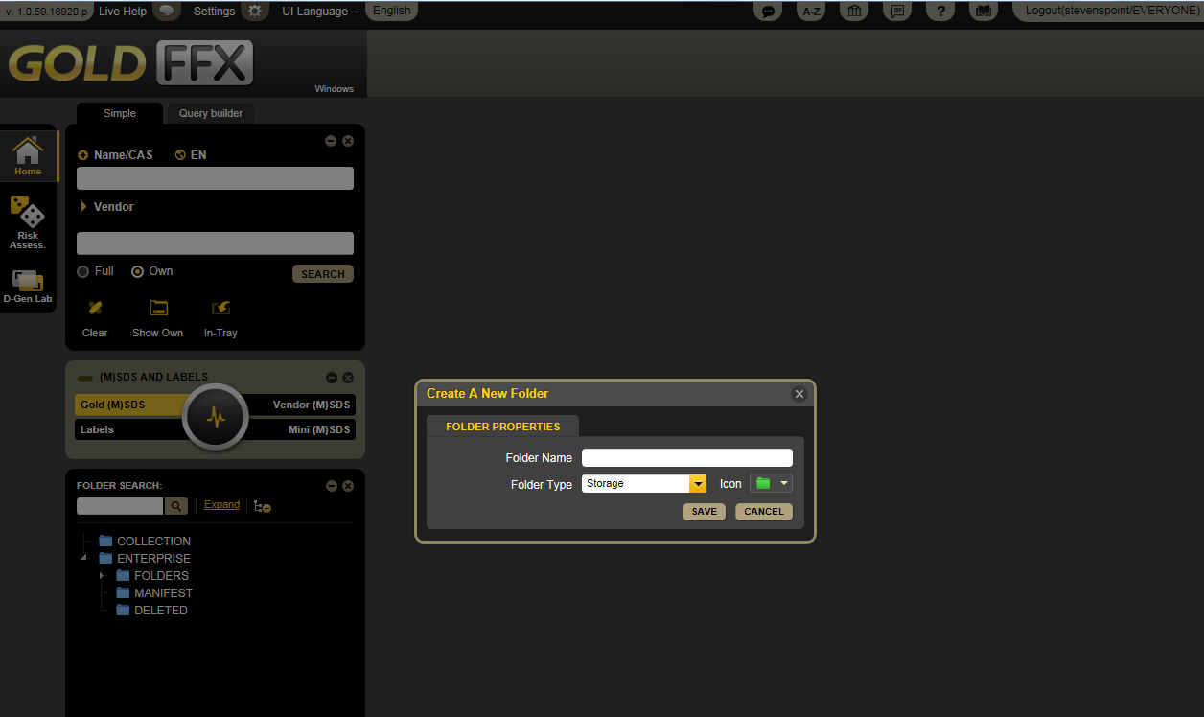
Type the name of the folder
Click “Save” to save the folder

Also, the mouse right click on folder under the parent directory will display an edit menu with a more tasks options for your additional needs.

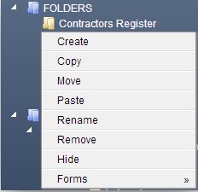

Conclusion
At the end of this document, you should be able to reach various SDSs according to your need. ChemWatch also will help you to identify the hazardous chemicals that may cause a health, physical or environmental hazard during handling or use and to convey information about these hazards. The SDSs provide us with information about hazards and advice on safety precautions.
For more information on GHS and ChemWatch, please visit
- http://jr.chemwatch.net/help/goldffx/Repository/GoldFFX%20Help.html?CreatingafolderunderparentFOLDER.html
- http://www.uwsp.edu/rmgt/Pages/ehs/safety/hazcom.aspx
or contact EHS for assistance.

