Transaction Search
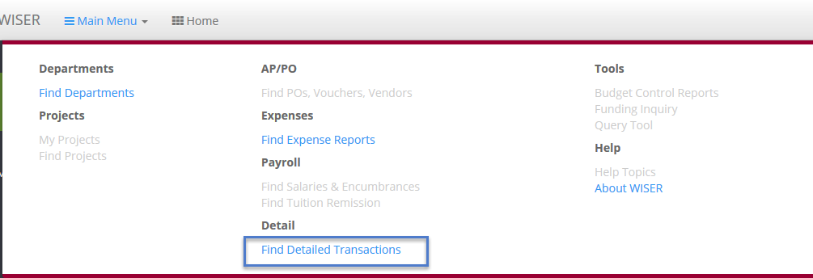
To view transaction information in WISER, navigate to the Main Menu and choose the ‘Find Detailed Transactions’ link.

On the ‘Find Transactions’ page, you will have many different search options. Any combination of these fields can be used to narrow your search results. Let’s take a look at some of those options.
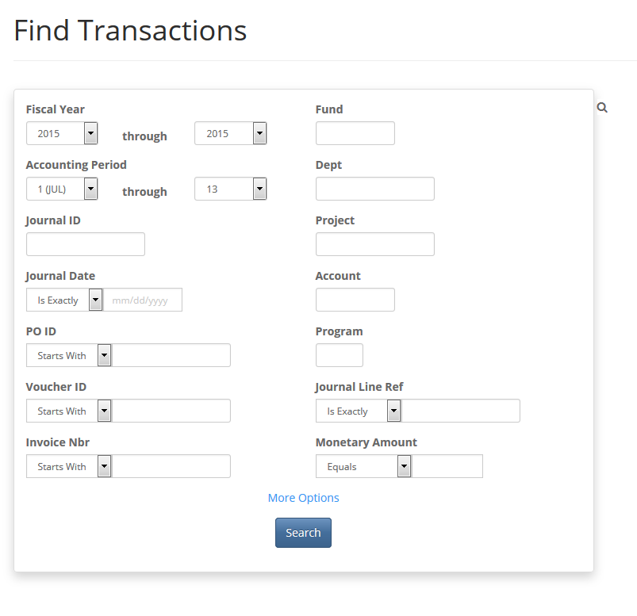
Find Transactions Search Page

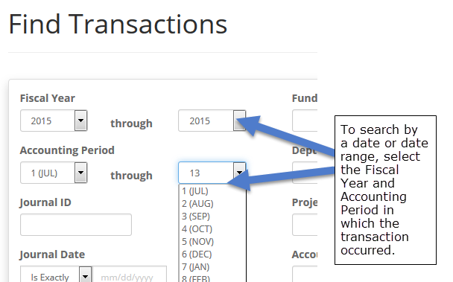
Date Range Filters
Fiscal Year
Accounting Period
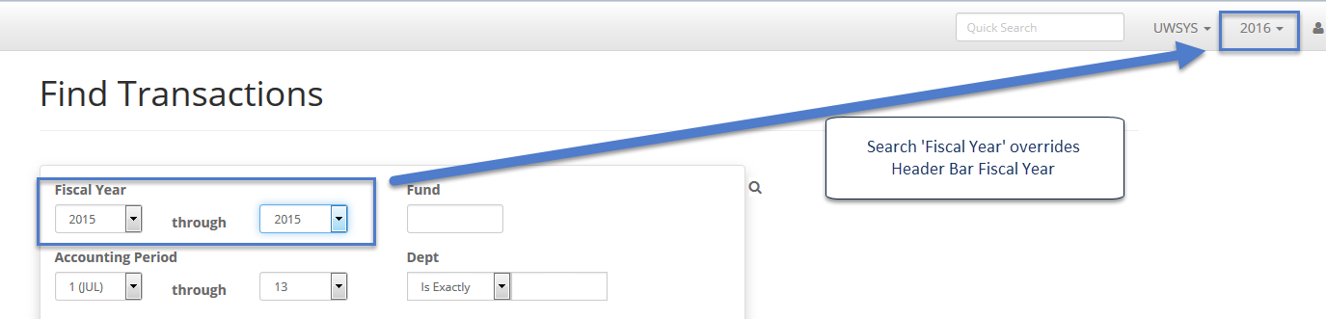
Users can narrow their search using the Fiscal Year(s) and Accounting Period(s) in which the transaction occurred. The Fiscal Year value will default to the year you have selected in the light grey header bar at the top of the page. You can override the default by simply selecting a different Fiscal Year, or range of years, in the search box. The Accounting Period will default to the range of Period 1-Period 13. You can override this default by selecting a different Period or range of Periods.

Journal Filters
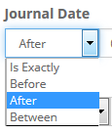
Journal ID
Journal Date
Journal Line Ref
Users can narrow their search by providing specific Journal information. Providing the Journal ID will take you directly to the detail for that Journal. You must enter the entire Journal ID for this search to work; a partial Journal ID will produce no results. The ‘Journal Date’ field can be narrowed to a single date or a range of dates, depending on your selection from the dropdown menu. Journal Line Ref can narrow results, if you have that information.

AP/PO Information
PO ID
Voucher ID
Invoice Nbr
Entering a PO ID (Purchase Order ID), a Voucher ID, or Invoice Number will restrict your result set to the specific values or range of values you provide. For each of these search fields, you have the option to enter the exact value, a ‘Starts With’ option, or a ‘Contains’ option. The ‘Starts With’ option will return values that begin with your input criteria. The ‘Contains’ option will return values which have your input criteria any place in the field.

Accounting Information
Fund
Dept
Project
Account
Program
Monetary Amount
The search boxes for Fund, Department, Project, Account and Program allow users to search for transactions belonging to any single field or combination of chartfield components, or the dollar amount on the transaction. These fields search on an exact match only. Partial values will return no results. The ‘Monetary Amount’ field can be used to find an exact amount, any amounts greater or less than your input, or a dollar range you specify.

More Options for Searching
Vendor Name
Source
Line Description
Source
System Source
Show Payroll Detail
Show Balance Sheet Accounts
Summarize Journals
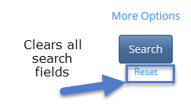
At the bottom of the search screen is the ‘More Options’ link. When clicked, it reveals additional search fields. The ‘Vendor Name’ field lets the user search for all transactions relating to a specific vendor. Note that the ‘Vendor Name’ field is not contained in the search result output; it is only a search limiter. The ‘Line Description’ search field allows you to narrow results based on text in the Journal Line Description. The ‘Source’ and ‘System Source’ fields allow you to filter on the source of the journal entry (Source-HRS, IUJ, APA, etc. or System Source- EXT, GAP, etc.).
Lastly, you have 3 checkbox options to display Payroll Detail, show Balance Sheet accounts and to summarize the journals.
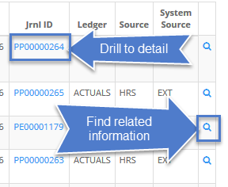
Note: The criteria entered in search boxes remains in the search boxes until ‘Reset’ has been selected to clear all search fields. Criteria may still exist in the ‘More Options’ fields when re-running searches, since the ‘More Options’ section defaults to a collapsed state. You may need to click the ‘More Options’ link to display hidden previously entered criteria.

Search Results
On the ‘Find Transactions Search Results’ screen, you will see the data output from your search. Here you can drill further into the data using any hyperlinked fields (blue font), find related transaction information using the blue magnifier at end of each row. This functionality will become more useful when additional pages of WISER are implemented.
Clicking a hyperlinked Journal ID will take you to the ‘Accounting Journal’ detail page. The detail here shows each journal line number, chartfield accounting detail, and related purchase order and voucher information.

