To view project data, navigate to the WISER Main Menu and choose the ‘Find Projects’ link under the ‘Projects’ heading.
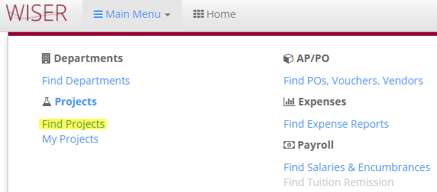

Find Projects Search:

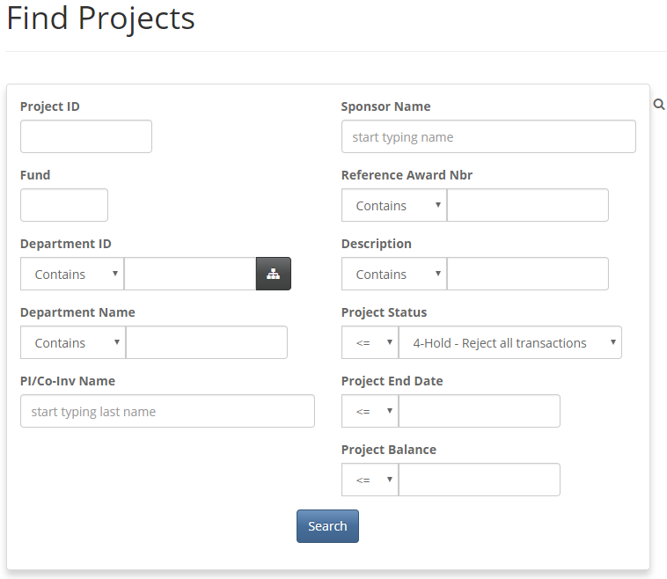
WISER displays varying project layouts depending on the project type (internal, gift, trust fund, etc.).
Enter Project ID or other search criteria and the appropriate project type layout will display.
Options in Header to Pin to Dashboard on Home page, Add to My Projects, or Export to Excel or PDF:

Internal Project:
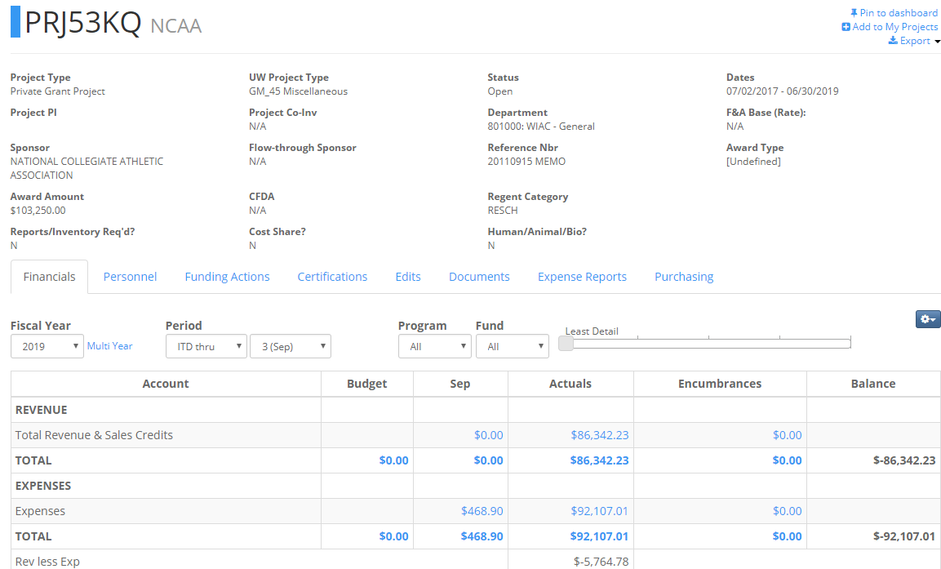
Click ‘Multi Year’ for Actual Activity by Year:
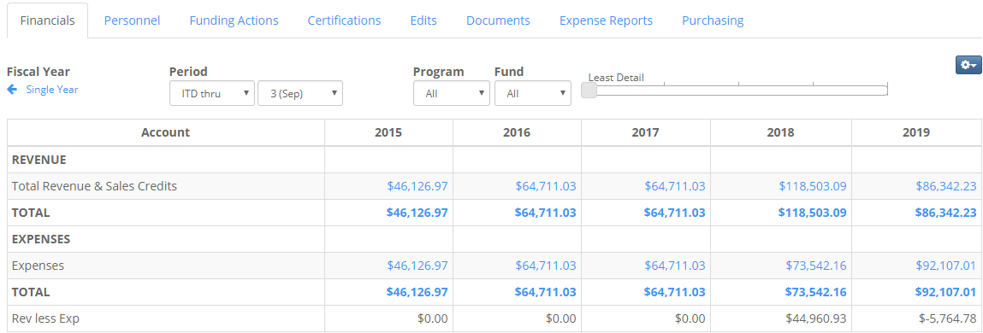
Click the ‘More Options’ icon to select a different tree or to include period 998:
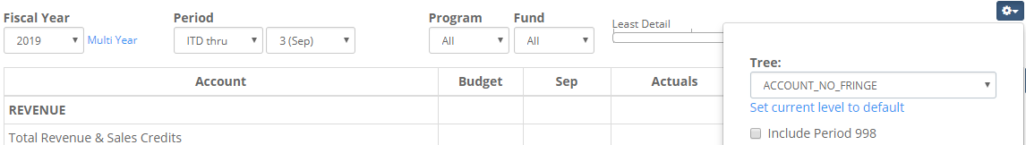

Project Lite Project:
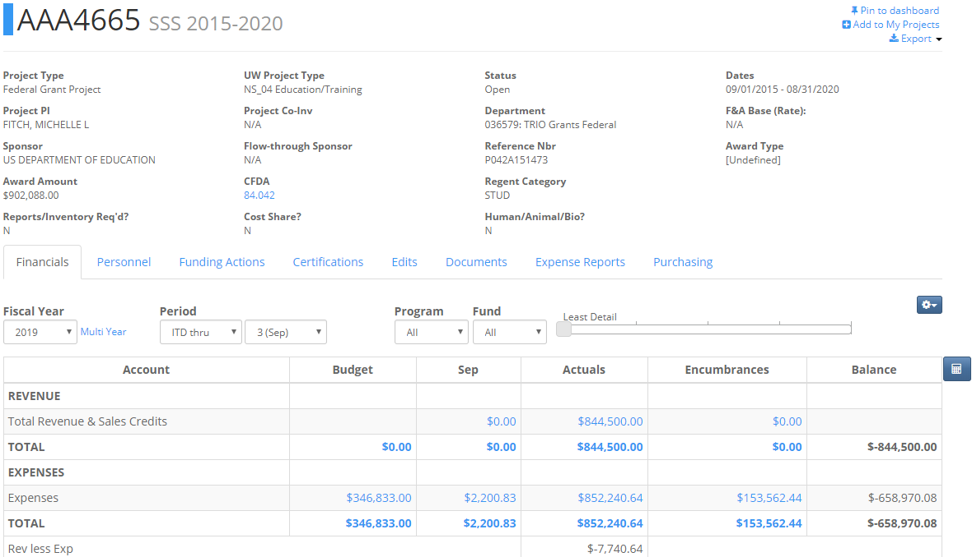
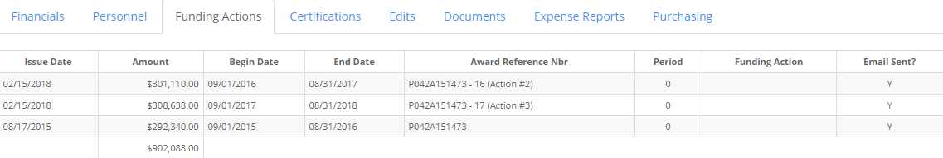
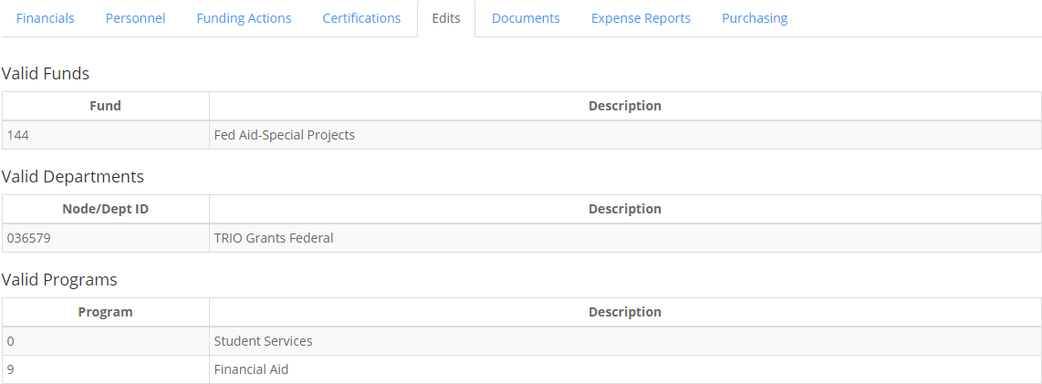
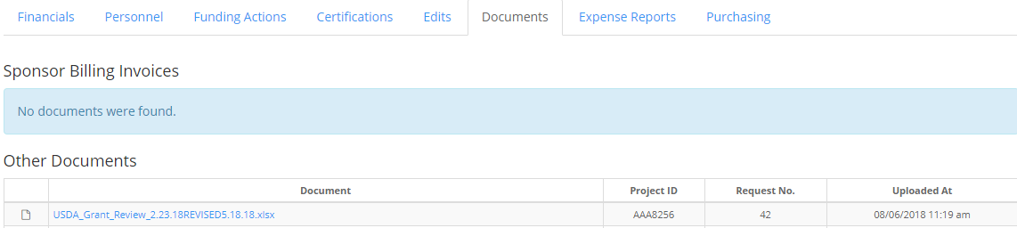
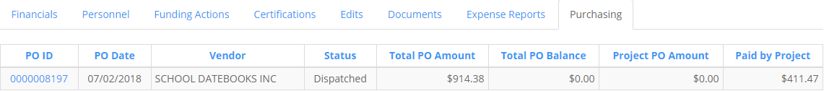

Gift Project:
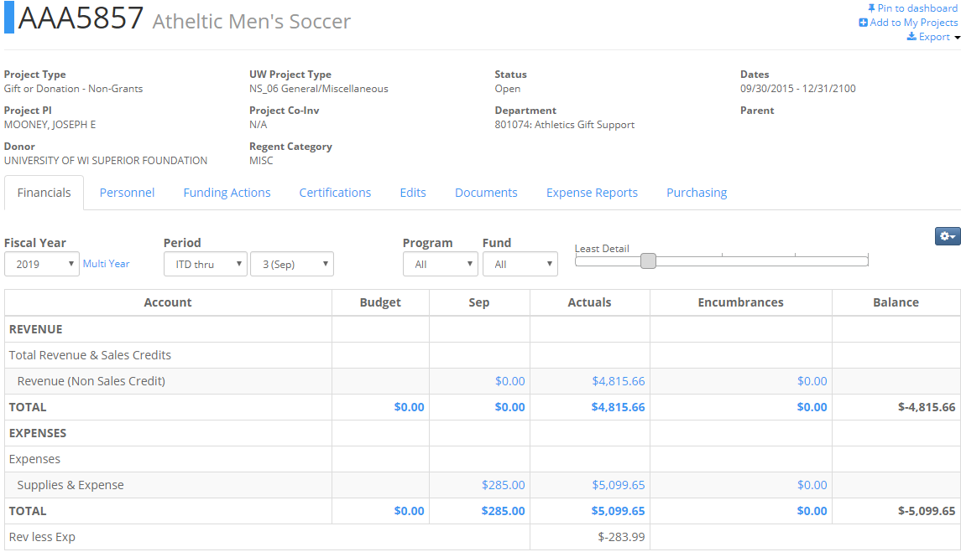
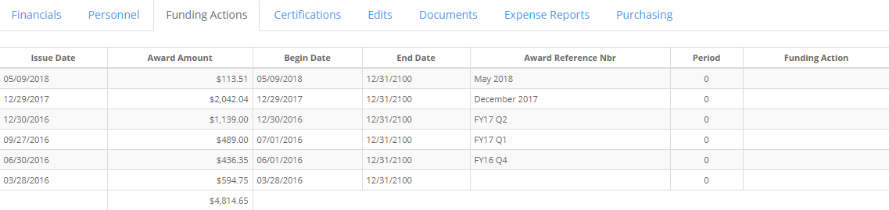
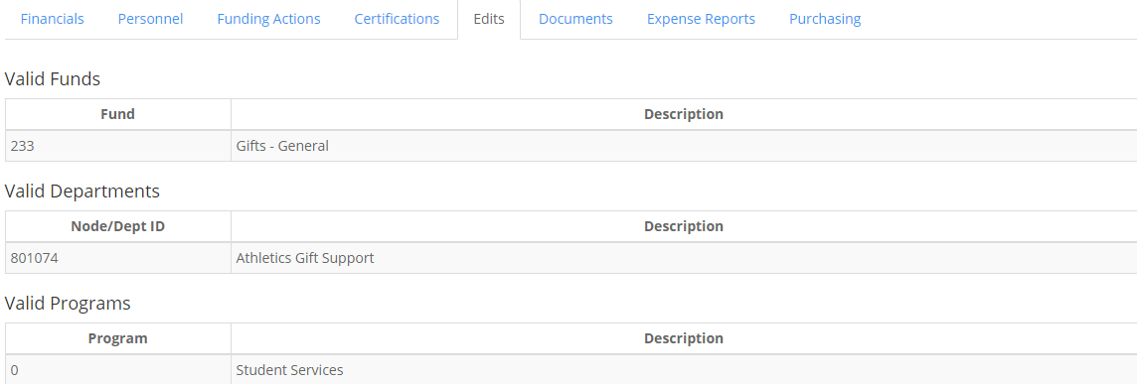

Trust Fund Project:
