Payroll Search
To view payroll information in WISER, navigate to the Main Menu and choose the ‘Find Salaries & Encumbrances’ link. 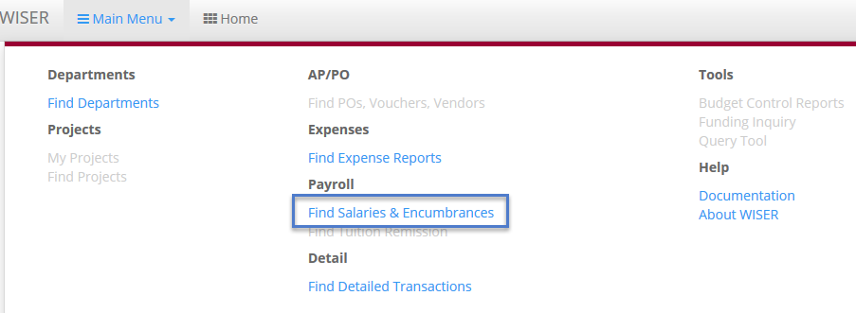

On the ‘Find Payroll Data’ page, you will have many different search options. Any combination of these fields can be used to narrow your search results. Let’s take a look at some of those options.
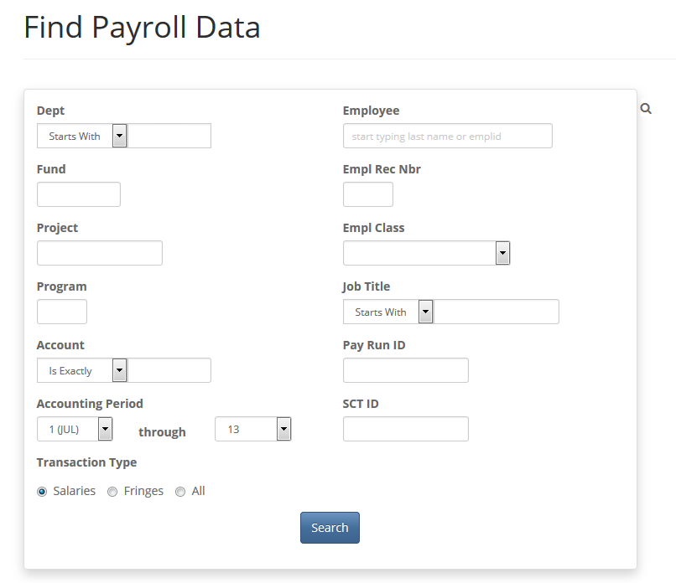
Find Payroll Data Search Page

Accounting Information
Dept
Fund
Project
Program
Account
Accounting Period

The search boxes for ‘Dept’, ‘Fund’, ‘Project’, ‘Program’ and ‘Account’ allow you to search for payroll data belonging to any single field or combination of chartfield components. The ‘Dept’ field offers the opportunity to search on a Department based on just the first few numbers, an exact match or a range of Departments. The ‘Account’ field can also be an exact match or the first few numbers in an Account code. The ‘Accounting Period’ boxes can be filtered on a single period or range of periods for the fiscal year you are searching upon. Fiscal year can be changed via the dropdown in the grey header bar.

Employee Data
Employee
Empl Rec Nbr
Empl Class
Job Title
To search for an employee, you can type the employee’s last name, partial last name or Employee ID (Emplid) in the ‘Employee’ field. The search field will display a list of available employees for the business unit and fiscal year selected. *The business unit and fiscal year are selected in the grey header bar at the top of the page.
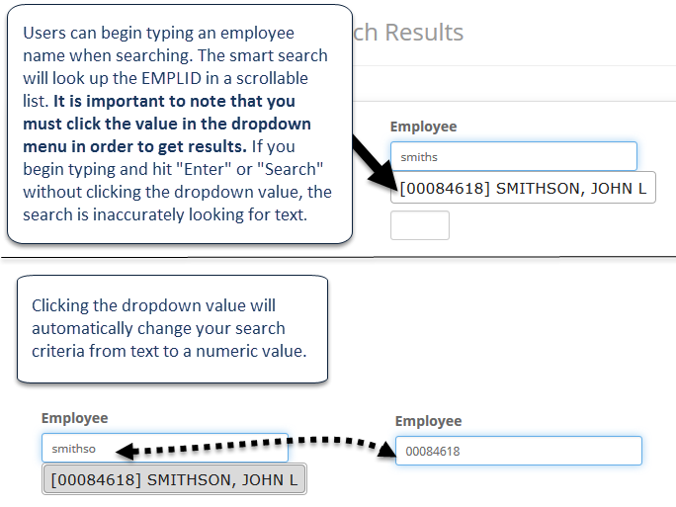

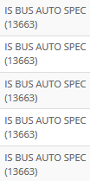
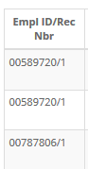
The ‘Empl Rec Nbr’ (employment record number, “ERN”) field is used in combination with the Emplid to uniquely identify employment information for an employee in HRS. The ‘Empl Class’ field is a dropdown list from which you can select a single value.
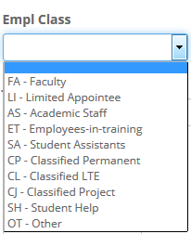
Empl Rec Nbr field and Empl Class Dropdown Values
The ‘Job Title’ field can be searched using an ‘Exact Match’, the ‘Starts With’ option, or ‘Contains’. Job title is case sensitive (CAPS) text. Even though the search results can contain a numeric portion, you cannot search using a number. Numeric values included in the search criteria will return no results.

Transaction Data
Pay Run ID
SCT ID
Transaction Type

‘Pay Run ID’ is a unique identifier of UW pay periods. You can use this field if you are looking for payroll information for a particular pay period. ‘Pay Run ID’ data is not included in the search results. It is used only as narrowing criteria. ‘SCT ID’ refers to the Salary Cost Transfer ID number. (This is not utilized at every institution.) This data is visible when drilling into the transaction detail from the original search result set. You can check a radio button under the ‘Transaction Type’ heading to view salary information, fringe benefit information or all payroll data for your selection.
If you need to search for the same payroll information for a different fiscal year, you can quickly and easily accomplish this by using the Fiscal Year dropdown menu in the WISER grey header bar. The Payroll data will automatically update on the page.
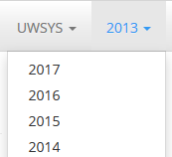

Search Results
Include Earn Dates
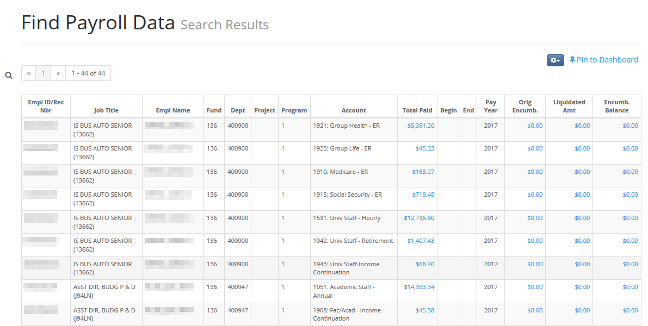
On the ‘Find Payroll Data’ search results screen, you will see your query output. You can click the hyperlinked (blue) values to see journal transaction details. On the transaction detail subpage, you can see the SCT ID values which correlate with any criteria you may have entered on the search screen. You can continue to drill into the data here; a new window opens. 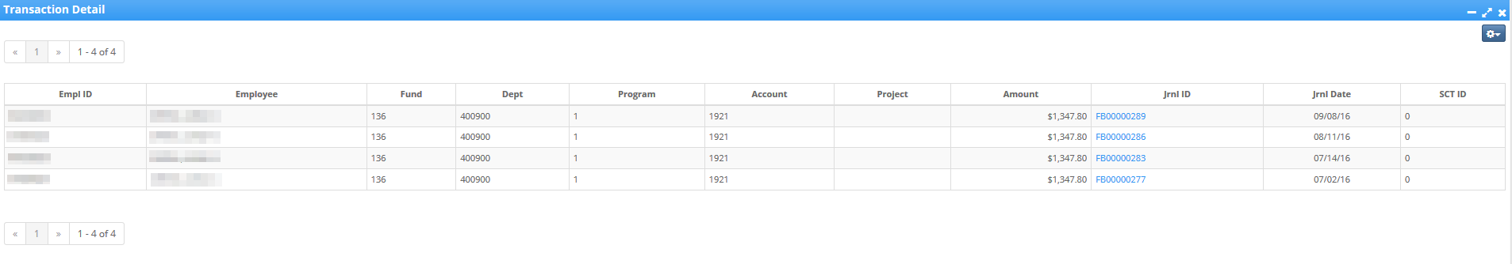
As with most WISER pages, you can click the dropdown menu on the ‘Transaction Detail’ screen to see additional actions or options- such as Export to Excel and custom column set up. Specific to Payroll data is the ‘Include Earn Dates’ option, which adds ‘Earn Begin Date’ and ‘Earn End Date’ fields to your ‘Transaction Detail’ information.
