Department Search
To view financial detail by department, navigate to the Main Menu and choose the ‘Find Departments’ option.
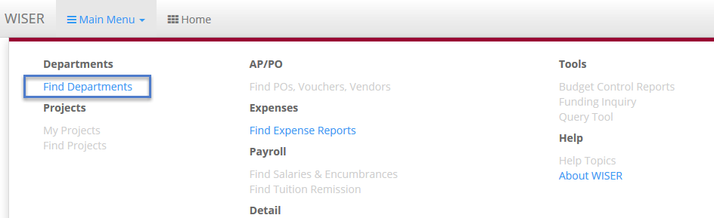
On the ‘Find Departments’ page, you will have the option to search using a single Department ID or a partial ID. You can also use the ‘Tree View’ to select the individual Department or a higher summary level.
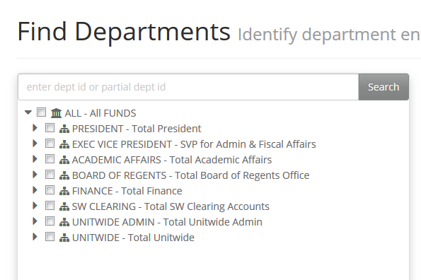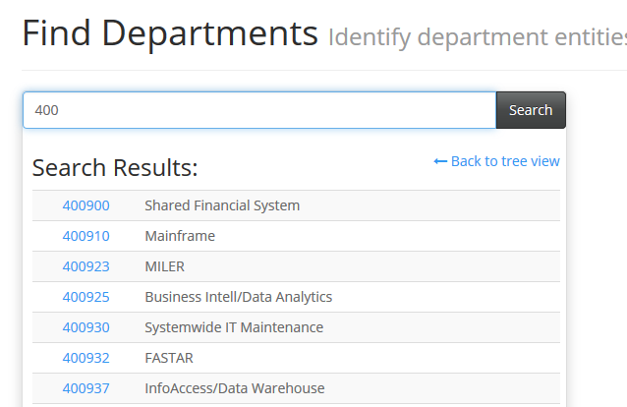
Search by tree view Search by Dept ID
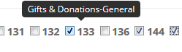
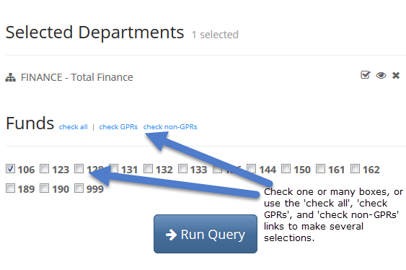
When you have made your selection, you will be able to next identify the funds you would like included in your output. You can check any of the checkboxes or you can click ‘check all’ to select all funds. You also have the option to select GPR funds or non-GPR funds. Hover over the fund to see the description, if needed.
When you have all the criteria determined, click 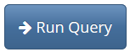to retrieve your results.
The icons to the right of the Selected Departments allow users to ‘Check all children’ in the tree view, to ‘Locate in tree’ and to ‘Remove’ the Department from the selection. Like many of the items in WISER, you can hover your cursor over any of these icons to see helpful, descriptive text if you are ever unsure of the icon’s purpose.
Please note: The ‘Check all children’ icon does not appear until the node has been expanded, using the carrot to the left.
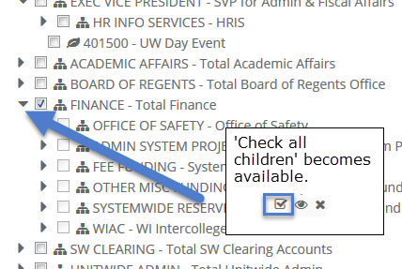
Don’t like your current selection? Click the dropdown after the page title to ‘Scope up to ALL FUNDS’ or ‘View in Dept Tree’ when available. You can also click your browser’s back button to return to the search screen, or you can navigate back to the search page through the main menu. 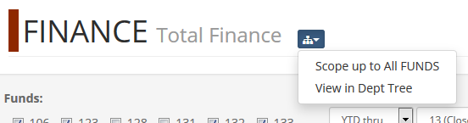

Financials Summary Page
The ‘Financials Summary’ detail page shows your results and helps you to further refine the detail, should you wish. You can change funds, change the date range, and narrow to a specific Program or Project in the light grey summary controls box at the top of the page. The ‘Options’ dropdown under the funds area allows you to ‘Select GPRs’, ‘Select non-GPRs’ or ‘Select all’ funds. 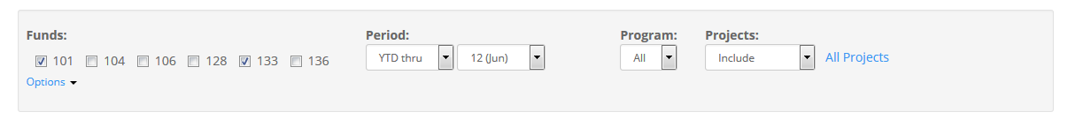 Changing the search criteria automatically causes the retrieved data to refresh. You will see an active spinning circle and “Loading…” displayed until the page data has refreshed.
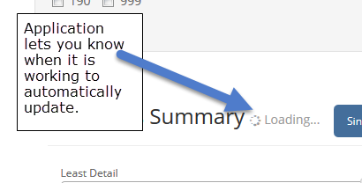

Year over Year Reporting
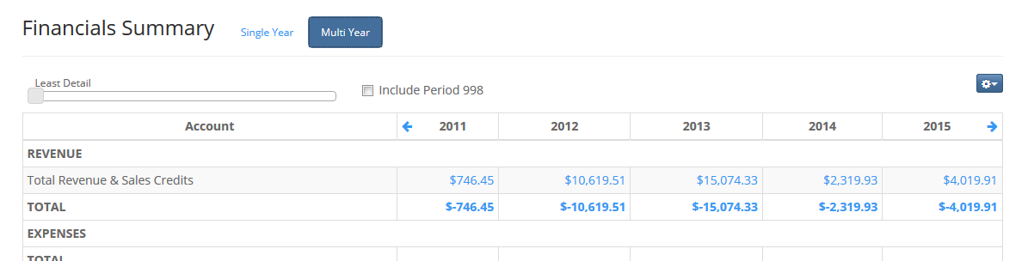
The ‘Financials Summary’ page also lets the user toggle between a ‘Single Year’ view and a ‘Multi Year’ view of the data. The ‘Multi Year’ view shows a 5 year side-by-side comparison. You can scroll through years using the blue arrows on either side of the year headings. Click any of the blue report text to drill into detail transactions.

Page Options

Tree Selection
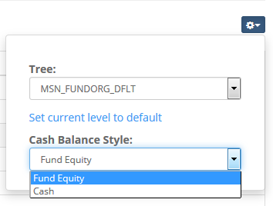
Want to change your tree? The on the far right of the Financials Summary page can be used to modify your tree options or set a default tree. Choose a tree from the dropdown menu, then click ‘Set current level to default’. 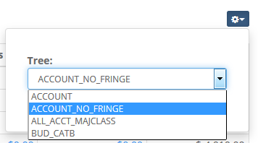 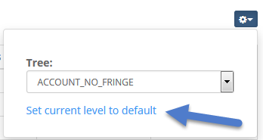

Cash Balance Style
If a cash fund was selected in your original query, you have the ability to change your view to include either ‘Fund Equity’ information or ‘Cash’ information in your report output. This option is available in both the ‘Single Year’ and ‘Multi Year’ reporting views.

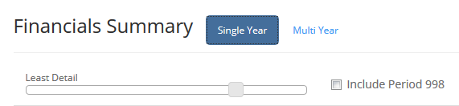
Slider Bar
The slider bar, an exciting new feature, lets you increase your report detail by changing your tree level. You can zoom out to a summary level and zoom back into the detail quickly and easily.

Detail Transactions
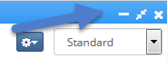
Clicking on any of the blue hyperlinked text on the ‘Financials Summary’ page will bring up transaction detail at the bottom of your screen, in a subpage.
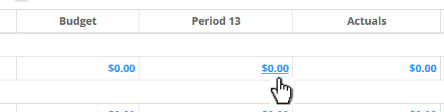 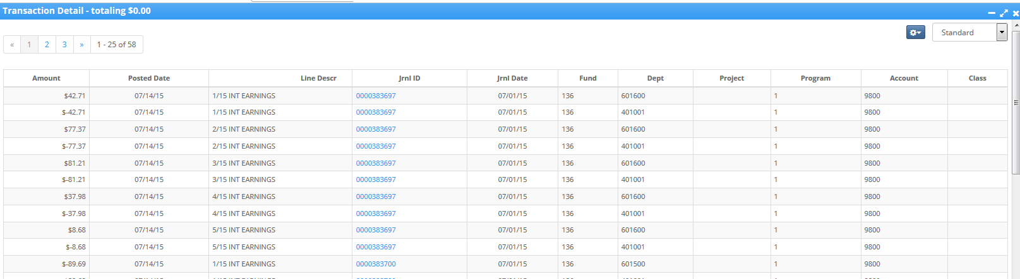
The ‘Transaction Detail’ subpage provides journal line level data. You can maximize, minimize or exit this subpage using the 3 icons in the upper right of the blue header bar.
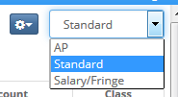
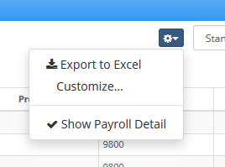
In this area, you can also change your view from ‘Standard’ to ‘AP’ or ‘Salary/Fringe’ using the view dropdown menu. Just to the left of that, you’ll see another dropdown. Here, you can export the retrieved data to Excel, customize your columns, or show/hide payroll detail.

Favorites and customizations

Favorites
Do you like this search and want to save it? Simply click the ‘Pin to Dashboard’ link at the top of the page to save it to your home page as a tile.

Customizations
On the detail transactions subpage, you can use the dropdown on the right to customize your view. Click the dropdown arrow, choose ‘Customize…’, and the ‘Customize Columns’ box will open. If you’d like to add extra fields/columns of data to your view, simply highlight the field in the ‘Available columns:’ box and click the right arrow to move the new column to your ‘Custom Columns’ list. 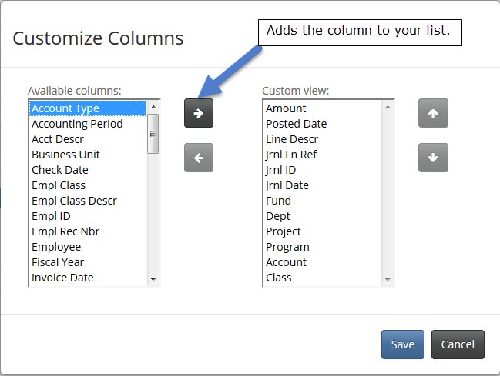
The default is for the new column to show last on the list. To reorder your new column in the view, highlight the column and click the up or down arrow to place it where you like. Moving the value up will move it to the left on your layout. Conversely, moving it down will move it to the right.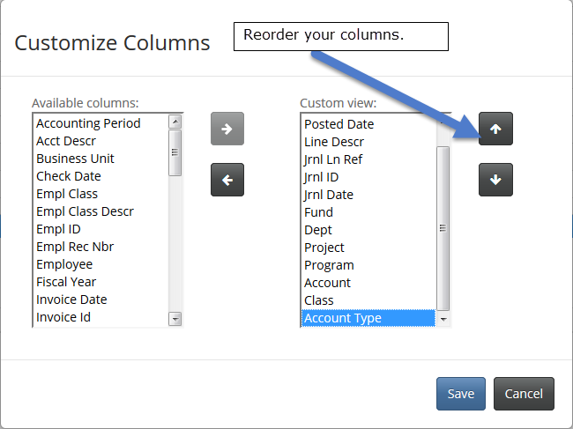
Remove unwanted columns by highlighting the value and clicking the left arrow, placing it back in the ‘Available columns:’ box. Again, helpful tooltips are available if you are unsure of any object’s purpose. Click ‘Save’ when you are done to save your changes, or ‘Cancel’ to back out without making a change.
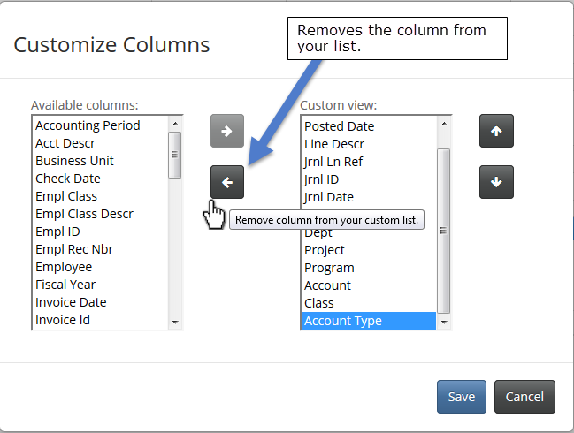
Have questions or comments? Please contact wisdm-bug@lists.wisc.edu or click the link in the bottom right hand corner of any WISER page.

