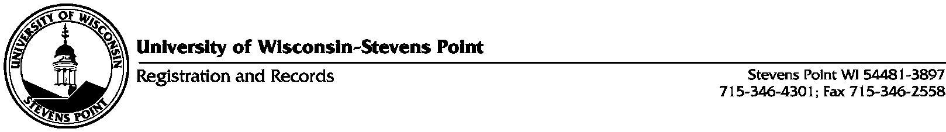

Completed Experiential Learning Activity (ELA) Approval Form

Any UWSP faculty or academic staff (instructional or non-instructional) member may serve as a mentor for an ELA.

- It is the responsibility of an approved ELA Mentor to report the completion of an ELA to Registration and Records Office (101 SSC) for each student that they may mentor. Electronic copies of this form can be e-mailed to: jroth@uwsp.edu.

- Mentors must retain a copy of the ELA Planning Form and Rubric for their own records and for future General Education Program assessment purposes. A copy of each form should also be given to the student.

- Use this approval form only to report a completed ELA to Registration & Records.

- Once the approval form is processed by Registration and Records, the Experiential Learning requirement will be reported on the Degree Progress Report (DPR) as being satisfied (listed as “OK” on the DPR).

Student’s Name | UWSP ID#
(press “tab” to add more rows)

Faculty/Staff ELA Mentor Name (print) _____________________________________________

Faculty/Staff ELA Mentor Signature________________________________________________

Date: ______________________

